CATERING MENU
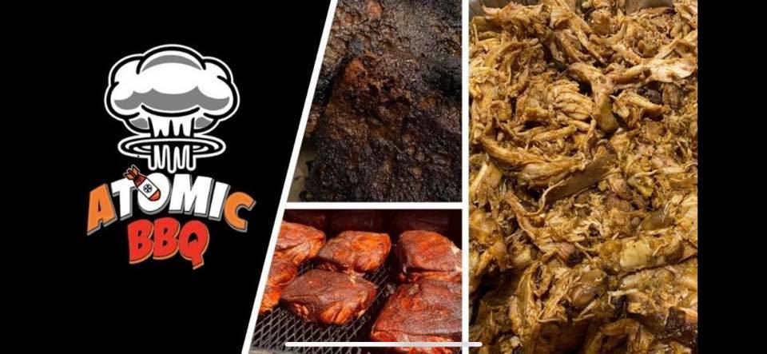

The Little Guy ($17.50 per person/min.50ppl)*
Choice of (2) meats
Choice of (2) sides
BBQ Sauce & North Carolina Vinegar upon request
Drinks: choice of- water, sweet tea, strawberry lemonade
Corn Bread Soufflé

The Big Guy ($20.50 per person/min.50ppl)*
Choice of (3) meats
Choice of (3) sides
Chopped House Salad
Corn Bread Soufflé
Drinks: choice of- water, sweet tea, strawberry lemonade
BBQ Sauce & North Carolina vinegar sauce upon request

* Includes delivery, plastic silverware, plates & napkins.
For full-service catering including set up, tear down and cleanup additional $$.

Smoked Meats (A LA CARTE)

Small feeds 10-15 ppl / Large feeds 20-25 ppl

Brisket Sm $80.00 Lg $155
Bacon Wrapped Chicken Sm $75.00 Lg $135
Pulled Pork Sm $65.00 Lg $125
Baby Back Ribs Sm $85.00 Lg $170.00
Pulled Chicken Sm $70.00 Lg$130

Sides
Small feeds 10-15 ppl / Large feeds 20-25 ppl
Mashed Potato Salad Sm $24 LG $45
Kicked up BBQ Beans Sm $24 LG$45
Smoked Mac & 4 Cheese Sm 24 LG $45
Bacon Ranch Pasta Salad Sm $24 LG $45
Roasted red potatoes W/Garlic & Onions Sm $24 LG $45
Bacon & Cabbage STIR FRY Sm $24 LG $45
Brunswick Stew Sm $28 LG $55
Baked Ziti Sm $28 LG $55
Anti-Pasta Salad Sm $28 LG $55
Rib Eye Chili & Corn Soufflé Sm $35 LG $70

Appetizer Platters (feeds 15-20 ppl)
$45 platter
Spinach Dip & Chips or French bread cubes platter
California Street Corn dip & Chips
Tex Mex spicy bean dip & chips
Pico Salsa & Chips
$60 platter
Mango/Cabo-Habo Mesquite Chicken Tostadas
Avocado, Cilantro & Lime Mesquite Chicken Tostadas
Stuffed Mushrooms w/chive & garlic infused cream cheese topped with Romano cheese breadcrumbs
Stuffed Roasted Jalapeno peppers w/ Sausage cream cheese & topped w/Romano breadcrumbs
Sweet smoked hickory bacon wrapped green beans
Fruit & Veggie platter
Fruit Tray $45
Fruit & Cheese Tray $65
Veggie Tray $40

Charcuterie Boards
(Individually quoted based on items & number of people)
Fruit, Cheese, Meats, Crackers, Breads, Nuts, Antipasti

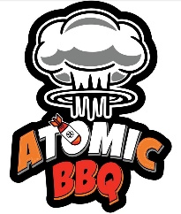
Contact us @ (239) 349-0162 or (239) 699-3990
facebook.com/ATOMICBBQSWFL

