Cake Serving Size & Pricing
Party Size – 2” w x 2” d x 3 ½”h Wedding Size – 1” w x 2” d x 3 ½”h
TINY SMALL MEDIUM LARGE X-LARGE
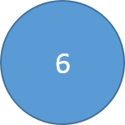 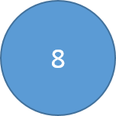 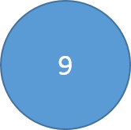 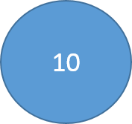 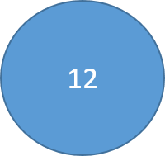
12 20-24 24-32 28-38 40-56
servings servings servings servings servings
$40 $50 $57 $65 $75
Minimum sculpted cake order is $150.
The above prices are the cake flavors, fillings and frostings shown below. They include simple borders, and either 3 piped roses or fondant polka dots, piped dots or Swiss dots, writing, and a fondant covered cake board. Additional charges will apply for fondant covered cakes, sugar work, chocolate work, edible images and other complex decorations.

.White or Yellow Vanilla Cake .Cookies and Cream .Sour Cream Almond
.Red Velvet .Chocolate Chip .Lemon .Chocolate .Marble

*Dairy Free Chocolate or Vanilla
*Egg Free Chocolate or Vanilla
*Vegan Chocolate or Vanilla

Premium Flavors (inquire about pricing please):

.Fresh Strawberry .Pound Cake .Butter Almond .Killer Fudge
.Coconut .Carrot
*Gluten Free/Vegan – Chocolate, Vanilla or Carrot
*We are not a gluten free facility. While we take every precaution to ensure this doesn’t happen,
our products may contain or come into contact with milk, wheat, nuts, soy, and other
allergens.

Fillings:
.Raspberry, Strawberry or Apricot Jam .Peanut Butter Frosting .Chocolate Cream Cheese
.Cookies and Cream .Brown Butter Frosting .Pastry Cream .Chocolate Croquant .Fueilltine

Premium Flavors (inquire about pricing please):
.Citrus Curds .Ganache .Fresh Seasonal Fruit .Chocolate or Fruit Mousse
.Fruit or Nut Flavored BC
*.Dairy Free Chocolate Ganache

Frostings:

.Swiss Meringue Buttercream .American Buttercream .Cream Cheese Frosting
.Vegan Frosting .Chocolate Fudge .Cream Cheese Frosting
.Raspberry, Orange or Lemon Buttercream
.White Chocolate, Caramel or Mocha Buttercream

