GAMES

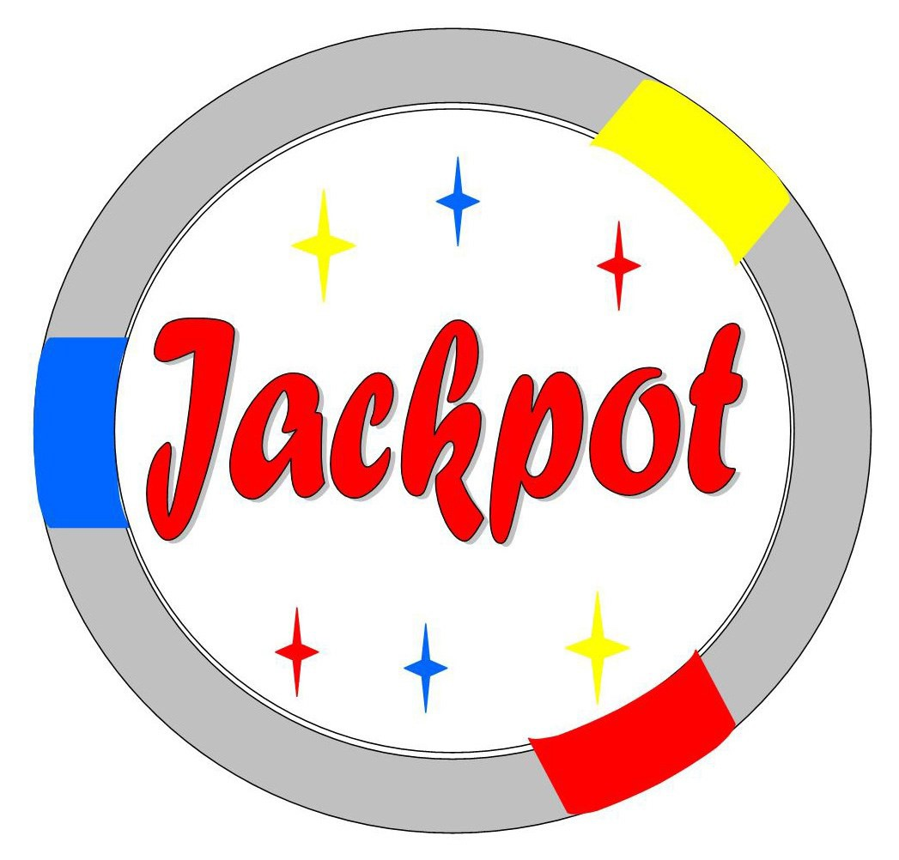
“Your Premier Casino Night Provider”

(216) 531-3500
www.jackpg.com

jackpotgames@gmail.com

Jackpot Games
Casino Equipment Rental
Founded in 1969 by John Copic Sr., Jackpot Games continues to provide friendly, reliable service. Located on East 185th St. in Cleveland for over 4o years, our family owned and operated business works with corporate and non-profit organizations to create fun, professional casino nights.
Our specialty is designing an event that is perfect for your group. You will receive personal attention, customizing a package that fits your needs. We will be happy to meet with you to help you with the planning process, and will be there to help every step of the way. You and your guests will be treated to a fun, friendly evening that you will be sure to remember!

How it Works
Your guests will receive a ticket to redeem at any table for chips. Players move throughout the casino and meet dealers who will not only patiently teach the games, but help them win.
After gaming ends, the friendly dealers will redeem the chips for raffle tickets and the raffle drawing of the prizes begins. Every guest has a chance to win, and the excitement lasts until the last ticket is drawn.

Available Games
Blackjack, Texas Holdem Poker, Let it Ride Poker, Three Card Poker, Caribbean Stud Poker, Pai Gow, War, Baccarat, Roulette, Money Wheel, Big 9 Wheel, Craps, English Craps,
Over/Under Dice, Slot Machines, Bingo.
(216) 531-3500
www.Jackpg.com jackpotgames@gmail.com

Party Packages
Packages include table games of your choice, chips, cards, raffle tickets, dealers, and delivery.

10 to 20 Guests = $ 695 1 Game of your Choice Seats 7-10 | 80 to 100 Guests = $ 2,655  8 Games + a Pit Boss Seats 56-80
20 to 30 Guests = $ 895 2 Games of your Choice Seats 14-20 | 100 to 125 Guests = $ 3,100  10 Games + a Pit Boss Seats 70-100
30 to 40 Guests = $ 1,200 3 Games of your Choice Seats 21-30 | 125 to 150 Guests = $ 3,470  12 Games + a Pit Boss Seats 84-120
40 to 50 Guests = $ 1,500 4 Games of your Choice Seats 28-40 | 150 to 175 Guests = $ 3,900  14 Games + a Pit Boss Seats 100-140
50 to 60 Guests = $ 1,795 5 Games of your Choice Seats 35-50 | 175 to 200 Guests = $ 4,350  16 Games + a Pit Boss  Seats 115-160
60 to 70 Guests = $ 1,995  6 Games + a Pit Boss Seats 42-60 | 200 to 225 Guests = $ 4,870  18 Games + a Pit Boss Seats 130-180
70 to 80 Guests = $ 2,395  7 Games + a Pit Boss  Seats 50-70 | 225 to 250 Guests = $ 5,500  20 Games + a Pit Boss  Seats 150-200
Chairs are NOT included. All Packages are based on standard pricing of 3 hours of gaming and located within 30 miles of Cleveland. There is an additional charge further than 30 miles. Custom pricing available.
Tax is not included.

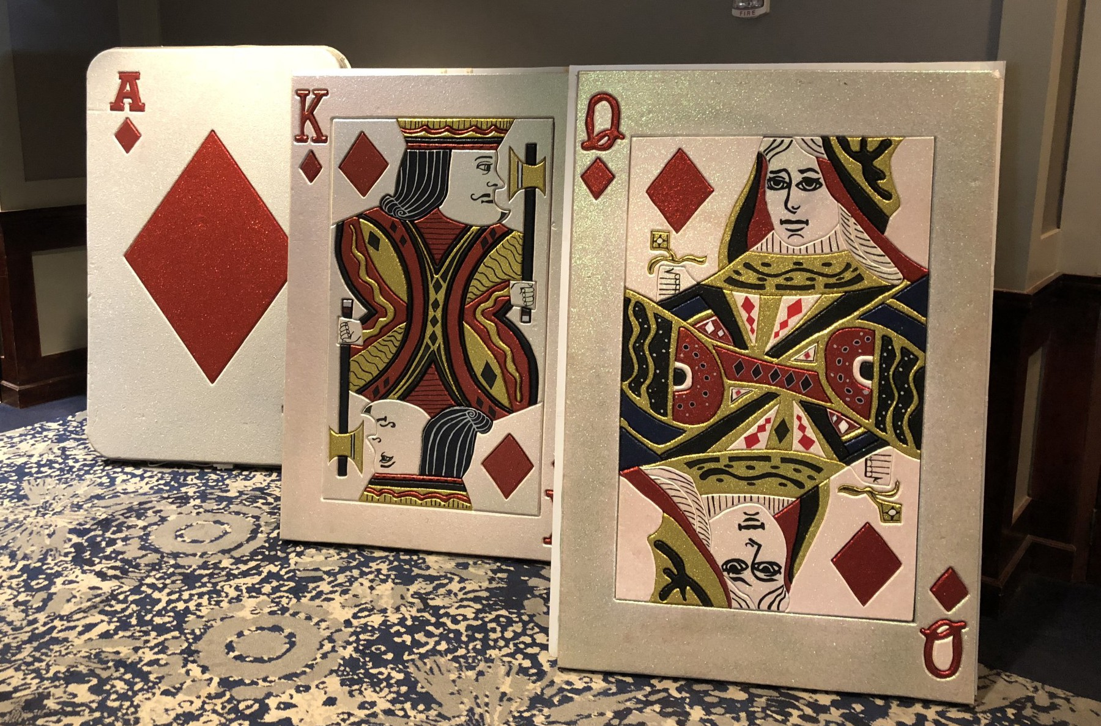
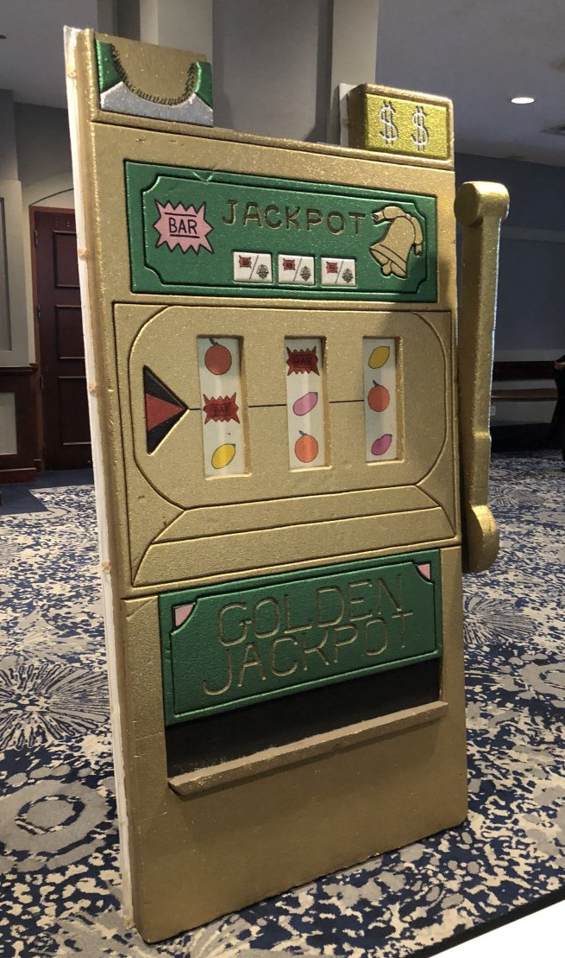
Fun Add Ons
Background DJ Service *Special* = $500 for up to 3 hours while your casino is open.
Interactive DJ Service = $250 per hour (minimum of 3 hours)
Decorations for Rent:

6ft Light up Ace of Diamonds - $ 200
6ft Light up King of Diamonds - $ 200 6ft Light up Queen of Diamonds -
$200

Special for all 3 Cards - $ 500

6ft Light up Slot Machine - $ 250

Framed Signs on Easels
$100 each, or $500 for all 6

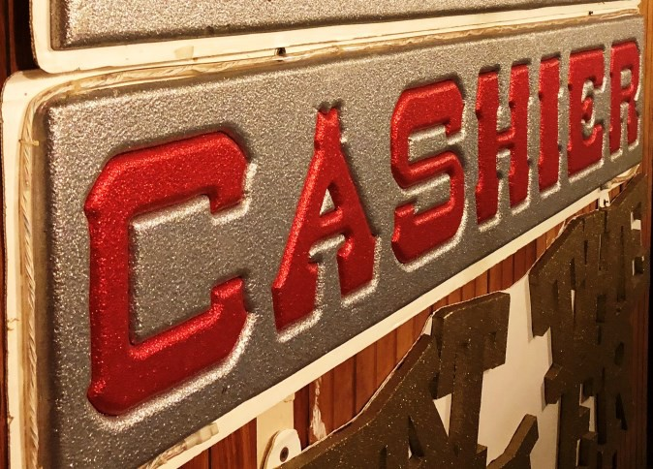
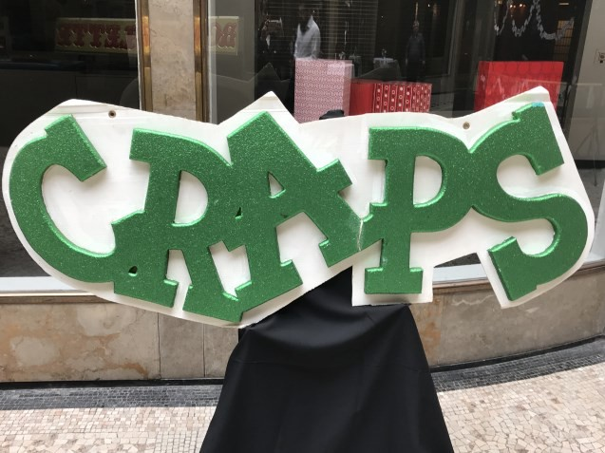
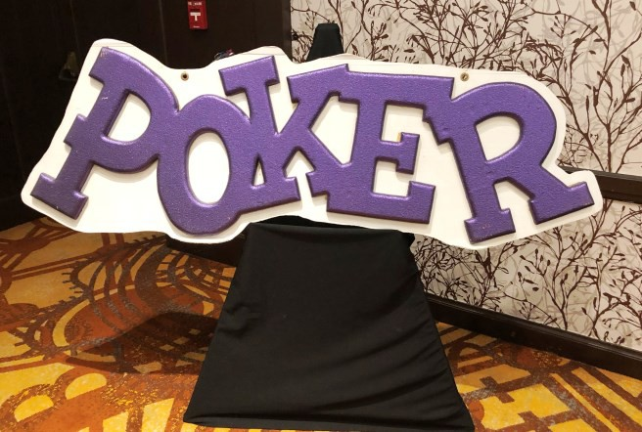
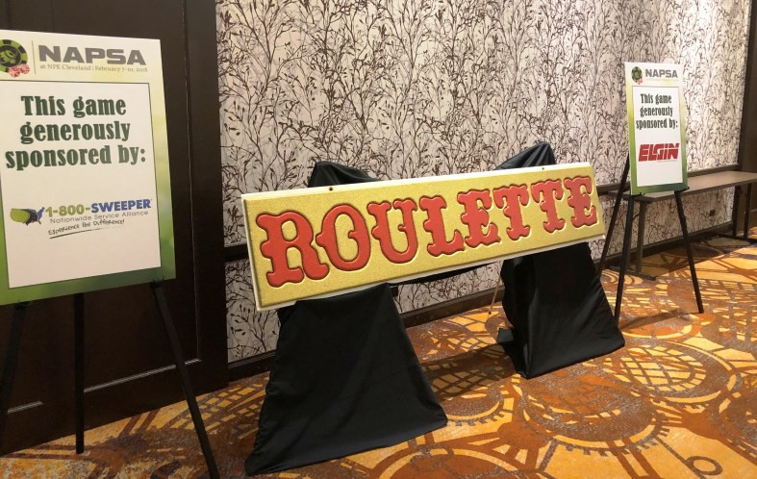
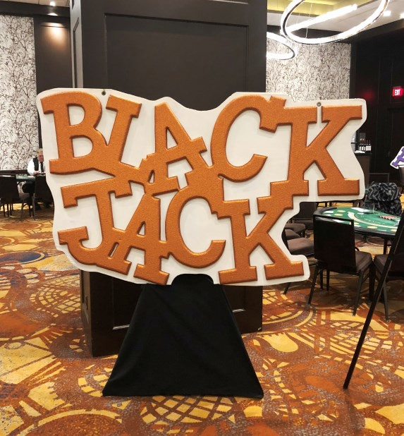
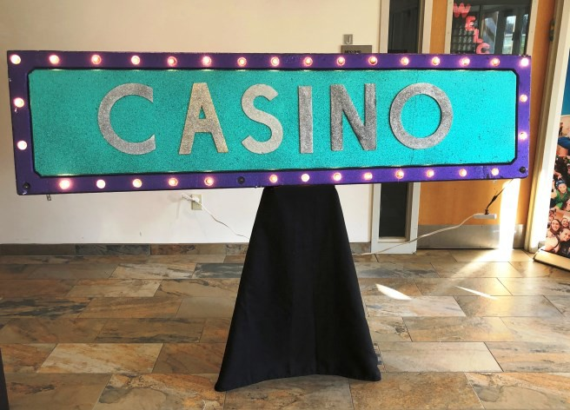

Vegas Posters on Easels
$50 each, or $200 for all 5
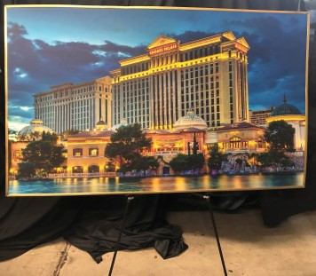
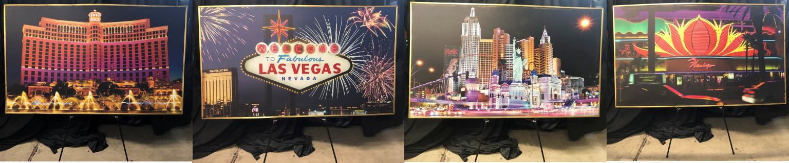
Reverse Raffle Boards with easels - $50/each to rent Reverse Raffle Tickets - $ 20/each to buy
Photo Booth, Money Machine
and Video Gaming also available. Check us out at www.Jackpg.com or call 216.531.3500 for details and pricing.

References
Corporate Events:

Steris Corporation
Michelle Perry - Michelle.Perry@Steris.com

House of Blues Cleveland
Julie Woyma - juliewoyma@livenation.com

ASMGI
Cody Darr - cdarr@asmgi.com

Fundraisers:

Lacey Seminsky Foundation
Jodi Seminsky - angelsmom75@yahoo.com

Caring Continues
Clare Brim - Clare.Brim@CWFC.org

Private Parties:

Valerie Hoit - vmhoit@sbcglobal.net

Jackpot Games (216) 531-3500 JackpotGames@gmail.com www.Jackpg.com

