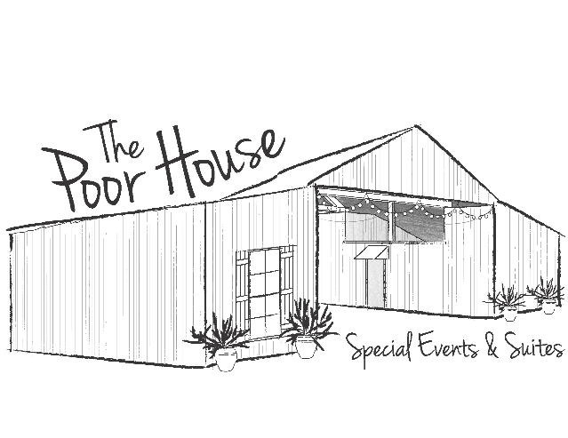
2016 Price Sheet
The base rental price for renting The Poor House (TPH) is $300.00 for a three (3) hour rental on Friday or Saturday. Sunday – Thursday the base rental fee is $200.00.
The base rental price includes the open area under the barn and a bathroom. A picnic table, wooden benches, serving tables, and TV are also included in the base price.
“The Big Weekend” price is $1,400.00. This includes all options available AND two suites with King Beds for two nights. Check in at Noon on Friday and check out at Noon on Sunday.
Options available: Additional Cost:
Extra Day on “The Big Weekend” $200.00
Suites (call for pricing/depends on date) $125.00 minimum per night/per suite
All Day Rental (9:00 A.M. – 12:00 A.M.) $100.00
Kitchen (required for stereo and ice machine) $100.00
Fire Pot (firewood included) $60.00
16 chairs/6 – 6’ rectangular /2 – 5’ round tables $50.00
Patio Heater (includes 5 gallons of propane) $40.00 per heater (2)
Additional restroom(s) $30.00 per restroom(2)
Additional Hour(s) $30.00 per hour
Large Barrel Fan(s) $20.00 per fan (2)
We can arrange labor for set up, clean up, and garbage disposal. The labor rate is $50.00 per hour/per man.
Please like us on Facebook at facebook.com/poorhousestarkville, follow us on Instagram at the_poorhouse and Pinterest at The Poor House Starkville, MS.
Thank you,
Mindy Wolfe 662.418.7621
Poorhouse13@gmail.com
Initials of Renter________

