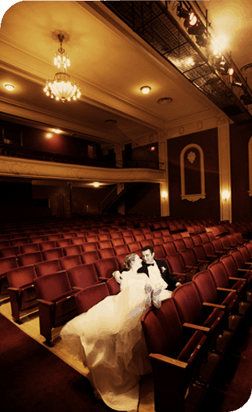
The Clifton Center is a beautiful place to begin a memory you will cherish forever.
_____________________________________________________________________
Make your wedding day memorable and historic! Have your wedding in our Eifler Theater with your reception in our newly renovated Reception Hall. The Eifler Theater is a unique beautifully restored vintage proscenium theatre with plush fixed seating. Our 4,000 sq. ft. Reception Hall space can accommodate up to 250 guests. Rentals includes use of our tables and chairs; early access to decorate; bride and groom rooms; an open catering policy; staff support for set-up, breakdown and meeting management; experienced staff and more.
Discover the best value in town for your wedding ceremony and reception. We are located in the heart of the Frankfort Avenue corridor in the Clifton/Crescent Hill area of Louisville.
RECEPTION HALL RENTAL
10 hour minimum $1,650
Each additional hour $150

EIFLER THEATER WEDDING & RECEPTION HALL
14 HOURS minimum $2,450
*Includes a technical staff member, lighting, sound, rehearsal & wedding

For more information contact:
Ann Drury
502.896.8480
adrury@cliftoncenter.org

2117 Payne Street, Louisville, KY 40206

