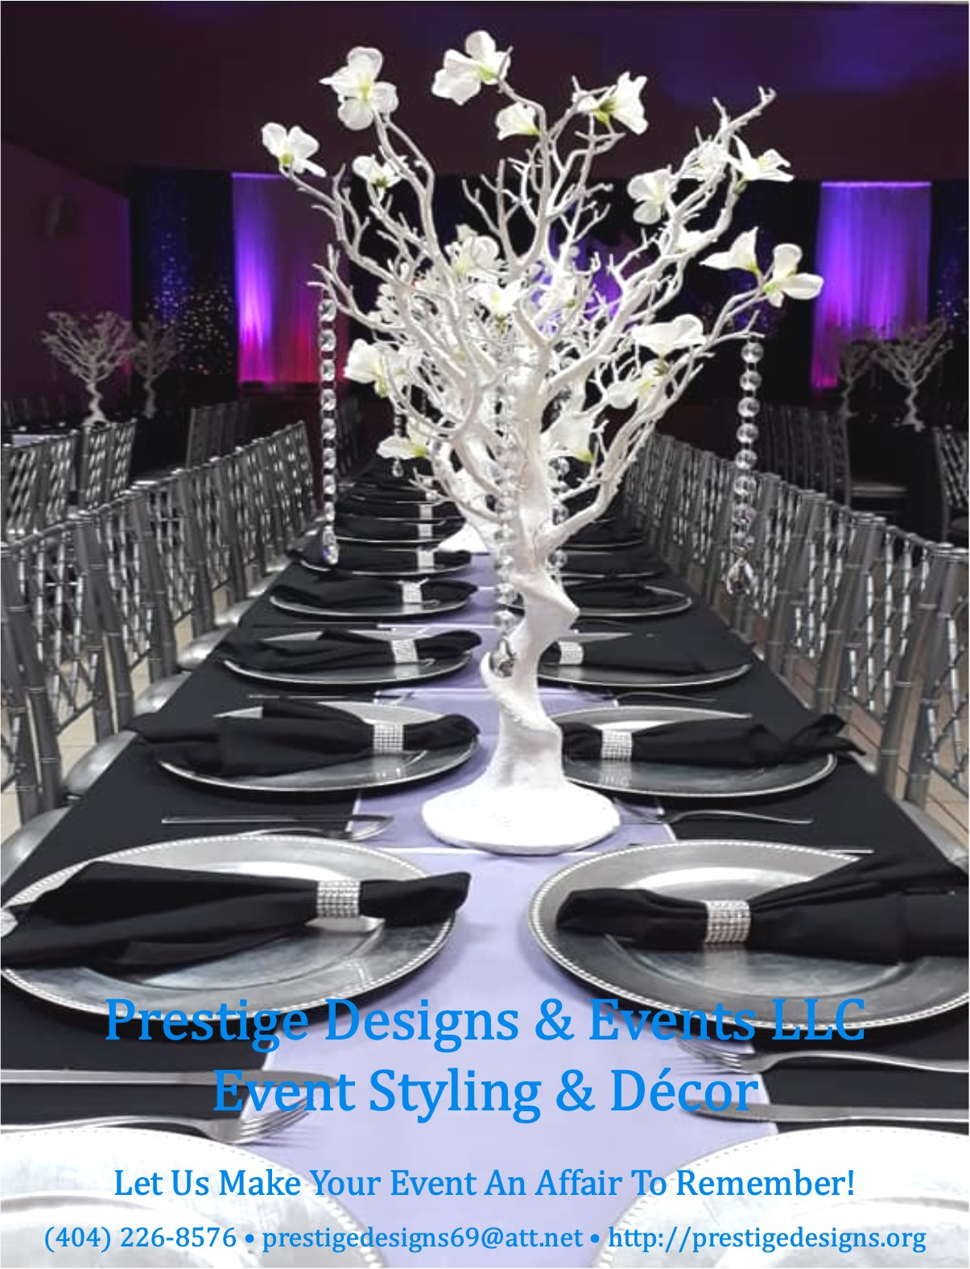

Creating

Unforgettable

Memories

One Event At a Time!

Prestige Designs & Events LLC is a full-service event planning and decorating company based in Decatur, GA. We specializes in weddings, corporate events, launch parties, social celebrations, religious gatherings, and much more!

Whether you’re planning an event for 20 or 200 guests,
we can create a design tailored to the unique style
you envision for your momentous occasion.

Our Event Styling & Décor Services include design, delivery, set-up, arranging, and take down of all the décor that we provide
so that you and your family can enjoy your day stress free.

To ensure your décor is set-up according to your vision, we would prefer to set-up the day before the event or three hours on the day-of, and two hours for breakdown.

Your Vision • Your Style • Your Day
We Make It Happen!

Event Styling & Décor Services
Based on 100 guests.
For clients who have planned everything for their event and need a creative design tailored to the unique style they envision
for their momentous occasion.

Silver Decoration Package: $2,500
• Standard Polyester of Satin Table Cloth
•Satin or Polyester Chair Covers w/ Matching Sash
• Satin Table Runner or Overlay
• Guest Table Setting w/ Centerpiece & Charger
• Head Table Decoration w/ Standard
• Gift Table Decoration w/ Standard Linen & Centerpiece
• Dessert Table Set-Up with Linen & Decor
• Entrance Signage/Display
• Photo Booth Backdrop w/ Props
Additional Guests: $15.00 per guest

Gold Decoration Package: $3,500
• Premium Table Linen
• Premium Chair Covers w/ Matching Sash
• Satin Table Runner or Overlay
• Napkins w/ Diamond Holders
• Guest Table Setting w/ Medium Centerpiece & Charger
• Head Table Decoration w/ Premium Linen
• Gift Table Decoration w/ Premium Linen
• Dessert Table Set-Up with Linen & Decor
• Entrance Signage/Display
• Photo Booth Backdrop w/ Props
Additional Guests: $20.00 per guest

Platinum Decoration Package: $4,500
• Premium Table Linen
• Premium Chair Covers w/ Matching Sash
• Satin Table Runner or Overlay
• Napkins w/ Diamond Holders
• Head Table Decoration w/ Premium Linen & Table Skirt
• Gift Table Setting w/ Premium Linen, Chargers, & and Premium Centerpiece
• Dessert Table Set-Up with Linen & Decor
• Entrance Signage/Display
• Photo Booth Backdrop w/ Props
• Formal Dinner Ware
Additional Guests: $30.00 per guest

Premium Linen: (available in a variety of colors)
- Table Cloth: Pintuck, Spandex, Flocking Damask, Flocking Taffeta, Sequin, Flamingo Petals, and Rosette.
- Chair Covers: Universal, Spandex, or Chivari Chair Caps.
- Chair Sashes: Organza, Taffeta, Pintuck, Chiffon, Spandex, and Embroidered Organza.
- Table Skirts: Curly Willow Taffeta, Rosetta, and Satin Lamour Ruffle.
- Table Runner: Organza, Sequin, Taffeta, Grandiose Rosette, Shimmering Polyester, Artificial Grass, Couture Tulle, and Lace Netting.
- Overlays: Organza, Taffeta, Pintuck, Sequin, 3D Rosete, Lace, and Razzle-Dazzle Glitter.

Ala Carte Add-Ons:
- Prince and Princess Throne Chairs $350.00

- Formal Fine China Dinnerware (100 guests) $800.00
(includes dinner plate, dessert plate, 3 set flatware, water goblet, and champagne flute). Additional sets at $8.00 per guest.

- Premium Disposable Dinnerware (100 guests) $300.00
(includes dinner plate, dessert plate, 3 piece flatware, water goblet, and champagne flute – high quality plastic). Additional sets at $3.00 per guest.

- Head Table Backdrop w/ Draping and Uplighting
- 8 ft x 20 ft (head table for up to 10 people) $300.00
- 10 ft x 24 ft (head table for up to 16 people) $400.00

To ensure your décor is set-up according to your vision, we would prefer to set-up the day before the event or three hours on the day-of,
and two hours for breakdown.

