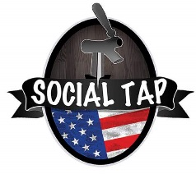
Brunch Buffet Options

The Basics
Scrambled Eggs
Choice of Two Meats (Bacon, Sausage, Ham)
Breakfast Potatoes
$9 Per Person ++

Breakfast Taco Bar
Scrambled Eggs
Choice of Two Meats (Bacon, Sausage, Ham, Chorizo)
Pico De Gallo, Sour Cream, Hatch Green Chili Sauce, Cheddar Jack Cheese
Corn and Flour Tortillas
Chips and Salsa
$12 Per Person ++

Sweet Tooth
Pancakes or French Toast
Maple Syrup, Butter, Blue Berry Syrup
Choice of Two Meats (Bacon, Sausage, Ham)
Scrambled Eggs
Potatoes
$12 Per Person ++
Additional Items
Fruit $2
Granola and Yogurt $3
Extra Meat (Bacon, Sausage, Ham, Chorizo) $2
Breakfast Potatoes $1
Tortillas (Corn or Flour) $1
Chips and Salsa $2
Guacamole $2
*all items priced per person ++

Pricing includes Soft Drinks, Coffee, and Tea

Alcohol and juice are additional
Bar Packages Available!

++ All parties are subject to applicable taxes and 20% service fee

