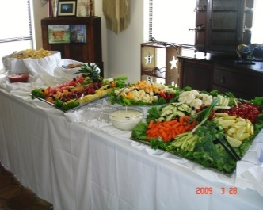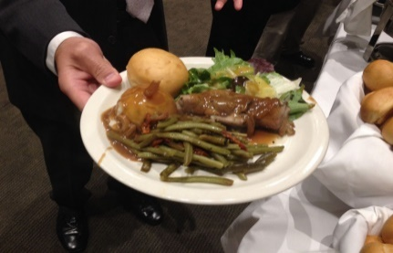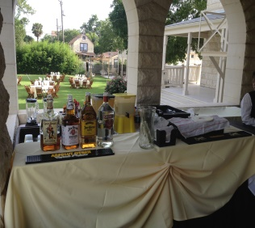
All-INCLUSIVE PACKAGE SPECIAL 2024
“GRAND BALLROOM @ SCOTTIH RITE ”
- BOOK TODAY !!!!
$99.99 + TAX PP
- BALLROOM W POLICE OFFICER - LINEN OF YOUR CHOICE (BLACK, WHITE OR IVORY) WITH IN HOUSE CENTER PIECES, WHITE OR BLACK CHAIR COVERS
- APPETIZERS: FRUIT- VEGETABLES- CHEESES – CHIPS AND SALSA
- DRINK STATION: ICE TEA- LEMONADE- ICE WATER – COFFEE
- FULL OPEN BAR SERVICES: BYOB STYLE–TABC LICENCE & LIABILITY
- DINNER: ELEGANT - SELECTION FROM OUR MENU
- FULL CHINA PRE-SETTINGS INCLUDING SILVERWARE & GLASSES
- PRESET ICED TEA AND ICE WATER
- SEMI-BUFFET OR SIT DOWN DINNER
- TOAST: CHAMPAGNE GLASS PROVIDED
10.COMPLETE CAKE CUTTING SERVICE: PLATES- FORKS-NAPKINS
***WAITER SERVICE FROM START TO FINISH $ 150 EACH***
(Waitstaff determined by number of Guests)
JUAN CARLOS RAMIREZ 210-387-4315
CALL TO SCHEDULE A TOUR AND A QUOTE

Sales@feedbackcatering.com www.Feedbackcatering.com
VOTED TOP 10 WEDDING CATERERS IN SAN ANTONIO FOR 2022!

