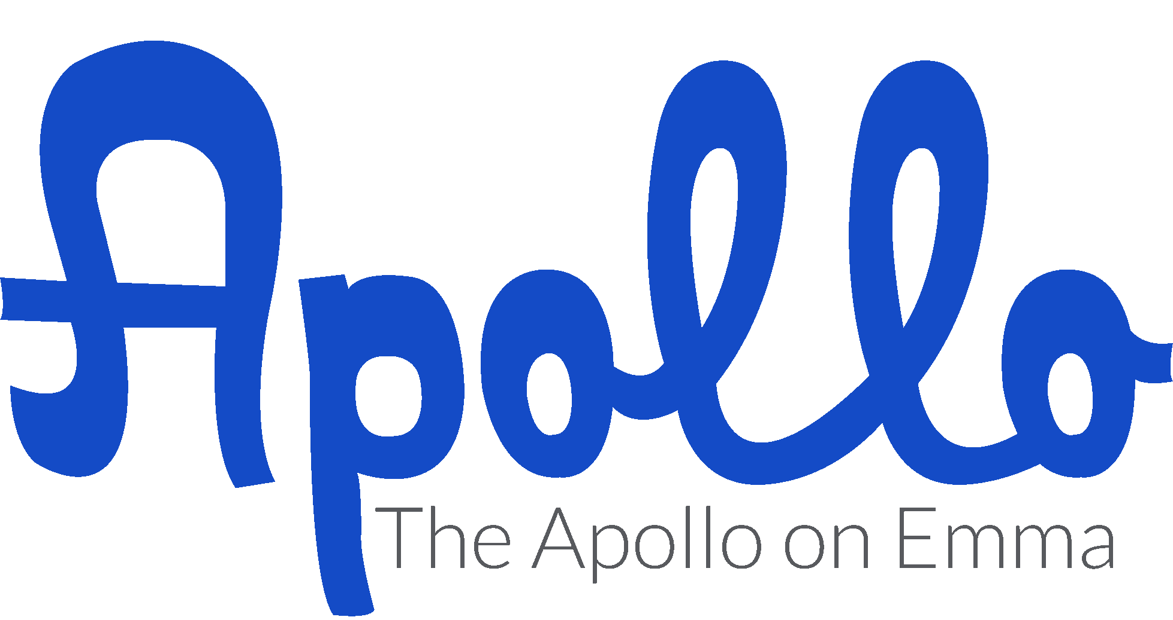

The Apollo on Emma
Pricing Information

Saturday - $4500.00

Ask about details on renting The Grove Cottage for additional cost as a
Bridal Suite | Bride & Groom sleeping quarters | Family Air bnb

- 9:00 am through 11:00 pm (Have until Midnight to have everything out)
- Chairs and tables for 400 (Including cushions for all your chairs)
- Catering kitchen with ice machine & commercial fridge
- Garden Patio that seats up to 200 & is covered year round
- Signature Cocktail Lounge with built in bar
- VIP Room overlooking the main ball room
- Full access to all A/V for showcasing movies or photos or dance screens
- Movie marquee to place special messages for your big event
- Two hour photo session with your photographer before your event date
- Bluetooth and Wi-Fi connections to all house speakers
- Local vendor recommendations
- Food truck service area
- Client can bring in and use any vendor of their choice

Day of Coordination can be added for additional price.

Friday - $3000.00

Ask about details on renting The Grove Cottage for additional cost as a
Bridal Suite | Bride & Groom sleeping quarters | Family Air bnb

- 9:00 am through 11:00 pm (Have until Midnight to have everything out)
- Chairs and tables for 400 (Including cushions for all your chairs)
- Catering kitchen with ice machine & commercial fridge
- Garden Patio that seats up to 200 & is covered year round
- Signature Cocktail Lounge with built in bar
- VIP Room overlooking the main ball room
- Full access to all A/V for show casing movies or photos or dance screens
- Movie marquee to place special messages for your big event
- Two hour photo session with your photographer before your event date
- Bluetooth and Wi-Fi connections to all house speakers
- Local vendor recommendations
- Food truck service area
- Client can bring in and use any vendor of their choice

Day of Coordination can be added for additional price.

Sunday - $2,500.00

Ask about details on renting The Grove Cottage for additional cost as a
Bridal Suite | Bride & Groom sleeping quarters | Family Air bnb

- 9:00 am through 11:00 pm (Have until Midnight to have everything out)
- Chairs and tables for 400 (Including cushions for all your chairs)
- Catering kitchen with ice machine & commercial fridge
- Garden Patio that seats up to 200 & is covered year round
- Signature Cocktail Lounge with built in bar
- VIP Room overlooking the main ball room
- Full access to all A/V for show casing movies or photos or dance screens
- Movie marquee to place special messages for your big event
- Two hour photo session with your photographer before your event date
- Bluetooth and Wi-Fi connections to all house speakers

There is a mandatory $250.00 cleaning fee for those accessing the full venue.

The Apollo on Emma is happy to break down your chairs & tables at the duration of your event for an additional $250.00. This does not include cushions.

Full Facility Rental Includes:
- Catering kitchen
- Metropolis Room | VIP Room
- 400 White Chivari chairs
- 35 60” Round tables
- 6 6ft. Rectangle tables
- 4 8ft. Rectangle tables
- Free Wi-Fi & Blue-Tooth
- Access to A/V
- Use of 7000 lumens high-def projector
- Over 5,000 square feet of space
- Local vendor recommendations
- Access to movie marquee board and lettering
- Cocktail Lounge with built in bar
- 9am through 11pm (Midnight everything out)
- Tables & Chairs for 350 guests
- Outdoor covered patio
- Food Truck Service Area
- Client can bring in & use any vendor of their choosing

If you would like your chairs and tables set up by an Apollo representative, there is a $250.00 additional fee, this DOES NOT include cushions. Ask about prices for Day of Coordination.
ALL INCLUSIVE PACKAGE

50 Guests or less $4700

Includes:
2 tier cake from Shelby Lynn’s Cake Shoppe
50 petite fours from Shelby Lynn’s Cake Shoppe
Venue 3 hours
White Chiavari chairs with white cushions
Reception tables
Linens for 10 tables
Dancefloor
Micro-Eats from Cara Marsh Catering
Day of Coordination (Including set up/break down + styling)
Ceremony backdrop
Champagne
Champagne glasses

Other additions that can be added to package for additional costs (this does not include tax).

$350 Floral arrangements including bridal bouquet
$300 Bar-tender
$280 Fork & Crust pie or bite size pies for 50 guests
$250 Acrylic cake table
$100 Cake plates + forks
$600 DJ for 3 hours or $400 for 2 hours
$800-1500 Photographer
Photographers to choose from at least 1 month in advance:
Steph Smith Weddings http://stephsmithweddings.com/
Keely Montoya Photography https://www.themontoyacollective.com/
Jason Hudson Photography https://www.hudsonphotos.com/
Benfield Photography https://benfieldphotography.com/
$100 Officiant

*We do not carry a liquor license so you may bring in your own.

To book contact Heidi Ann Faires at theapolloonemma@gmail.com
We require 50% of the total amount due in order to reserve your date.
Remaining balance is due 60 days prior to your event date.

The capacity for each room is:
Outer Lobby 42
Cocktail Lounge 100
Ballroom 551
Metropolis Room 55
Garden Patio 250

We offer a 10% discount on our Friday, Saturday and Sunday rates to all non-profit and fundraising organizations.

Time variations and pricing available upon request. Email or call us with any questions regarding renting the space during the Sunday through Thursday time frames.

Located in historic downtown Springdale, the vintage building makes for great photography. We offer photo sessions at The Apollo on Emma starting at $100 per hour. All brides that book with us for a Friday through Sunday will have a 4 hour at no extra cost, bridal or engagement shoot with their photographer. This 2 hour shoot must be taken during Monday through Thursday with a scheduled appointment.

Holiday Pricing for the following Holidays will be set at a varied rate. For details please email us at theapolloonemma@gmail.com

New Years
4th of July
Christmas
Labor Day Weekend
Memorial Weekend

There are several breweries and a few local bistros that are within walking distance including Black Apple Crossing, Bike Rack Brewery, & The Odd Soul.

Arkansas Missouri Railroad is only a block and ½ away from The Apollo on Emma and offers rides from downtown Springdale to Dickson Street.

There are several shops that offer great gift for weddings & events.

We have a local florist for all your event needs at Organic Creations.

Shelby Lynn’s Famous Bakery is located just blocks from the venue and offers an array of Wedding Cakes to delectations.

There are also a few food trucks that offer services as well as local eateries including Mothership, Mr. Taco Loco, Spring Street Grill, Big Sexy Food, The Odd Soul Pizzeria and more. We are happy to offer any vendor recommendations as needed.

