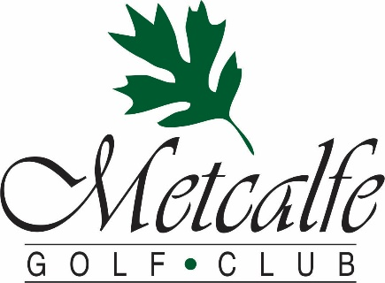
The METALFE GOLF Club is home to HICKORIES, a full -service Restaurant,
which is the perfect venue to host your wedding.

- Superb cuisine including our famous Hickories Roast Beef “au Jus”
- Friendly country service in a relaxed atmosphere
- 60-person Main dining room with adjacent 80-person patio shaded by our 400 year old Oak Tree
- Interlock deck covered by our 120-person banquet tent, overlooking our 9-hole course’s 1st hole
- Private room with stone fireplace with seating for 30
- Off Site catering service available for Weddings, Rehearsal Dinners & Brunches
- Pre-wedding golf outings
- Find out why our clients tell us over and over “We serve the best banquet meals they have ever had”
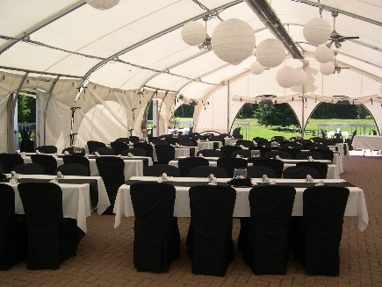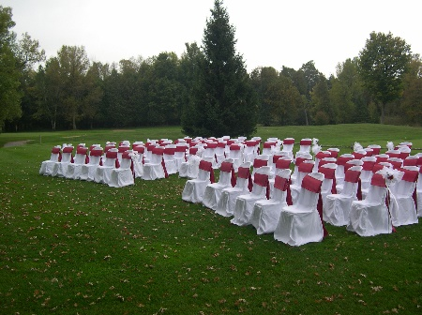

Here Is What Our Wedding Clients Have to Say:

“The Metcalfe Golf Club was the perfect location for our wedding. When planning, they were more than eager to cater to our details and give helpful suggestions. We were married under their beautiful 400 year old Oak Tree giving us great shade on a hot summer day. The tent for our reception equipped with ceiling fans was beautifully decorated and gave a scenic view of the greens. Everyone thoroughly enjoyed their meal and then some. We will definitely be going back!”
- Lori & Claude Bouchard

“I was overjoyed to see Brigitte and Joe's wedding come to life the way that it did. From the prepping and planning stages to the day of the wedding, everything was more than what I could have imagined. You were so helpful every step of the way and shared all of your knowledge with us that made the day go so smoothly. The food was absolutely delicious- cheers to the Chef! and the staff were all so kind and well organized. Thank you for accommodating the decoration set-up as well.” - Natalie T, Bridesmaid
To Book an Appointment to Discuss Your Wedding, Wedding Reception, Rehearsal or Golf Outing (613) 821- Fore (3673) or weddings@metcalfegolf.com

Appetizers & Punch Packages

“Plattered” Nibbles

Crisp Garden Vegetables, Lemon Ranch Dip
Mixed Canadian Cheeses & Crackers

Exotic Fruit Punch (non-alcoholic)
$8.95/person

“Passed Around” Appetizers

Caprese-Baby Bocconcini & Cherry Tomatoes, Basil Pesto Dip
Beef Kafta Skewers, Tzatziki Dip
Baby Shrimp Salad on Rye
Oriental Egg Roll Bits, Plum Sauce

Exotic Fruit Punch (non-alcoholic)
$8.95/person

“Extreme” Combo
Crisp Garden Vegetables, Lemon Ranch Dip
Mixed Canadian Cheeses & Crackers

Beef Meatballs tossed in Parmesan Cheese, Sweet Teriyaki Sauce
Tomato Bruschetta with Greek Feta Cheese
Herbed Cream Cheese & Cucumber Rounds
Ham & Cheddar Cheese Bits

Exotic Fruit Punch (non-alcoholic)
$13.95/person

13% HST & 10% Gratuity are not included (based on 25 people min.)

Individual Appetizers & Punches

Hot Appetizers
(served by the dozen, minimum 2 dozen)

Beef Meatballs tossed in Parmesan Cheese, Sweet Teriyaki Sauce $15
Tomato Bruschetta with Greek Feta Cheese $15
House-brined Chicken Wings, Dipping Sauces & Ranch Dip $15
Beef Kafta Skewers, Tzatziki Dip $18
Golden Chicken Nuggets, Plum Sauce $18
Oriental Egg Roll Bits, Plum Sauce $18
Baked Italian Sausage wrapped in Puff Pastry, Maple-Mustard Dip $18
Breaded Tiger Shrimp, Vodka Cocktail Sauce $24
Applewood Bacon Wrapped Scallops, Vodka Cocktail Sauce $24

Chilled Appetizers
(served by the dozen, minimum 2 dozen)

Herbed Cream Cheese & Cucumber Rounds $13
Ham & Cheddar Cheese Bits $13
Prosciutto Wrapped Melon $18
Caprese-Baby Bocconcini & Cherry Tomatoes, Basil Pesto Dip $18
Cold Water Smoked Salmon on Rye $18
Baby Shrimp Salad on Rye $18

Cocktail Platters
(Serves 25 people if added to a meal)
(Additional quantities is recommended if being served without a meal)

Crisp Garden Vegetables, Lemon Ranch Dip $49
Mixed Canadian Cheeses & Crackers $99
Sandwich Wedges including Tuna, Salmon, Roast Beef, Egg, Ham… $79
Seasonal Fruits, Sweetened Vanilla Sour Cream Dip $89
Assorted Olives, Marinated Vegetables & Pickles $39
Sliced Cold Cut “Deli” Meats $89
Assorted Dessert Squares $69
Assorted Cakes $99

Fruit Punches
Exotic Fruit Punch, $85 serves 50 people
Spiked Fruit Punch, $135 serves 50 people

We can recommend the appropriate quantities to have before your meal
or on their own for a cocktail reception

13% HST & 10% Gratuity are not included

Buffet Dinner Selections…
Entrées Choices:
Our Famous Roast Beef “au Jus”
Breast of Chicken, Thyme-Forest Mushroom Cream Sauce
Peppered Pork Tenderloin, Brandy-Apple Demi-glace
Baked Atlantic Salmon, Citrus-Dill Hollandaise Sauce
Pasta
Penne Noodles in with Sundried Tomato “Rose” Sauce
(Included in all Buffets)

Hot Sides
Steamed Seasonal Vegetable Medley
Honey-Butter Glazed Baby Carrots
Roasted Red Pepper & Green Beans
Parisienne Potatoes
Roasted Baby Red Potatoes
Lemon-Thyme Rice Pilaf

Salads
Crisp Greens & Garden Vegetables with an array of Dressings
Beet-Mandarin Salad with Fennel & Maple-Raspberry Vinaigrette
Pesto-Olive Oil Fusilli Salad
Creamy Potato Salad
Authentic Greek Salad
Traditional Caesar Salad
Creole Sunset Coleslaw
Seafood Pasta Salad
Seasonal Salad Selection

Dessert Choices:
An assortment of Cakes and Pies to satisfy your taste,
served with Tea & Coffee

$35.95/person with 1 Entrée, 2 Hot Sides & 3 Cold Sides

Each additional Entrée $4/person
Each additional Side $3/person

All prices are per person
HST 13% & 10% Gratuity are not included
Gourmet 3 or 4 Course Table Service Dinner Selections
Truly make your dinner experience with adding a 4th course for $5

Appetizers
(choose 1)

Our Chef’s Seasonal Soup Creation
*
Exotic Greens with Herbed Croutons, Crisp Garden Vegetables
& Our In-house Made Lemon-Garlic Dressing
*
Exotic Greens with Sun-dried Cranberries, Vine Cherry Tomatoes
& Herbed Goat’s Cheese Balls with Raspberry-Basil Vinaigrette Drizzles
*
Bruschetta Trio of Wild Mushroom Ragout, Traditional Tomato-Basil
& Smoked Salmon-Caper “Concasse”

Entrees
(choose 1)

Oven Roasted Chicken Supreme
Creamy Wild Mushroom-Thyme Ragout, Lemon Rice Pilaf
& Grilled Seasonal Vegetables $39.95
*
Herb-roasted Ontario Pork Tenderloin Medallions
Caramelized Ontario Peach & Fennel Chutney,
Roasted Fingerling Potatoes & Grilled Seasonal Vegetables $39.95
*
Grilled Atlantic Salmon Filet
Dill-Citrus Hollandaise Sauce, Baby Shrimp-Parmesan Risotto
& Grilled Seasonal Vegetables $42.95
*
Grilled Alberta Angus Beef Tenderloin
Pepper Infused Brandy Cream Sauce, Buttermilk Mashed Potatoes
& Grilled Seasonal Vegetables $49.95

Dessert
A variety of freshly baked Cakes are available to match your tastes,
served with Tea & Coffee

All prices are per person
HST 13% & 10% Gratuity are not included

After Dinner Selections

These packages are only recommended when added to a dinner.

Our Chef has a wide range of experience and can create
any menu you desire.
Please contact us to discuss other options

Hickories Poutine Bar
Crisp East Coast Potato Fries
St. Albert Cheese Curds
Hickory Smoked Bacon Bits
Montreal Smoked Meat
Rich House Gravy
$9.95

Evening Nibblers
A Selection of Sandwich Wedges
Crisp Garden Vegetables with Leon “Ranch” Dip
Coffee & Tea
$8.95

Late Night Munchies
A Selection of Sandwich Wedges
Crisp Garden Vegetables with Lemon “Ranch” Dip
Assorted Sweets
Domestic Cheese Tray
Coffee & Tea
$14.95
All prices are per person
HST 13% & 10% Gratuity are not included
Sample Wedding Package #1
Appetizers during Cocktail Hour/Photographs
Crisp Garden Vegetables, Lemon Ranch Dip
Mixed Canadian Cheeses & Crackers
Beef Meatballs tossed in Parmesan Cheese, Sweet Teriyaki Sauce
Tomato Bruschetta with Greek Feta Cheese
Herbed Cream Cheese & Cucumber Rounds
Ham & Cheddar Cheese Bits

Exotic Fruit Punch (non-alcoholic)

3 Course Gourmet Table Service Dinner
Featuring:
Our Filet of Salmon, Chicken Supreme or Pork Tenderloin

Late Night Munchies
A Selection of Sandwich Wedges
Crisp Garden Vegetables with Lemon “Ranch” Dip

Coffee & Tea

$59.95/person (Beef Tenderloin add $10.00/person)

Sample Wedding Package #2
Appetizers during Cocktail Hour/Photographs
Crisp Garden Vegetables, Lemon Ranch Dip
Mixed Canadian Cheeses & Crackers

Exotic Fruit Punch (non-alcoholic)

Buffet Dinner Featuring
Our Famous Roast Beef “au Jus”, Roast Chicken Breast with Mushroom Cream Sauce & Penne in Sun-dried Tomato “Rose” Sauce

Hickories Late Night Poutine Bar

Coffee & Tea

$55.95/person

Let us customize a Package for You!!!!!
All prices are per person
HST 13% & 10% Gratuity are not included
Wine Options
Metcalfe Golf Club is licensed under the LLBO. We offer three options for wine service at your reception

#1 Our House Wine
Pelee Island Vidal (White) & Baco Noir (Red)
If you select our House Wine, you will be charged for the wine which is poured at the cost of $28 per litre.

#2 L.C.B.O Wine
You may select any wine carried by the LCBO and we will have it on hand for you. The cost is the LCBO retail price plus $12 per bottle. (based on a 750ml bottle)

#3 Homemade Wines
As permitted by the alcohol and gaming commission you may serve homemade wine at your reception. You are responsible for obtaining & presenting the special occasions permit to the Metcalfe Golf Club three days before your reception. A maximum of two bottles per table of 8 are allowed to be served. If you choose to bring your own wine alcohol, service from our bar will be stopped during your dinner.

A corkage fee of $12 per bottle is charged. (based on a 750ml bottle)

HST 13% & 10% Gratuity are not included

Other Information
Wedding Cakes (or Cupcakes) are the only food items that may be supplied by you

Recommended Services

DJ - Quality Entertainment 526-8742 www.qualityentertainment.ca
Regular Rate $849 – Metcalfe Golf Club Rate $749

Live Music – Metcalfe Music Entertainment Rick Smith 821-1195
www.metcalfemusic.com

Wedding Officiants – All Season’s Weddings Kathleen Everett 821-1106
www.allseasonsweddings.com

Wedding Cakes – Top of the Hill Bakery Jeff Stoveld 590-1447
www.topofthehillbakery.com

Photography – Love Bunny Photography Christine Melenhorst – 821-5143
www.lovebunnyphotography.com

To Book Your Wedding, Rehearsal Dinner or Golf Outing,
Please Contact us at (613) 821- Fore (3673) or info@metcalfegolf.com
Metcalfe Golf Club – 2018 Wedding Fees
Fireplace Room, Main Room or
Patio Rental $299

Banquet Tent Rental $499

Wedding Service on Site $150

SOCAN FEE (to have music) $59.17
RE SOUND FEE (to have music) $59.17

The Following Items Are Included in Our Rental Fees:
- Our house table cloths in a selection of green, burgundy, blue, black, royal blue & white
- White linen napkins
- Our banquet patio tables & bistro chairs
- Our selection of dishes
- Full table set – linens, glasses, silverware, plates, coffee cups & saucers
- Glass flower vases
- LED candles in frosted holders
- Pictures on site
- Bartenders
- Cutting of your wedding cake

The Following Items Are NOT Included in Our Rental Fees:
- Additional quantities or colors of linen or runners
- White and black runners available at a cost of $3 each
- Additional tables or chairs
- Additional dish rentals

All prices subject to 13% HST

