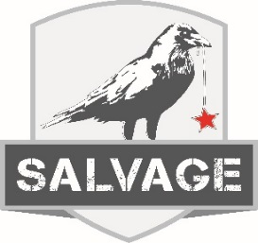

$20.00 per guest. Excludes tax & gratuity.
Includes Non- Alcoholic Beverage of Choice

Entrees
Salvage Cobb
Smoked Turkey / Bacon / Avocado / Egg / Tomato /
Swiss Cheese / Bleu Cheese Crumbles / Creamy Ranch Dressing

Prime Rib French Dip
Thinly Sliced Prime Rib / Melted Provolone Cheese /
Toasted French Roll / Au Jus / Steak Fries

Chicken Bruschetta Sandwich
Marinated Grilled Chicken Breast / Melted Provolone Cheese /
Tomato Bruschetta Topping / Steak Fries

Grilled Beef Fajitas
Grilled Beef / Bell Peppers / Onions / Sour Cream /
Guacamole / Tomato / Cheese / Flour Tortillas /
Refried Beans / Spanish Rice

Chicken Cordon Bleu
Breaded Chicken Breast / Swiss Cheese / Sweet
Virginia Ham / Mashed Potatoes / Seasonal Vegetables

Dessert
Bread Pudding

