Unique as Your Wedding
L&L Farm venue offers the wedding of your dreams tailored to fit your specific desires! Our vendors are some of the best in the wedding industry... leave the work to us and we’ll arrange them or feel free to bring your own vendors. Request a tour now and let’s get started on making your dream wedding a reality!

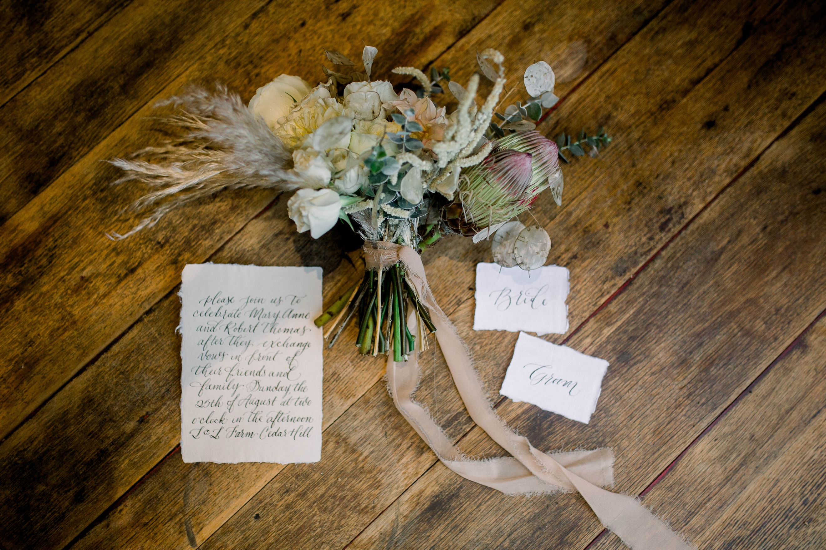

2020/2021 Rental Pricing

Friday 10-hour rental ranges from $5600 - $6400
Saturday 12-hour rental ranges from $ 6800 - $7700
Sunday 8-hour rental ranges from $4600 - $5000

Two Day Rental
Exclusive use of Venue for Rehearsal, Ceremony, and/or Reception
Add 4 hours on a Thursday (5 – 9) to any Friday event for an extra $ 1000
Add 6 hours on a Friday (4 - 10) to any Saturday event for an extra $ 2000

What’s included:
- Exclusive access to our 5,300 sq ft venue and private farm
- 1-hour Rehearsal
- Multiple options for ceremony and reception sites, indoor & outdoor
- Tables and wood bistro chairs for 200 guests
- Set up of tables and chairs
- Accent tables
- Use of fireplace in courtyard and maintained by L&L team
- L&L team members onsite throughout the evening
- Parking area and paved handicap spaces
- A/C and heated wedding party suites
- Large Industrial bar area with indoor and outdoor access
- Indoor guest temperature-controlled ADA restrooms
- Open Vendor Policy as long as insured and licensed, if applicable
- No hidden fees

Need help hiring vendors, services, or rentals? Please contact us for help!
We require event insurance purchased for your event through Wedsafe.com (approx $175)

