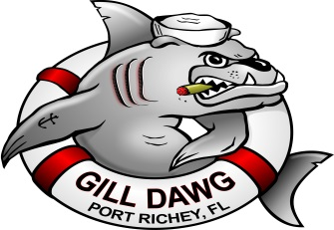
5419 Treadway Drive Port Richey, Fl. 34668. 727-842-1070
www.gilldawg.com
Event Center Reservation Agreement
Date_________________________
Name ____________________________________ Home Phone ____________________________________
Address __________________________________ Work Phone _____________________________________
City _____________________________________ Cell Phone _______________________________________
E-mail Address ______________________________________
Secondary Contact _______________________________ Home Phone ______________________________
Address _______________________________________ Work Phone ________________________________
City __________________________________________ Cell Phone __________________________________
E-mail Address _________________________________
Event Information
Event Date ______________________________
Party Size Estimate ________________________ Reservation Time _____am/pm to _____am/pm
A non-refundable, non-transferable deposit of $500.00 ( plus applicable sales tax and service charge ) is required to reserve the Gill Dawg Event Center. While tentative bookings are allowed, all bookings must be confirmed by a deposit with the return of this agreement or the reservation will be cancelled. The deposit will be credited to the final bill. Payment must be made prior to or on the day of the event.
Payment may be mailed or presented in person. MasterCard, Visa, Discover and American Express accepted.
I have read and agree to the policies stated on the previous page and the above conditions.
_________________________________________________ ______________________________
Customer Signature Date
_________________________________________________ _______________________________
Event Coordinator Signature Date

