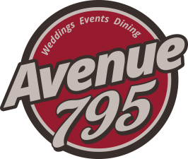
The Fond du Lac Columbian Club, Inc.
795 Fond du Lac Avenue
Fond du Lac, Wisconsin 54935
Sean M. Maroney - Manager
Banquet Facility
Buffet / or Family Style
Menu Selections $21 per person
Choice of Two Entrees
Crispy Baked Chicken with Dressing
Roast Turkey Breast with Dressing
Country Baked Ham
Roast Pork Loin
Braised Beef Tips
Sliced Roast Sirloin
Baked Cod

Choice of One Side
Whipped Potatoes w/ Gravy
Wild Rice
Rice Pilaf
Buttered Egg Noodles
Roasted Red Potatoes
Au Gratin Potatoes
Choice of One Vegetable
Sweet Whole Kernel Corn
Green Beans
Baby Carrots
Sweet Peas
California Medley

All family style and buffet meals include: your choice of a House Tossed Salad, Caesar salad or Homemade Cole Slaw. Includes Fresh Rolls and butter, and Beverage (Milk, Coffee, and Water)

We require a minimum attendance guarantee 72 hours in advance.
All prices are subject to tax of 5.5% and service charge (gratuity) of 18%

We would love to work with you on custom menus for your event.
Subject to availability of products and necessary pricing adjustment

