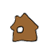

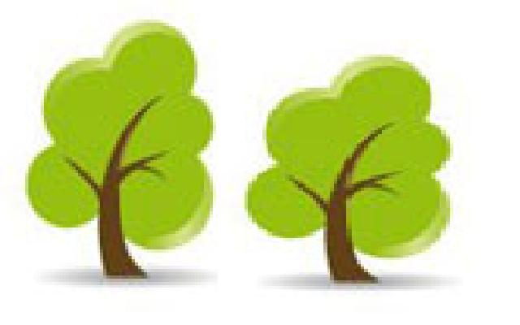

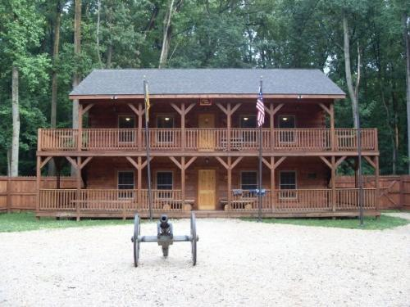

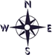
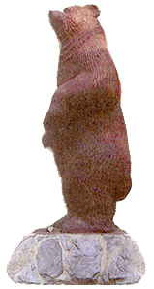
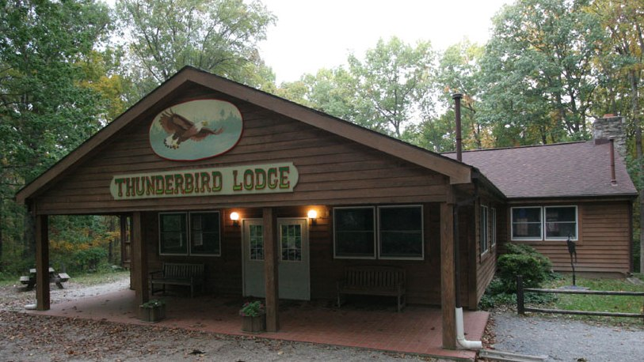
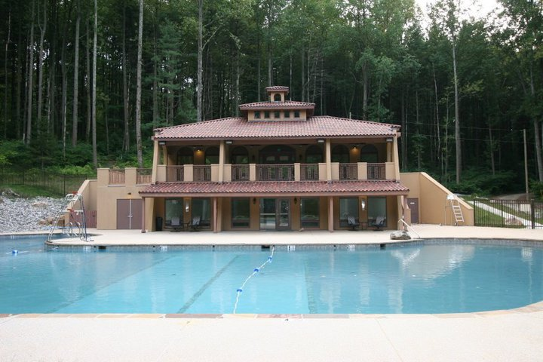
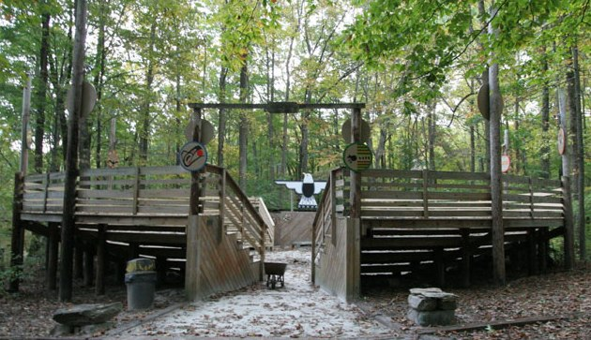
Field
The Glen
To I-83
3
1
6
7
8
18
11
12
13
14
15
24
21
2
5
9
Camp Puh’Tok Entrance
Covered Bridge
The Glen
Hacienda & Pool
Frog Hollow
Tlingit Lodge
Yukon Lodge
Denali Lodge
Top Bar Ranch
Camp Office
South Platte
Chimney Rock

Scott’s Bluff
Sweetwater Station
Willamette Valley
Nurse’s Lodge
Trading Post
Thunderbird Lodge
Nature Lodge
Homestead
The Pueblo
The Council Ring
The Hogan
Fort Mackinac
Fort Mackinac
Alaskan
Village

Indian Village
Pioneer
Village
17433 Big Falls Rd.

Field
To Big
Falls Rd.
4
10
Top Bar Ranch
Welcome
to
Camp Puh’tok
19
16
17
23
20
22
Office

