“More Than a Meeting”

The Windermere’s beautifully appointed, yet practical Conference Center with 114 guestrooms is perfect for business meetings and conferences of all sizes and styles.

A little work and a little play are keys to successful meetings at the Windemere Hotel & Conference Center. Whether you are meeting for the day or extending it overnight, our “More Than a Meeting” takes care of every need.

Package Includes:
Deluxe Continental Breakfast
Private Luncheon
AM / PM Refreshment Break
Podium and microphone, riser staging,
With 8 x 8 Screen and
Flipchart w/Pad & Markers
Wireless High Speed Internet
Only $42.00 ++ per person

Plus 20 % Service Charge and an 8.05% City Sales Tax
If group needs an LCD Video Projector, add-on $ 225.00++

Add-on a full hot breakfast buffet with private room for your group or in the back of the meeting room for your group to start the morning off right!
For only an extra $ 10.00++ per person

Day Break Express

Continental Breakfast
Includes Assorted Breakfast Baked Goods, Assorted Fruit Juices, assorted yogurts,
Royal Cup Coffee, Brewed Decaf and Herbal Tea @ $9.50++ per person

Mid Morning Break
Sliced Fresh Fruit display with Berries, hard boiled eggs,
Royal Cup Coffee, Brewed Decaf and Herbal Tea @ $9.50++ per person

Afternoon Break
Assorted Soft Drinks and Bottled Waters
Homemade Assorted Cookies, granola bars and Frozen Fruit Bars
Royal Cup Coffee, Brewed Decaf and Herbal Tea @ $9.50++ per person

All Day Break Package @ $22.95++ per person

Coffee Break Packages

Royal Cup Coffee, Brewed Decaf and Herbal Tea
$3.95++ per person

Add Assorted Breakfast Baked Goods
$4.00++ per person

Add Assorted Fruit
$4.00++ per person
All day Coffee Break Package @ $10.95++ per person

Continental Breakfast

Assorted Juices, Fresh Baked Muffins, Danish and Pastries, Bagels and Cream Cheese, Royal Cup Coffee, Brewed Decaf and Herbal Tea

$9.95 ++ per person

Deluxe Continental

Continental Breakfast with Fresh Sliced Fruit display, Seasonal Berries, assorted Yogurts,
And hard boiled eggs

$12.95 ++ per person

Served Breakfast
(Minimum of 50 people)

All Breakfasts Include, Danish and Muffins, Country Potatoes, Juice
Royal Cup Coffee, Brewed Decaf, Herbal Tea and Milk

Fluffy Scrambled Eggs,
Crisp Bacon or Sausage
$16.95 per person ++

Southwestern Scrambled Eggs
With Peppers, Mushrooms, Onions and Cheese,
And Breakfast Ham Steak
$17.95 per person++

Classic Eggs Benedict with Hollandaise Sauce
$18.95 per person ++

Combination Plate of
Southwestern Scrambled Eggs with Biscuit and Gravy, and Crispy Bacon
$18.95 per person++

Combination Plate of
Fluffy Scrambled Eggs with French toast,
and Sausage
$18.95 per person++

Breakfast Buffets
(Minimum of 50 pp for our buffets)

The Express Buffet

Assorted Fruit Juices, Sliced Fresh Fruit, French Toast & Maple Syrup
Scrambled Eggs, Country Potatoes
Bacon, Assorted Yogurts
Danish and Muffins
Freshly Brewed Royal Cup Coffee, Decaf, and Herbal Tea, and Milk

$17.95 per person ++

The Courtyard Buffet

Assorted Fruit Juices, Sliced Fresh Fruit
Fluffy Scrambled Eggs, Scrambled Eggs with Cheese, Ham, Mushrooms, Peppers, Onions
Country Potatoes, Crispy Bacon, Biscuits and Gravy
Assorted Yogurts, Danish and Muffins
Freshly Brewed Royal Cup Coffee, Decaf, and Herbal Tea, and Milk

$18.95 per person ++

Additional Buffet Item

Omelet Station Waffle Station
Prepared with your favorite ingredients Prepared with your
Ham, Bacon, Cheese, Mushrooms, Choice of Syrup
Peppers, Onions and Fruit Topping
$4.00 per person ++ $3.00 per person ++

Brunch Buffet
(Minimum 50 Guests)

Assorted Danish, Muffins, Croissants
Assorted Juices
Sliced Fresh Fruit
French Toast with Maple Syrup
Scrambled Eggs
Bacon and Sausage
Country Potatoes
Garden Salad with Choice of Dressing
Pasta Salad
Chicken Piccata
Carved Prime Rib
Roasted Potatoes
Fresh Steamed Vegetables
Rolls and Butter
Royal Cup Coffee, Decaf and Tea
Assorted Desserts
Champagne or Mimosa Toast
$29.95 per person ++

Ala Carte

Royal Cup Regular and Decaf Coffee $26.00 per Gallon
Iced Tea $26.00 per Gallon
Lemonade $30.00 per Gallon
Fresh Fruit Punch in Fountain $30.00 per Gallon
Assorted Juices $22.00 per Gallon
Assorted Sodas $ 1.75 each
Assorted Bottled Seltzer Water $2.25 each
Bottled Waters $ 2.00 each
Assorted Yogurt $ 2.00 each
Granola Bars $ 1.75 each
Assorted Danish and Muffins $21.00 a Dozen
Chocolate Fudge Brownies $18.00 a Dozen
Assorted Fresh Baked Cookies $16.00 a Dozen
Per Dozen Assorted Candy Bars $18.00 a Dozen
Whole Fresh Fruit $ 1.50 each
Fresh Fruit Skewers $1.50 each
Ice Cream Bars $ 2.00 each
Chocolate Dipped Strawberries $2.00 each
Popcorn, Pretzels, Potato Chips $10.00 per lb.
Small Cheese and Cracker Tray (serves 40 people) $120.00
Crudités of Vegetables with Herb dip (serves 40 people) $115.00
Sliced Fresh Fruit Display with Yogurt Dip $120.00
(Serves 40 People)

Courtyard Snack Break

Executive Break

Crudités of Vegetables with Herb Dip
Assorted Cookies
Flavored Popcorns
Assorted Sodas
$7.50++ per person

Cookie Break
Fresh Baked Chocolate Chip, Oatmeal, &
White Chocolate Macadamia cookies
Peanut Butter and cinnamon Cookies
Fat free Snack well cookies
Assorted Sodas and Milk
Coffee, Brewed Decaf and Herbal Tea

$8.50 per person ++

Express Break
Chocolate Walnut Brownies
Chocolate Dipped Strawberries
Low fat granola bars, Candy Bars,
Cold crisp fresh vegetables with dip
Lemonade, Coffee, Brewed Decaf
And Herbal Tea

$9.50 per person ++

Fresh Fruit Break

Assorted Juices
Fresh Fruit Skewers
Whole Fresh Fruit
Assorted Yogurts with Toppings
Low fat Fresh Fruit Bars
Assorted Sodas and Bottled Waters
$10.50 per person ++

Plated
Lunch Entrees
(Minimum of 50 people)

All Lunches are served with a Caesar Salad, Spring Mixed Green Salad, or a Fresh Fruit Cup
Chef will select appropriate starch and fresh vegetables
Mixed multi grain rolls and butter

Fresh brewed Royal Cup Coffee, Brewed Decaf, Herbal Teas

Fresh brewed Iced tea and light Dessert

Mediterranean Chicken Pasta
Penne pasta with sundried tomatoes, spinach, mushrooms, peppers,
Pine nuts, feta cheese, marinated chicken breast
In a creamy chipotle Alfredo sauce
$18.95++ per person

Roast Prime Rib of Beef
Au jus and creamed horseradish
$24.95++ per person

Chicken Scampi
Medallions of sautéed chicken breast
With garlic and white wine
$ 22.95++ per person

Grilled Atlantic Salmon
With lemon caper cream sauce
$ 24.95++ per person

Roast Pork tenderloin
With naturel sauce
$20.95++ per person

Baked Lemon Chicken
With light brown sugar glaze
$20.95++per person

Beef Tenderloin Tips
With button mushrooms
$20.95++per person

Vegetarian or
Homemade Meat lasagna or Meat Loaf
$19.95++per person

Lunch Buffet
(Minimum 50 Guests)

The Courtyard Deli South of the Courtyard

Garden Salad with Choice of Dressing Southwest Salad with Vinaigrette Dressing
Potato Salad Southwest Corn Salad
Pasta Salad Taco Bar
Assorted Display of Ham, Turkey Cheese Enchiladas
And Roast Beef Chicken Fajitas
Array of Sliced Cheeses Spanish rice and Refried Beans
Assorted Deli Rolls and Breads Tortilla Chips and Salsa
Relish Tray and Condiments Sour Cream, Guacamole
Assorted Cookies and Brownies Churros and Mexican Flan
Coffee, Brewed Decaf and Iced Tea Coffee, Brewed Decaf and Iced Tea

$20.95 per person ++ $22.95 per person ++

The Oriental Express Touch of Italy

Garden Tossed Salad with Sprouts Caesar Salad, Pasta Salad
And Chow Mein Noodles Marinated Tomato Salad
Pineapple Coleslaw Chicken Parmesan over Spaghetti
Oriental Chicken Salad Vegetable Lasagna
Teriyaki Chicken Breast Chicken Fettuccine Alfredo
Beef and Broccoli Fresh Steamed Vegetables
Fried Rice and Steamed Rice Garlic Bread Sticks and
Egg Rolls Fresh Rolls and Butter
Chef's Choice of Dessert Fruit Pies and Sherbet
Coffee, Brewed Decaf and Iced Tea Coffee, Brewed Decaf and Iced Tea

$22.95 per person ++ $22.95 per person ++

Hot
Luncheon Buffet
(Minimum of 50 pp for our buffets)

(Choice of Three)

Garden Fresh Salad
Pavilion Caesar Salad
Pasta Salad
Red Skinned Potato Salad
Seafood Salad
Marinated Mushrooms
Courtyard Waldorf Salad
Creamy Cucumber Salad
Sweet Potato Salad
Fresh Fruit Salad

Entrees

Roast Sliced Beef with Aujus
Vegetable or Meat Lasagna
Beef Tenderloin Tips
Poached Lemon Salmon
Red Snapper Almandine
Roast Pork with Roasted Chili Sauce
Sonoran Chicken
Tequila Chicken
Chicken Piccata
Lemon Chicken

2 Entrees $23.95 per person ++
3 Entrees $26.95 per person ++

Buffet includes
Rice or Potato, Fresh Vegetables,
Rolls and Butter
Coffee, Brewed Decaf and Herbal Tea
And Assorted Dessert Station

Lighter Lunches
(Minimum of 50 people)

Southwest Crispy Chicken Salad
Marinated Chicken breast in hot wing sauce
Over a bed of crisp mixed greens, black beans,
Mexican corn, shredded cheese, tortilla strips
And chipotle ranch dressing, Beverage $17.95++per person

Grilled Panini Sandwich
Crusty French baguette bread stuffed with
Turkey breast, provolone cheese and grilled
Artichoke hearts, roma tomatoes and honey Dijon mayo
Fresh fruit garnish and beverage $ 17.95++ per person

Chicken Fajita Pita Sandwich
Marinated white meat chicken breast with grilled peppers
And onions, diced tomatoes, shredded cheese, lettuce
Wrapped in a whole grain pita pocket, fresh fruit garnish
And beverage $17.95++ per person

Chicken Wrap
Marinated grilled tequila lime chicken breast with
Flour or whole wheat tortilla, shredded lettuce, cheese, diced
Tomatoes, drizzled with chipotle ranch dressing, fresh fruit garnish
And beverage $17.95++ per person

Malibu Chicken Club Sandwich
Grilled chicken breast with crisp smoked bacon,
Avocado and provolone cheese, potato chips
Beverage $18.95++ per person

Mesa Southwest Plate
Homemade cheese and chicken enchiladas,
Crisp taco with seasoned ground beef,
Shredded lettuce with diced tomatoes, sour cream, Spanish rice
Refried beans and homemade tortilla chips and zesty salsa
Beverage $ 17.95++per person

Homemade Walnut Chicken Salad Sandwich
Served on toasted seven grain wheat bread, sliced tomatoes, sprouts,
With fresh fruit garnish and homemade cookie
Beverage $17.95++ per person

Vegetarian Delight
Toasted whole wheat sub roll with cheddar cheese, sprouts, avocado,
Sliced cucumbers, tomatoes, spinach, lettuce, accompanied by sliced fresh fruits and berries and cottage cheese, Beverage $16.95++ per person

Courtyard Box Lunches

Italian Sub Sandwich

Baked Potato Chips, Crisp Veggie Sticks, Whole Fresh Fruit,

Homemade Cookie, and Soda

$15.95 per person ++

Choice of Sandwich

Roast Beef and Cheddar or Ham and Swiss or Turkey and Provolone

On a Flakey Croissant with Pasta Salad, Piece of Fresh Fruit

Chocolate Fudge Brownie

Choice of Soft drink or bottled water

$16.95 per person ++

Soup and Salad Buffet

Choice and any one soup and four assorted salads with mini breads and rolls and condiments

Homemade Soups
Hearty Vegetable, Chicken and Wild rice, Texas Chile, Clam Chowder
Minestrone, Corn Chowder, Mushroom Barley, potato leek

Garden Fresh Salad with choice of dressings
Romaine and Spinach with raspberry vinaigrette dressing
Caesar Salad
Creamy cucumber salad, sweet potato salad, Greek salad
Homemade red skinned potato salad, pineapple coleslaw
Walnut chicken salad, Tuna salad
Fresh fruit salad, seafood salad
Egg salad, four bean salad, California Waldorf Salad
Ambrosia salad
Marinated Artichoke Hearts and Mushrooms
Shrimp and avocado salad

Sherbet and Jell-O parfaits

Coffee tea decaf and lemonade

One type of homemade Soup and Salad lunch buffet @$15.95++per person

Two types of homemade soup and Salad lunch buffet @ $ 17.50++ per person

Dinner Buffet

(Minimum 50 People)

Salads
(Choice of Four)
Tossed Caesar Salad
Garden Salad with Choice of Dressing
Romaine and Spinach with Raspberry Vinaigrette
Red Potito Salad, Pasta Primavera Salad
Fresh Fruit Salad, Greek Salad
Marinated Mushrooms, Seafood Salad
Sliced Beefsteak Tomatoes with
Shredded Mozzarella, California Waldorf,
Creamy Cucumber Salad

Entrees
Chicken Piccata
Chicken Marsala or Lemon Herb Chicken
Teriyaki Chicken
Stuffed Sonoran Chicken
Carved Roast Prime Rib of Beef
(Chef’s carving charge @ $75.00)
Roast Beef with Bordelaise Sauce
Roast Pork Tenderloin
Grilled Halibut or Filet of Salmon

Meat or Vegetable Lasagna

(Choice of Two)
New Potatoes with Herb Butter
Sautéed Zucchini, Wild Rice Blended
Rice Pilaf, Fresh Steamed Vegetables
Baked Potatoes, Potatoes Au Gratin
Lyonnais Potatoes, Green Beans Almandine

Fresh Baked Rolls and Butter
Assorted Desserts
Royal Cup Coffee, Brewed Decaf and Herbal Tea

Choice of Two Entrees $32.95per person ++

Choice of Three Entrees $35.95per person ++
(Our ballrooms require a 100pp minimum for a Saturday Evening)

Theme Buffets

(Minimum 50 people)

Each Buffet is served with Royal Cup Coffee, Brewed Decaf and Herbal Tea
Assorted Fresh Baked Rolls and Butter

Western
Western Salad with Dressing
Cole Slaw
Corn on the Cob
Ranch Beans
T-bone Steak
Choice of BBQ Chicken
Or BBQ Ribs
Cherry or Apple
Pie A La Mode

$32.95++ per person
Southwestern
Fiesta Salad with
Cilantro Dressing
Fresh Fruit Salad
Mexican Corn Salad
Cheese Enchiladas
Chicken and Beef Fajita Station
Spanish Rice
Refried Beans
Churros and Flan

$29.95++ per person

Italiana
Antipasto Salad
Caesar Salad
Pasta Salad
Italian Sausage
Chicken Parmesan
Vegetable Lasagna
Steamed Vegetables
Garlic Bread Sticks
Assorted Desserts

$30.95++ per person

Oriental
Vegetable Display with Dip
Tossed Salad with
Ginger Vinaigrette
Oriental Salad
Egg Rolls
Beef and Broccoli
Sweet and Sour Pork
Teriyaki Chicken
Fried Rice
Stir Fried Vegetables
Assorted Desserts

$30.95++ per person

(Our ballrooms require a 100pp minimum for a Saturday Evening)

Plated Dinner Entrees

All Dinners are served with a Garden Salad and Choice of Rice or Potato, Fresh Vegetables,

Fresh Baked Rolls and Butter
Royal Cup Coffee, Brewed Decaf, Herbal Tea and Dessert

Roast Prime Rib of Beef Au Jus
$32.95 per person ++

Broiled Filet Mignon
$34.95 per person ++

Grilled King Salmon
$31.95 per person ++

Blackened Swordfish
$30.95 per person ++

Shrimp & Lobster

Fettuccini Alfredo

$27.95 per person ++
Chicken Marsala with
Fresh Mushrooms
$28.95 per person ++

Sonoran Chicken
$28.95 per person ++

Filet Mignon & Shrimp Scampi
$35.95 per person ++

Broiled Top Sirloin
$28.95 per person ++

Chicken Cordon Bleu
$28.95 per person ++

(Our Ballrooms require a 100pp minimum for a Saturday Evening)

Dessert Options

Carrot Cake

New York Style Cheese Cake

Double Chocolate Cake
Ice cream with topping
Assorted Mousse cakes
Fruit Filled Pies
Peach Melba

Hors D’oeuvre Receptions

The Courtyard

Garden tossed salad with choice of dressings on the side,

Corn Tortilla Chips
With Salsa, Guacamole

Cheese Enchiladas

Mini Beef Chimichangas
Refried Beans & Spanish Rice
Fajita Station
(Chicken and Beef)
with Cheese, Diced Tomato and Sour Cream
Flour Tortillas

Iced Tea, Coffee, and Decaf
$28.95 per person ++

The Pavilion

Imported and Domestic Cheese Display

Vegetable Display with Dip
Fresh Fruit Display with Yogurt Dip
Crab Stuffed Mushrooms
Spinach in Phyllo
Seafood Puff Pastry
Scallops wrapped in Bacon
Thai Chicken Skewers with Peanut Sauce
Petite Beef Kabobs

Iced Tea, Coffee, and Decaf station

$30.95 per person ++

(Our ballrooms require a 100pp minimum for a Saturday Evening)

A La Carte Hors D’oeuvres
All Hot and Cold Hors D’oeuvres listed below are included in the Complete Wedding Reception Packages, unless otherwise selected. Pricing that is listed is based on any Hors D’oeuvres ordered in addition to what is included in the Complete Packages.

Hot Hors D’oeuvres
Smoked Chicken Quesadilla Horns $160.00++ per 100 pieces
Mini Vegetable Spring Rolls $130.00++per 100 pieces
Chicken Teriyaki Skewers $160.00++per 100 pieces
Spinach Pesto Puffs $145.00++per 100 pieces
Southwest Beef Tortilla Crisp $240.00++per 100 pieces
Mushroom Caps Stuffed with Crabmeat $250.00++per 100 pieces
Boneless Chicken Tempura with Sweet and Sour $230.00++per 100 pieces
Swedish Meatballs $195.00++per 100 pieces
Mini Assorted Quiche $140.00++per 100 pieces
Chicken Flauta with Prickly Pear BBQ Sauce $230.00++per 100 pieces
Pineapple and Water Chestnuts wrapped in Bacon $175.00++per 100 pieces
Spinach and Mushroom Puff Pastry $150.00++per 100 pieces
Red Chile Beef Mini Chimichanga $175.00++per 100 pieces
Mini Chicken Wellingtons $230.00++per 100 pieces
Scallops wrapped in Bacon $240.00++per 100 pieces
Assorted Mini Deep Dish Pizzas $145.00++per 100 pieces
Baked Breaded Zucchini Rounds $145.00++per 100 pieces
Beef Cocktail Franks wrapped in Puff Pastry $160.00++per 100 pieces

Cold Hors D’oeuvres
Imported and Domestic Cheese Tray with Crackers and Lavosh $180.00++ (Serves 50pp)
Sliced Fresh Fruit Tray with Yogurt Dip $180.00++ (Serves 50pp)
Assorted Mini Finger Sandwiches $160.00++ per 100 pieces
Crudités of Vegetables with Herbed Dip $140.00+++ (Serves 50pp)
Tortilla Chips with Homemade Salsa $35.00++ (Serves 25pp)
Ruffled Potato Chips with Onion Dip $35.00++ (Serves 25pp)
Spinach and Cream Cheese Dip in Sourdough Baked Bread Bowl $45.00++ (serves 25pp)
Decorative Fresh Fruit Skewers $200.00++ per 100 pieces
White and Dark Chocolate Dipped Strawberries $200.00++ per 100 pieces
Boars Head Deluxe Low Sodium Ham and Asparagus Cream Cheese Rolls $160.00++per 100 pieces
Boars Head Golden Turkey Breast, Spinach and Cream Cheese Pinwheels $150.00++per 100 pieces

Upgraded Cold Hors D’oeuvres
(Not included in the Complete Packages)
Jumbo Gulf Shrimp with Cocktail Sauce on Crushed Ice $250.00++ per 100 pieces
Smoked Salmon Display with Lobster Medallions with $200.00++display (Serves 40pp)
Lavosh & Crackers

Beverage Selection

Host Bar Cash Bar
Cordials $ 6.00 per drink $ 6.50 per drink
Premium Brands $ 6.00 per drink $ 6.50 per drink
Call Brands $ 5.00 per drink $ 5.50 per drink
House Wine $18.00 per bottle $19.00 per bottle
$ 4.50 per glass $ 5.00 per glass
Champagne $18.00 per bottle $19.00 per bottle
$ 4.50 per glass $5.00 per glass
Upgraded Wine $6.00 per glass $6.50 per glass
Imported Beer $ 4.50 per bottle $ 5.00 per bottle
Domestic Beer $ 4.25 per bottle $ 4.75 per bottle

Non Alcoholic Sparkling Cider $ 9.00 per bottle

Soft Drinks $ 2.00 per drink
Unlimited Soda Bar $ 3.00++ per person
Fruit Punch $30.00 per gallon
Ginger ale Punch $30.00 per gallon
Margaritas $50.00 per gallon
Champagne Punch $45.00 per gallon
Keg of Beer $325.00 ++ Domestic
$375.00++ Import

Bar Labor Charge of $75.00++per Bar

Windemere Audio Visual Services
Projectors
35mm Slide Projector with Wireless Remote $ 50.00
High Intensity Light Overhead $ 50.00
LCD Projector with audio mixer and cabling $225.00
Screens
6 Ft. Tripod $ 25.00
8 Ft. Tripod $50.00
10 X 10 Fast Fold with Dress Kit $140.00
7.5 X 10 Fast Fold with Dress Kit $125.00
9 X 12 Fast Fold with Dress Kit $140.00
Microphones
1st Mic Free, Additional Microphone $ 25.00
Lavalier Microphone $ 25.00
Wireless Lavalier or Wireless Hand Held Microphone $ 125.00
Table Microphone Stand $ 5.00
Floor Microphone Stand $ 10.00
PZM Table Microphone $ 35.00
Video
½ VHS Player/Recorder with Remote $ 0.00
25” Color Monitor $ 75.00
½ VHS Camcorder with Tripod $100.00
XGA Data Video Projector with VCR, Mixer and Cart $325.00
Video Projector with cable connections to laptop $275.00
Camcorder Video Technician Labor (Per Hour) $ 20.00
Audio
Portable Cassette Recorder $ 25.00
Stereo Cassette Deck with Mixer $ 60.00
DVD Player or CD Player with Mixer $ 50.00
Stereo Boom Box $ 25.00
4 Channel Mixer $ 35.00
Portable Stereo Sound System with Mixer (200 Watts) $150.00
Special Packaged Deals
2 25” Color Monitors/VHS $160.00
4 25” Color Monitors/VHS $250.00
Miscellaneous
High Speed Wireless Internet No Charge
Lap Top Computer rental per day $ 175.00
Laser Pointer $ 40.00
Flipchart with Paper & Markers $ 25.00
Tripod Easel $ 7.00
1,000 Watt Spot Light $ 80.00
100 Watt Spot Light $ 30.00
Overhead Acetate Roll $ 15.00
Safelock Stand $ 5.00
TV Stand $ 10.00
Speaker Phone $ 30.00
3 X 4 Chalkboard or Whiteboard $ 20.00
Technician Labor (Per Hour) $ 30.00
2-Way Radios $ 15.00

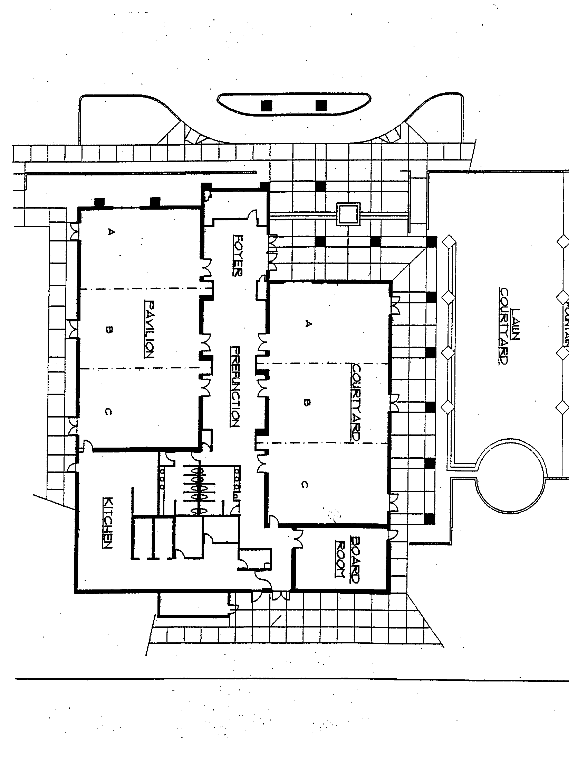

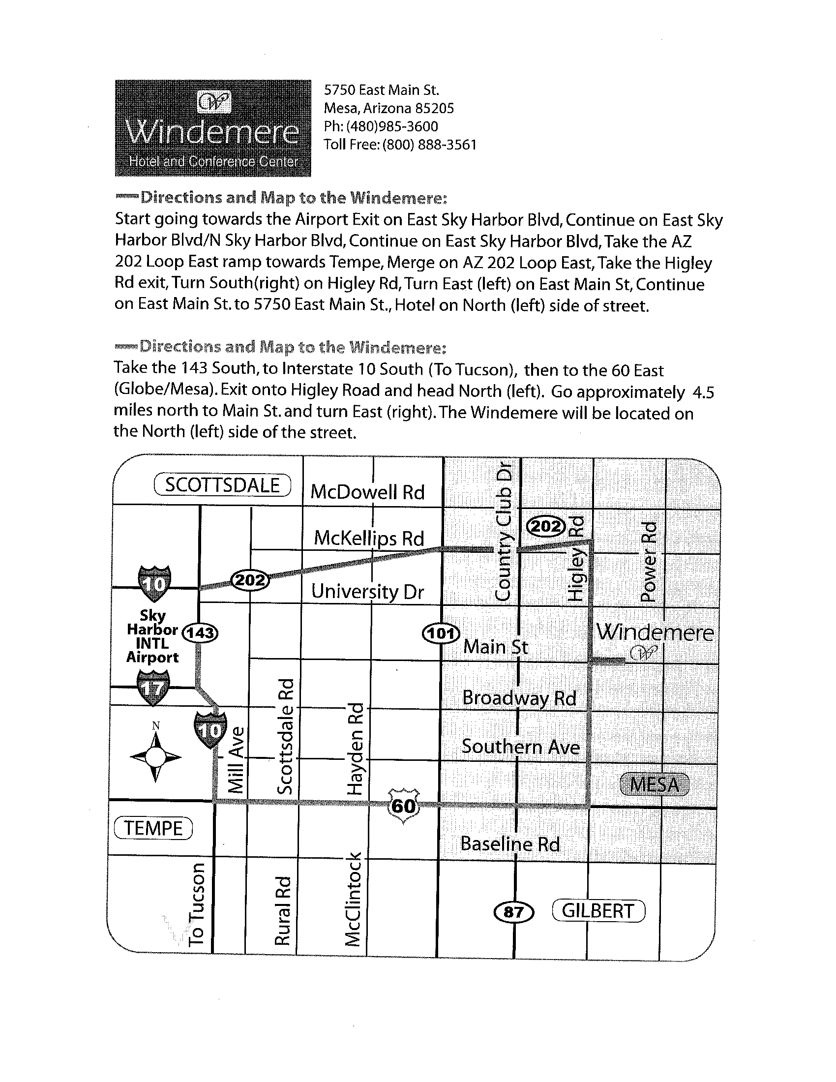

Windemere Policies

- The Windemere Hotel and Conference Center will add a 20% service charge and an 8.05% sales tax to all charges.

2. A guaranteed number of guests attending all functions contracted on a per person basis must be confirmed at three business days prior to the start of the function. The Client will be charged for the greater of either the guaranteed number or the actual number of guests served. If the guarantee is not received when required, the Client will be charged for the expected number as indicated on the Banquet Event Order or the actual number served.

3. The Hotel will prepare food and set the function room for 5% over the guaranteed number. This is the maximum we will prepare. We, as the Hotel, are not obligated to bring in any more chairs or tables or prepare any more food other then what your guaranteed number of attendees is and 5% over the guaranteed amount of attendees. If the guarantee number increases, the food preparation and room set counts will be limited to the guaranteed number. As the client, if there are more guests to arrive, payment will be taken care by the conclusion of the event by cash, debit or credit card to take care of the extra accommodations.

4. Meeting times are as follows, daytime 7:30 am to 4:30 pm day or evening 5:30pm to 11:30pm. The Client will be charged for any additional time at the rate of $150 per hour. Times are customized per each individual group.

5. NO FOOD OR BEVERAGE OF ANY KIND IS PERMITTED IN FUNCTION ROOMS UNLESS THE HOTEL PROVIDES IT. NO FOOD OR BEVERAGE PROVIDED BY THE HOTEL IS ALLOWED TO BE REMOVED FROM THE CONFERENCE CENTER DUE TO THE MARICOPA COUNTY HEALTH REGULATIONS.
* CELEBATORY CAKE IS AN EXCEPTION.

6. A non-refundable and non-transferable advance deposit is required. This deposit will be credited to your master account and the balance of charges will be due three (3) days prior to the function date based upon your final guarantee by cashiers check, money order, debit or credit card and cash. The hotel will not accept personal checks for the final payment. An additional payment will be made 1 month after booking that will be credited to your master account. Payment depends per each individual groups booking date compared to actual date of event.

7. The Client agrees to begin the function promptly at the scheduled time and agrees to have all attendees vacate the function room and have all equipment, meeting materials and personal items removed by the closing time indicated. Failure to properly vacate may result in overtime charges at the rate of $150 per hour. The setup / break down of vendors is not included in this overtime charge.

8. The Client agrees to conduct an orderly function in compliance with the rules of the Hotel. The Hotel reserves the right to exclude or eject any and all persons exhibiting objectionable behavior from the function. The Client agrees to accept responsibility and pay for any damage to the Hotel premises.

9. Function rooms are assigned by the number of guests expected. If attendance increases or decreases, the Hotel reserves the right, with notification, to reassign function space suitable for attendance or type of function.

10. The Hotel will not accept responsibility for the damage or loss of any items in function rooms or public areas prior to, during or following a function. Arrangements for security of exhibits, merchandise or articles set up for display must be made prior to the event.

11. If there is more than one group scheduled on a particular date, either group will NOT be permitted to solicit their goods, materials, handouts, information etc. to the opposite group on or around premises.

12. On a Saturday EVENING there will be a minimum of 100 Adults. If under 100 Adults you will be responsible for payment of 100 guests.

I understand that the guarantee number of attendees and payment is due three business days prior to my function. Final payment will be made by any other means except personal check. A non-refundable advance deposit is required; this deposit will be credited to your master account. An additional payment will be made 1 month after booking the date. If a cancellation is to occur within 10 days of the event date, full payment is due; if within 30 days prior to the event date 75% of estimated charges would be due if a cancellation is 31 days or more prior to event date 50% of estimated charges are due. There are NO exceptions for any group on our payment policies.

Signature__________________________________________________Date_____________________

