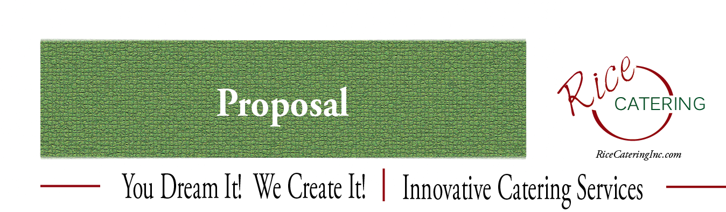

BRUNCH BUFFET MENU

Wonderful Assortment of Bagels, Breakfast Pastries, Danish & Muffins
Presented with Flavored and Plain Cream Cheese,
Assorted Jams, Jellies and Sweet
Whipped Butter

Smoked Norwegian salmon Display and Delicate White Fish Salad
Presented with Tomatoes, Onion, Hard Boiled Eggs, Olives,
Capers. Lemon Wedges and More

Mixed Baby Greens with Crumbled Goat Cheese, Caramelized Pecans,
Mandarin Oranges and Mango Vinaigrette

Blueberry Stuffed Mini Croissant French Toast
Fresh Mini Croissants Stuffed with Fresh Blueberries,
Blueberry Jam & Cream Cheese, Baked French Toast Style
With Brandy Pure Maple Syrup

Assorted Mini Quiche
Mini Florentine, Lorraine & Cheese Quiche
Topped with Caramelized Onion

Sliced Tropical Fruit Presentation including
Pineapple, Honeydew, Cantaloupe, Watermelon, Kiwi,
Cascades of Grapes and Fresh Field Berries

Frittata
Sautéed Bacon, Italian Sausage, Mushrooms,
Onions, New Potatoes, Spinach, Peppers
& Cheddar Cheese

Filet Mignon Eggs Benedict
Grilled Rosemary & Peppercorn Marinated Filet Mignon,
Poached Eggs, Sautéed Spinach on Toasted English Muffin with Ancho Chili Hollandaise Sauce
(Add $3 per/per)

Traditional Eggs Benedict
Canadian Bacon, Poached Egg & Toasted English
Topped w/ Hollandaise Sauce

Olive Oil Roasted New Potatoes with Thyme & Rosemary

Hickory Smoked Bacon & Sausage Links

Homemade Biscuits & Gravy
Based on 100 Guest

4 Selections----------$12.95 per/per
5 Selections----------$15.95 per/per
6 Selections----------$17.95 per/per

Omelet Station
To the Delight of your Guests, Our Uniformed Chef will prepare to order….
Delicious Omelets made with your choice of Spinach, Scallions, Mushrooms,
Tomato, Broccoli, Red & Green Peppers, Onion,
Swiss, Feta, Cheddar Cheese & More!
(add $3.00 per/per)

NON-ALCOHOLIC BEVERAGES
Regular & Decaf Coffee, Orange & Cranberry Juice
Assorted Sodas, Sparkling, Mineral Waters, Ice & Garnishes

