Plated Lunch
Sandwiches &
Salads Menu
(Choice of Two)

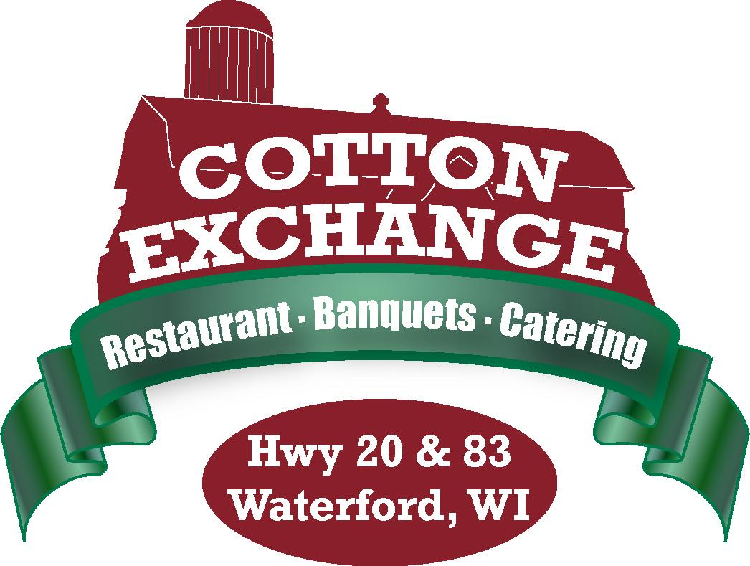
Served with a cup of Soup du Jour
Sandwich3s served with Potato Chips & Pickle
Salads served with Freshly Baked Roll & Butter
Coffee, Tea and Milk

Italian Beef with Mozzarella Cheese
Served in a Hoagie Bun
Hot Ham & Cheese
Served on a Kaiser Roll or Pretzel Roll
Chicken Salad Sandwich
With Lettuce & Tomato
Philly Cheese Steak
Sliced Beef, grilled Onions & Green Peppers, Provolone Cheese
Choice of Wrap or Hoagie Bun
Chicken, Bacon, Cheddar Ranch Wrap
Grilled chicken, Bacon, Cheddar Cheese, lettuce, Tomato, Onion & Ranch Dressing
Chicken Cordon Bleu Wrap
Chicken, Ham & Swiss Cheese with Alfredo Sauce
Cowboy Pork Sandwich
Slow cooked Barbecue Pork topped with Onion Haystack served on a bun
Meatball Bomber
Meatballs with Marinara & Provolone Cheese
All American Cheese Burger
American Cheese, Bacon, Onion, Lettuce, Tomato & Pickle
Kansas City Burger
Topped with Barbecue Sauce & Onion Haystack
Nacho Burger
With Pepper Jack Cheese & Jalapenos
Swiss Mushroom Burger
Topped with Swiss Cheese & Sautéed mushrooms
Chicken Caesar Salad
Chopped Romaine Lettuce topped with Grilled Chicken Breast, Croutons & Cheese
Served with Caesar Dressing
Cashew Chicken Salad
Mixed Green, Grilled Chicken, Mandarin Oranges, Cashews, Red Onion, Tomato & Carrots
Served with Raspberry Vinaigrette or Ranch Dressing
Classic Wedge Salad
Wedge of Iceberg Lettuce with Tomato Wedges, Red Onion, Diced Hard Boiled Egg, Chopped Bacon
With homemade Creamy Bleu Cheese & Crumbles
Taco Salad
Seasoned Ground Beef, Lettuce, Tomato, Shredded Cheddar Cheese, Salsa & Sour Cream
Served in a Taco Shell
Chef Salad
Mixed Greens with Ham, Turkey, Cheddar Cheese, Onion, Tomato & Hard Boiled Egg
Served with Ranch or French Dressing

$9.95 per person
Name cards or place cards with entrée choice must be provided when selecting more than one entrée
19% taxable service charge and 5.1% sales tax to be added

