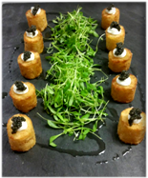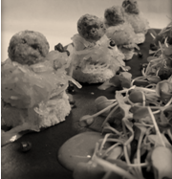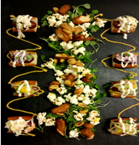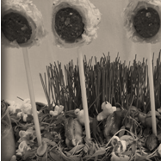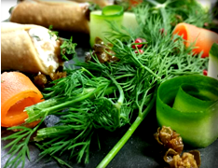

Plated Meal Packages

All Packages Include

On The Bar
Lemon Rosemary Olives
House Made BBQ Snack Mix

To Start
Spinach Dip and Hummus with Crisps and Crackers
Vegetable Stuffed Mushrooms or Tomato Basil Pizza

First Course Selections
One Seasonal Selection for your guests

Enhance your dinner with a Pasta Course

Entrée Selections
Served with Artisanal Breads and Butter

Option 1 – Single Chicken Entrée - $33.00 per person

Option 2 - Chicken & Fish Entrée Combo Plate - $35.95 per person
Guests enjoy one entrée plate with two proteins

Option 3 - Beef & Fish Entrée Combo Plate - $39.95 per person
Guests enjoy one entree plate with two proteins

Option 4 - Two Entrée Selections - $42.95 per person
guest selection at the table

Vegetarian Entrees Available Upon Request

Beverages Included
Unlimited Soft Drinks and Juices, French Roast Coffee & Herbal Tea

