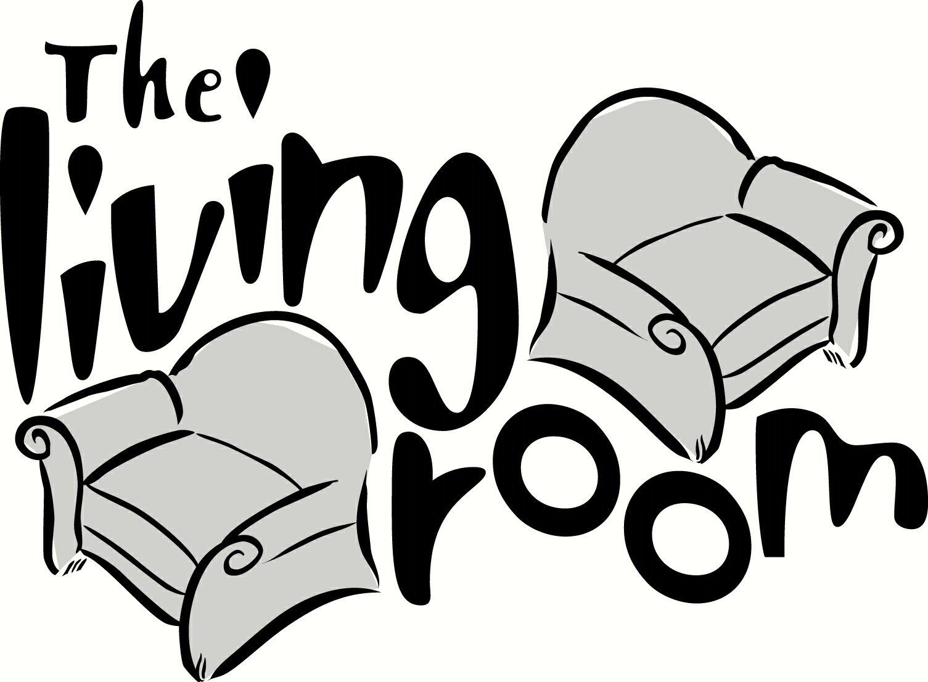

All American Breakfast*
Two Eggs, Any Style ◦ Pancakes ◦ Bacon Home Fries
14

Buttermilk Pancakes
Maple Syrup ◦ Butter
Add Chocolate Chips 1 ◦ Blueberries 2 Raspberries 2 ◦ Strawberries 2
10
Eggs Benedict
Canadian Bacon ◦ Poached Eggs Hollandaise
Substitute Smoked Salmon 5
10
Grass Fed Angus Burger
Lettuce ◦ Tomato ◦ Onions ◦ “Iggy’s” Black Pepper Brioche Bun ◦ French Fries
Additional Toppings: Bacon, Avocado, Fried Egg, Cheese ($1.00 ea.)
16
California Chicken Club
Bacon ◦ Avocado ◦ Swiss Cheese ◦ Lettuce ◦ Tomato ◦ Onion ◦ Lemon Aioli Sourdough ◦ French Fries
13

Dessert

“S’mores”
Dark Chocolate Ganache ◦ Nutella Powder
Graham Crackers ◦ Toasted Marshmallow Ice Cream ◦Warm Milk Chocolate Sauce
8

Churros
Mexican Hot Chocolate Sauce
8
Before Placing Your Order,
Please Inform Your Server If Anyone In Your Party Has A Food Allergy
*Consuming raw or undercooked meat or eggs may increase your chances of food borne illness

