

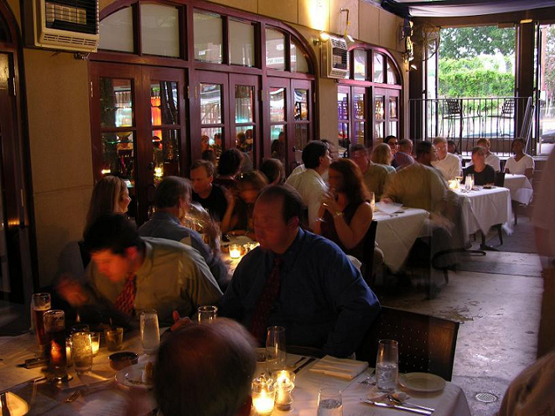

Ocean is locally owned and operated by Chef/Owner George Reis.
Join us for dinner at Ocean, recipient of the AAA Four Diamond Award for 2007-2011, and winner of the Wine Spectator Award of Excellence for the past six years.
Ocean has also received Four Stars by the Birmingham News.

Ocean offers the world’s best, freshest seafood in a comfortable, contemporary, upscale atmosphere. Ocean’s ambiance is candle lit, white tablecloth with soft aquatic tones. The menu changes nightly and we offer fresh oysters and fish from around the world, including British Columbia, Japan, New Zealand, Hawaii and the Mediterranean. We infuse our food with flavors both exotic and homegrown to create a cuisine that is both intriguing and familiar.

Ocean is open for dinner Tuesday through Saturday beginning at 5:30 p.m. and offers complimentary valet service at the front of the restaurant.
Reservations are recommended and can be made at 205-933-0999.
Ocean has space available for your private parties and special event and can accommodate parties from 10 to 200 people. We have three private dining rooms available, with flat plasma screen televisions, perfect for business meetings, rehearsal dinners, wedding receptions and much more. Ocean can also cater at your location.

Ocean 1218 20th Street South Birmingham, Alabama 35205 www.oceanbirmingham.com

