

Your Wedding at the Prestigious Bartlett Country Club

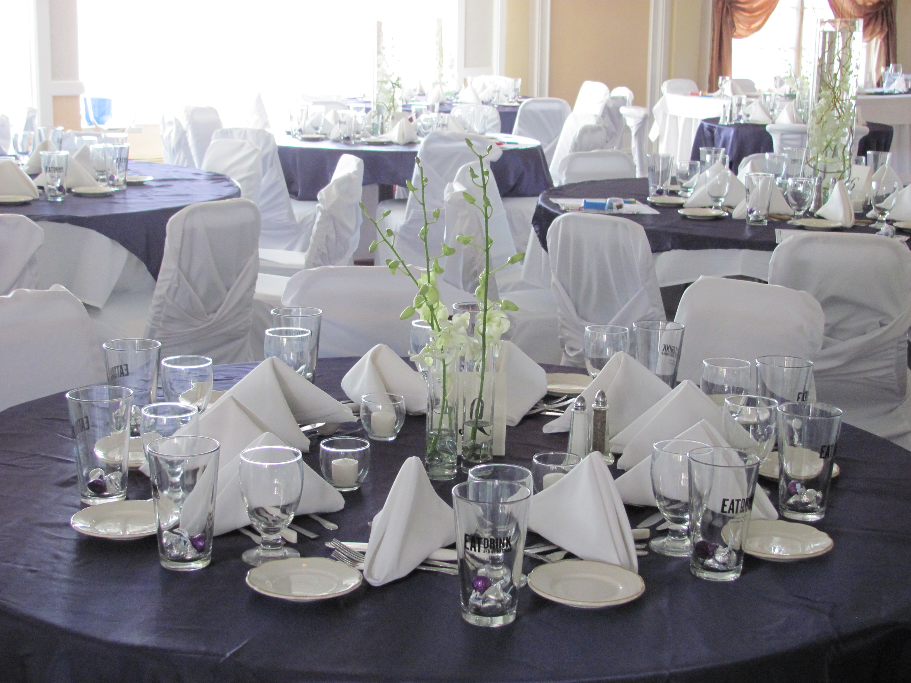

Booking your event

Once you have decided to have your Wedding Reception at The Bartlett, A signed contract with your deposit of $1,000.00 will act as your commitment to hold your Wedding date. The deposit will be applied toward the balance of your wedding and is non-refundable once it is received.

Planning your day

Our Wedding Coordinator and Chef will be pleased to custom design a menu to meet any themes or styles, as well as coordinate any rental needs associated with your event.

The Bartlett will provide the following free of charge: Dance floor, white or ivory linen of all the tables, skirting on your primary tables, linen napkins, china, glassware, and flatware. Set-up, tear down, and clean-up of the house for standard service.

The Bartlett Country Club has a complete Catering Service with exclusive rights to all Food and Beverage with the exception of wedding cakes. Therefore, no outside food or beverages may be brought into or on premises. Based on the size of your event the Bartlett also reserves the right to host multiple events in the facility and or remain open to members of the country club.

Our Bars can be open a maximum of 5 hours and no later than 1:30 am. No outside alcohol will be permitted on premises. Our bartenders will not serve anyone under the age of 21 or without proper I.D. Any guests that are visibly intoxicated will not be served, and at no time will shots be served.

Decorating can be done the day of the event. Tacks or nails may not be used. Confetti is not permitted, if a ladder is needed our staff will assist you. An additional charge will be billed for this service.

The Bartlett Country Club adheres to New York State Open Flame Law. No open flame is permitted inside any building. Candles must be contained in a globe with the flame at least two inches below the top of the globe.

On Site ceremonies require additional staffing and set-up. Fees associated with these services are determined on an individual basis.

All decorations and personal items are required to be removed the night of the event. The Bartlett Country Club is not responsible for items left behind on the property.

A guaranteed number of attendees, your menu, and your set-up will be required 14 day prior to your event. The guarantee number of Guest is the minimum number you will be required to pay for. A credit card will be required to be on file in case you have more in attendance then your guarantee.

A seating chart must be provided 7 days before the event. This seating chart needs to include table number, number of guests, and entrée choices.

A minimum guest count of 50 guests must be met to be eligible to hold a Wedding Reception at the Bartlett Country Club. A surcharge will be added to any reception not meeting the required minimum.

Our Payment Schedule is as follows: 3 months before your event 50% due, 1 month before your event: 90% due; 1 week before your event; paid in full. Beverage service on consumption will be required to be paid in full the night of the event.

Bartlett Country Club
Wedding Menu

Champagne and Cheese Display
For the wedding party upon arrival

Appetizers and Salads
Select one
Seasonal Soup or Bisque
Traditional Chef Salad
Spinach and Mushroom Salad
Seasonal Fruit cup
Caesar Salad
Crab Cakes on Roasted Corn and Tomato Salsa with Cilantro Lime Aioli (add $2 )
Caprese Salad Slice Fresh Tomatoes and Fresh Mozzarella Cheese with Basil and Aged Balsamic Vinegar (add $1)

Poultry Selections
New Orleans Stuffed Chicken Breast with Andouille Sausage & Cajun Pommodoro Sauce$18
Italian Baked Chicken Bruschetta $17
Grilled Cider Basted Chicken with a Cider Reduction Sauce $17
Sautéed Chicken Breast with French Herb Sauce $17
Chicken Normandy in a Marsala Demi-Glace $17
Long Island Duck with Fig and Balsamic Compote $24
Seafood Selections
Grilled Mahi-Mahi with Tropical Fruit Salsa $24
Italian Broiled Haddock Bruschetta $17
Grilled Ahi Tuna Steak $25
Martini Salmon with Green Olive Vodka Sauce $23
Blackened Mahi Mahi with Sweet Thai Chili Sauce $22
Italian Baked Shrimp Scampi $21
Broiled Red Snapper with Citrus Beurre Blanc $25
Lobster Tail with Drawn Butter $36
Meat Selections
Filet of Sirloin $22
Roasted Prime Rib of Beef $25
Filet Mignon with Zinfandel Demi-Glace $33
Montreal Pork Loin with Dijon Demi-Glace $18
Cider Basted Pork Medallions with Hard Cider Reduction $19
Filet Mignon with Wild Mushroom Sauce $34
Petite Filet with Two Baked Stuffed Shrimp $30
Petite Filet with Herb Marinated Chicken $27
Rack of Lamb with Fig Compote $32
12 oz. NY Strip with Rosemary Demi-Glace $25
Maximum of two entrees

Wedding Dinner Buffet

Artisan Bread Baskets
With butter blossoms
Soup of the Moment
Served

Choice of any two Salads:
Seasonal Greens with Gourmet Dressings
Classic Caesar Salad with Parmesan and Garlic Croutons
Marinated Cucumber, tomatoes, Kalamata Olives and Feta Cheese
Roasted Vegetable Cous Cous Salad
Greek Salad with Cucumbers, Red onion, Tomatoes, Banana peppers, and Feta Cheese

Pasta
Choose one
Seafood Pasta in a pesto cream sauce
Stuffed Manicotti
Baked Penne Pasta
Baked Lasagna

Entree Selection:
Grilled Cider Basted Chicken Breast with Cider reduction $21
Mushroom Stuffed Chicken Breast with Tarragon Cream Sauce $22
Herb Chicken Breast with Green Peppercorn Brandy Sauce $22
Braised Beef Burgundy $21
Grilled Sirloin with Caramelized Shallots in a Red Zinfandel Sauce $27
Montreal Crusted Pork Loin with Hard Cider Reduction $26
Grilled Mahi-Mahi with Tropical Fruit Salsa $24
Teriyaki Glazed Salmon $24

Add a Carved meat Selection
Carving Fee of $25 for chef attendance
Prime Rib $7
Tenderloin of Beef $9
Pork loin $4
Top Round of Beef $6

A Second Entree Selections can be added to your buffet for and additional cost
Chefs Selection of Starch and Seasonal Vegetable

Coffee and Tea included

All Prices are subject to a 19% Admin/Event fee as well as an 8% N.Y State Sales Tax

Cocktail Hour
Hors d Oeuvre Packages

Option #1

Imported and Domestic Cheese Display
Accompanied by Artisan breads, Crackers, and Fresh Fruit Garnish

Spanakopita
Scallops Wrapped with Bacon
Italian Bruschetta on Garlic Crostini

$7.95 per person

Option #2

Imported and Domestic Cheese Display
Accompanied by Artisan Breads, Crackers, and Fresh Fruit Garnish

Vegetable Crudité Display
A Ravishing Display of Grilled and Raw Seasonal Vegetables, with Gourmet Dips

Maryland Crab Cakes with Cilantro Lime Aioli
Asian Chicken Brochette with Sweet Thai Chili Sauce
Southwest Tostadas with Roasted Corn and Black Bean Salsa

$8.95 per person

Option #3

Antipasto Display

A Magnificent Display of Imported and Domestic Meats, and Cheeses, Artisan Breads
and Grilled and Marinated Vegetables.

Jumbo Shrimp Cocktail Shooters
Smoked Duck with Raspberries and Balsamic Reduction
Roasted Pepper, Chevre, and Fresh Basil Palmiers

$ 10.95

Hors D' Oeuvres

Chilled
Priced per fifty pieces

Italian Bruschetta $60
Roasted Corn and Black Bean Salsa on Crostini $60
Southwestern Chicken Roulade $75
Roast beef with Roasted Peppers and Horseradish Sauce $100
Shrimp Cocktail Shooters $100
Pepper Seared Ahi Tuna with Wasabi Mayo and Pickled Ginger Canapé $100
Polenta Crostini with Pickled Red Onion and Roquefort Cheese $75

Spoons
Priced per fifty pieces

Seared Scallop with Pickled Ginger and Wasabi $100
Smoked Duck with Raspberry and Balsamic Reduction $100
Saffron and Coconut Shrimp $100
Calamari Salad with Asian Cucumber Fennel Slaw $100

Hot
Priced per fifty pieces

Boneless Buffalo Chicken with Bleu Cheese Dressing $75
Spanakopita $75
Sausage Stuffed Mushrooms $85
Dijon Chicken Brochettes $85
Asian Chicken Brochettes with Sweet Thai Chili Sauce $85
Lobster and Goat Cheese Palmiers $100
Jumbo Scallops wrapped in Bacon $100
Maryland Crab Cakes with Cilantro Lime Aioli $100
Jerk Pork Skewers $85
Seafood Stuffed Mushrooms $85
Prosciutto Basil and Chevre Palmiers $85

Station Weddings
All stations are based on appetizer portions for your guest
a minimum of four stations are required

Fresh Inspirations $6
An Assortment of Fresh Spring Greens, And Romaine Lettuce, with various Salad Toppings, Gourmet Dressing and Grilled Chicken.

Potato Bar $5
Mash Potatoes and Sweet Mash Potatoes with Various toppings of Cheeses, Fresh Herbs, Pesto's, Bacon, Pea's, Honey, Brown Sugar, and Gravy.

Curry Station $6
Sautéed Chicken in Red Curry Sauce, Sautéed Lamb in Garam Masala Sauce, Basmati Rice, Pita Bread, and Flat Bread.

Pasta Station $6
Bowtie Pasta with Broccoli and Grilled Chicken in a Pesto Alfredo Sauce. Penne Pasta with Peppers and Onions in A Marinara Sauce with Italian Sausage.

Vegetable Station $4
Chef selections of two Seasonal Vegetables

Seafood Station $15
Raw Clams and Oysters, King Crab, Shrimp Cocktail, Mussel Marinara, Lemons, Coctkail Sauce.

Sushi Station $7
An assortment of Shrimp, Ahi Tuna, and Vegetarian Rolls wrapped in Sushi Rice and Nora Paper with traditional accompaniments of Wasabi, Pickled Ginger, and Soy Sauce.

Asian Station $7
Shrimp and Chicken Stir Fry with Asian Vegetables and Sauces accompanied by Fried Rice and Lo Mein

Southwestern Fajita Station $7
Flour Tortillas with Shreded Lettuce, Cheddar Jack Cheese, Jalapenos, Black Olives, Red Onion, Guacamole, Sour Cream and Grilled Chicken with Peppers and Onions. And Spanish rice

Fruit Fondue Station $6
Fresh Strawberries, Pineapple, Melon, Pretzel, Marshmallows, and Chopped Nuts in a Smooth Melted Chocolate.

Carving Stations
Based on appetizer portions and are accompanied by artisan rolls
Chef attendance required @ $25 per station

Prime Rib $7
Beef Tenderloin $9
Montreal Pork loin $5
Pepper crusted Round of Beef $6
Roast Turkey $5
Pit Smoked Ham $5

Beverage Service

Cash Bar or Hosted Bar

HOUSE PREMIUM
Cocktails $4.50 $5.50 and up
Beer $3.50 $4.50 and up
Wine by the glass $6.00 $8.00 and up
Bottled water $2.00
Sodas/ Juice $2.00

Open Bar ( by the hour) Standard Premium
One Hour Open Bar $11.00 $13.50 per person
Two Hour Open Bar $16.00 $18.50 per person
Three Hour Open Bar $21.00 $23.50 per person
Four Hour Open Bar $26.00 $28.50 per person
Five Hour Open Bar $30.00 $33.50 per person

Beer, Wine and Soda Package (by the hour)
First Hour $9.00 per person
Each Additional Hour $4.00 per person

Draft Beer
Half Keg of Domestic Beer $250
Half Keg of Premium Beer $300

Unlimited Soda Package
$5.50 per person

Wine or Champagne Toast
$2.95 per person

