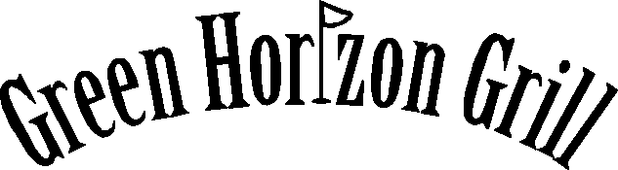
Private Party Served Dinner Menu - $29.00 per person

Appetizer Choices: Select One for Group

Bruschetta Bites

Boneless Wings
(Hot, Mild, BBQ, Sweet Chili)

Mozzarella Sticks with Marinara

Meatballs
(Swedish, Italian)

Vegetable Tray with Dip

Mini Chicken quesadillas

Cheese & Cracker Tray with Grapes

Scallops Wrapped in Bacon

BBQ Shrimp Wrapped in Bacon

Dinner Choices: Each Guest Pre-Selects One

New York Strip Steak
A 10 oz strip steak grilled to your liking

Crab Cakes
Two crab cakes made from The Bridges own recipe, a house favorite.

Fantail Shrimp Platter
10 jumbo breaded fantail shrimp, deep fried to a golden brown.

Chicken Chesapeake
Chicken breasts grilled and then topped with crab imperial and melted cheeses.

Broiled Scallops
Half pound of sea scallops broiled in lemon and butter

Salmon
A 8 oz portion of salmon drizzled in lemon and butter.

Filet Mignon
A 6 oz filet grilled to your liking

Seafood Platter
8 oz broiled haddock, 2.5 oz crab cake, and 3 fantail shrimp

Chicken Parmesan
2 Italian chicken breasts served on a bed of linguini topped with marinara and assorted melted Italian cheeses.

Stuffed Shrimp
6 jumbo shrimp stuffed with ¼ pound of broiled crab imperial.

All meals are served with salad, baked potato, vegetable of the day, rolls & butter along with dessert, coffee or hot tea. Appetizers, alcohol, and gratuity are extra.
Depending on group size some items may be omitted, please mention specific items desired when booking reservation.

