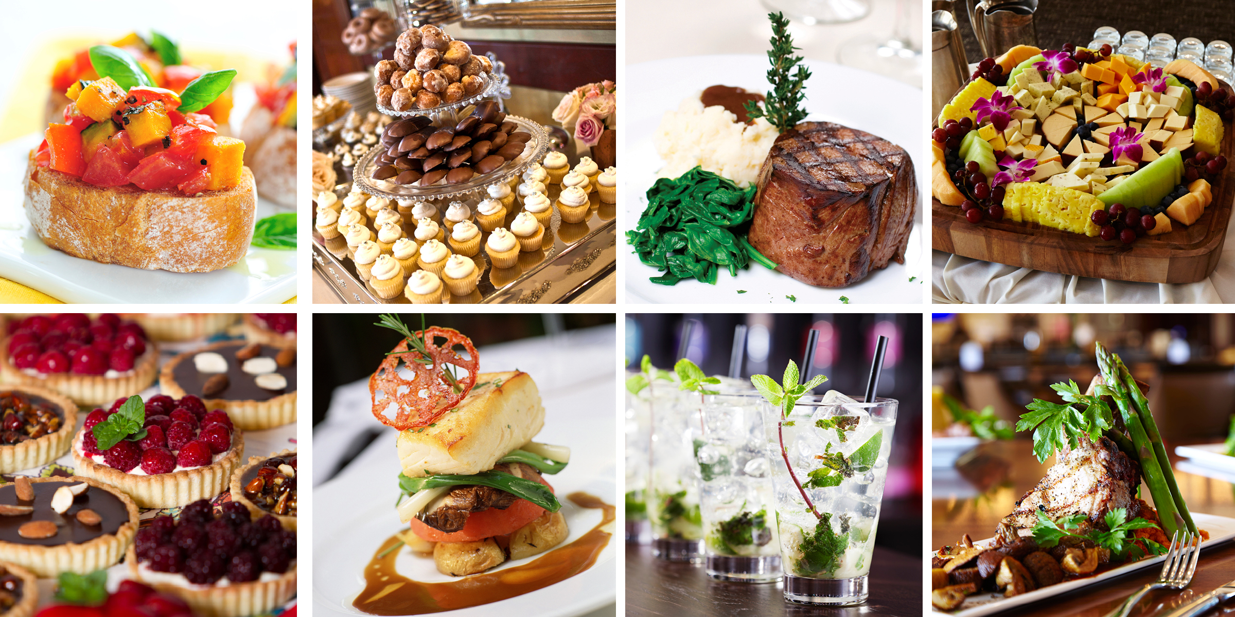
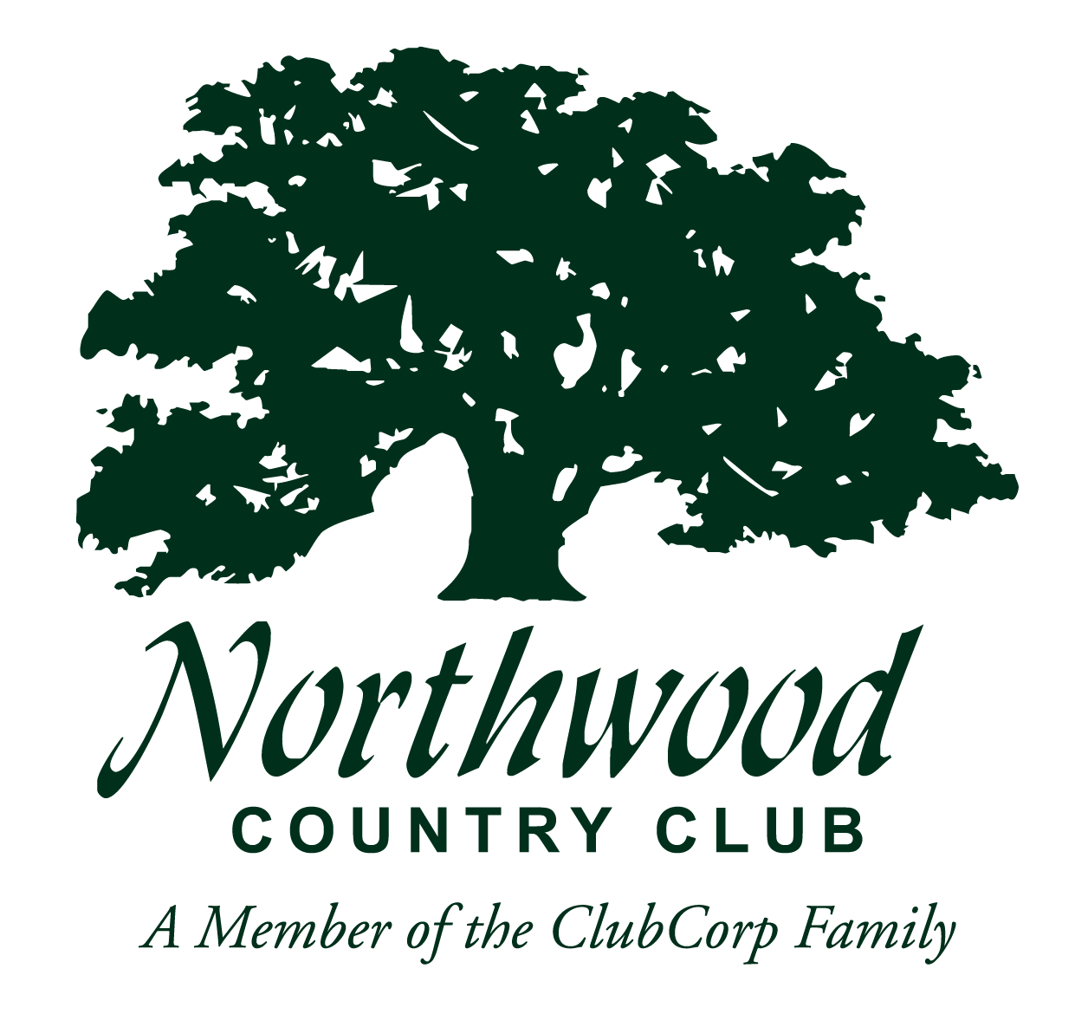
PEACE ON EARTH PACKAGE
< >

Buffet Dinner
Includes Non-alcoholic beverages, dinner rolls & butter

Choice of Salad
Choice of Two Entrees
Choice of Two Accompaniments
Choice of One Dessert
$25 Per Person
(20 person minimum)

DECEMBER DELIGHT PACKAGE

Buffet Dinner
Includes Non-alcoholic beverages, dinner rolls & butter

Choice of Two Hors d’ Oeuvres displays
Choice of Salad
Choice of Entrees
Choice of Two Accompaniments
Choice of Dessert
$30 Per Person
(20 person minimum)

Two Entrée $35 Per Person
Three Entrée $40 Per Person
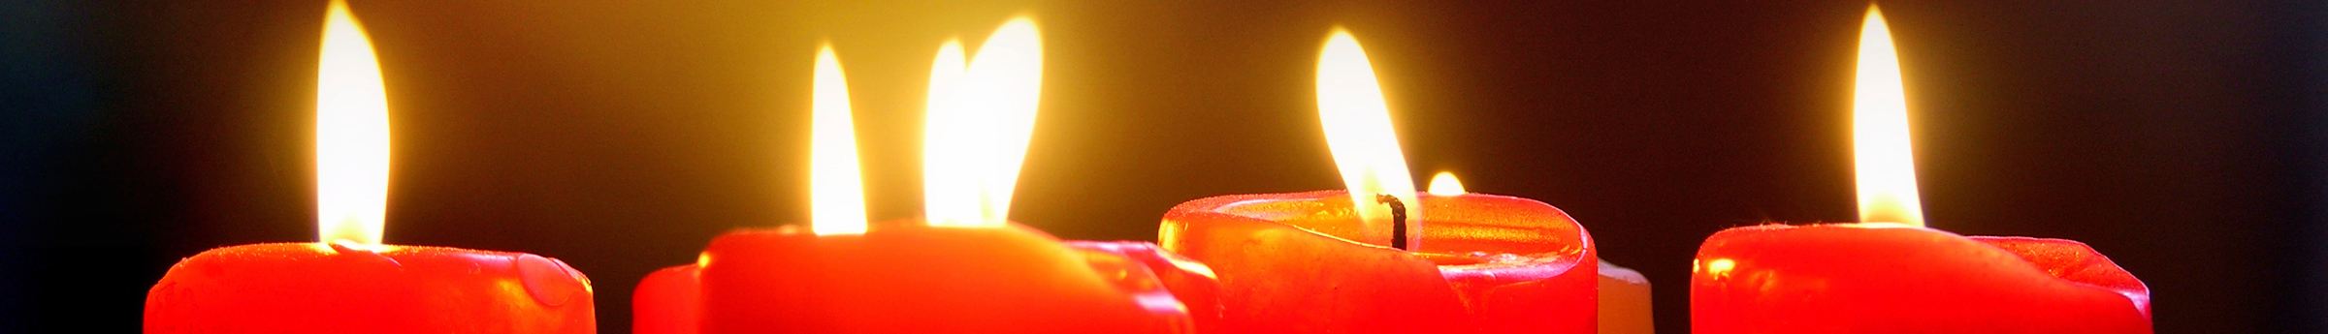

HORS D’ OEUVRES

Chefs Charcuterie Board
Smoked Salmon with Lemon Dill Bruschetta
Cucumber Canape with Yogurt & Mint
Seasonal Fruit & Cheese Display
Vegetable Spring Rolls & Sweet Chili Sauce
Swedish Meatballs
Assorted Imported Cheese & Cracker Display

SALADS

Mixed Green Salad with Cucumbers, Tomatoes, Red Onion and assorted Dressings
Traditional Caesar Salad with Croutons and Parmesan Cheese with Caesar Dressing

ENTREES

Roasted Chicken Breast with Herb de Provence & Brown butter
Fire Grilled Salmon with Bourbon Glaze and Charred lemon
Chicken Cordon Blue with Fresh Herb Cream Sauce
Carved Turkey Breast with Stuffing “Just like Momma’s”
Scaloppini Chicken with Marsala or Lemon Butter Cream Sauce
Maple Glazed Sliced Ham
Roasted Pork Loin with Cranberry Chutney
*Inquire about our Vegetarian Selections***

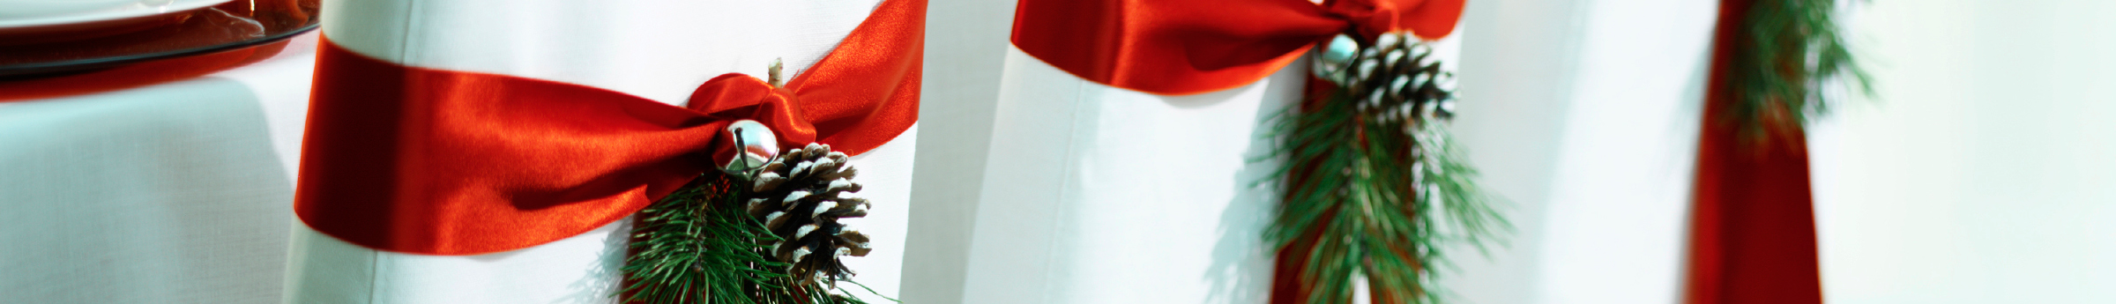

ACCOMPANIMENTS
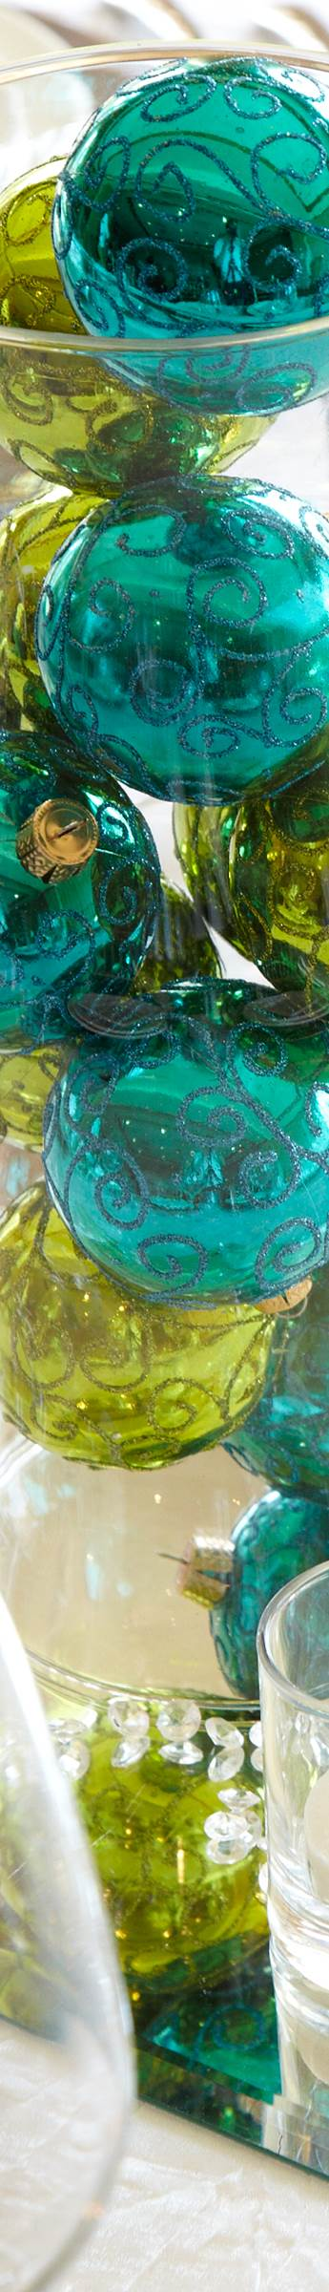
Roasted Garlic Whipped Potatoes
Green Bean Casserole
Sous Vide Sweet Potato Puree
Homemade Dressing
Green Bean Almandine
Season Vegetable Medley
Fire Roasted Herb Potatoes

DESSERTS

Assorted Cheesecakes
Crème Brulee with Macerated Fruit
Assorted Cookies & Brownies
Baily’s Brownie Chocolate Delight
Tiramisu Shooter
Chocolate Mousse with Raspberry Garnish

BAR

House Wines, Six Beer Selections (Domestic and Import)
$13 per person for two hours |$22 per person for four hours |Tickets $6 each
House Wines, Six Beer Selections (Domestic and Import), House Liquor
$19 per person for two hours |$26 per person for four hours |Tickets $8 each
House Wines, Six Beer Selections (Domestic and Import), Premium Liquor
$26 per person for two hours |$38 per person for four hours |Tickets $10 each

$100 Bartender Fee |Cash Bar Available

All packages include Event Coordination, Holiday Decorated Private Rooms, Uniformed Staff, White Tablecloths, Red or Green Napkins, Standard Centerpieces, and Beverage Station (Iced Tea, Water, and Coffee).

ADDITIONAL OFFERINGS

Seasonal Beverages
Hot Chocolate Station $6 per person
Egg Nog $6 per person
Champagne Punch $6 per person
Pomengranate Martini $8 each
Sage Bourbon Apple $8 each

CENTERPIECES
(Standard centerpiece - white pillar candle, hurricane, mirrored tile)
Hurricane Glass, Red Pillar Candle, Wreath Base, Mirrored Tile $3 per table
Ornament filled Vase, Mirrored Tile, Votives $4 per table



< title >

<Insert content here.>

< title >

<Insert content here.>


< title >

<Insert content here.>

< title >

<Insert content here.>

< title >

<Insert content here.>

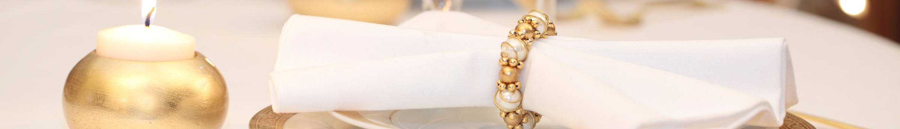

< title >

<Insert content here.>



< title >

<Insert content here.>



