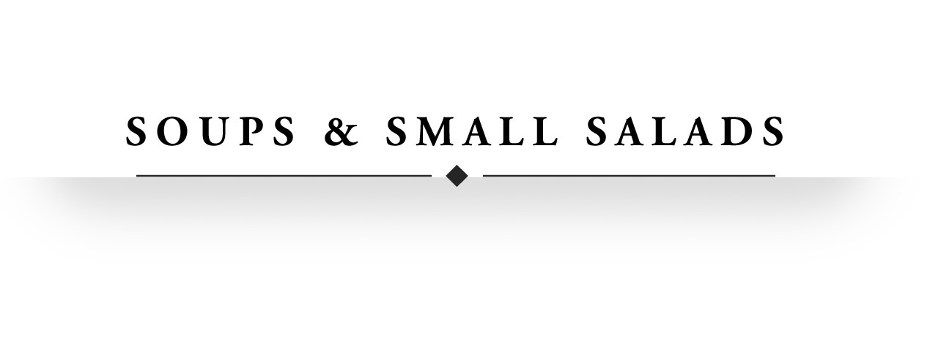

Small Caesar Salad 8.5
Chopped romaine and iceberg lettuce with Caesar dressing, croutons and parmesan cheese

Iceberg Wedge 9.5
Iceberg wedge with blue cheese crumbles, apple wood smoked bacon slices, sliced red onion, chives and blue cheese dressing

House Salad 9.5
Butter and romaine lettuces, cherry tomatoes, shaved radishes, lemon croutons, parmesan vinaigrette

SMALL TRUFFLED BEET & MOZZARELLA SALAD 9.5
Red and gold beets, caramelized shallots, house made mozzarella, basil, white truffle vinaigrette
(Dinner Only)

Charred Red Pepper Soup 8.50
Charred red peppers simmered and blended with vegetables. Topped with a basil, pesto crostini.

Roasted Corn & Chicken Chowder 10
Sweet corn and chicken chowder with bacon, peppers, potatoes and rich cream



Au Gratin Potatoes 20

mACARONI & CHEESE 20

Yukon Gold Mashed Potatoes 17

Creamed Corn 19

SAUTÉED Cremini Mushrooms 19

SAUTÉED Asparagus 20

SAUTÉED Broccoli 17

cREAMED sPINACH 19

bRUSSELS sPROUT HASH 20
bacon, onion, toasted almonds

GREEN BEANS 19
Country ham, melted shallots, toasted almonds

