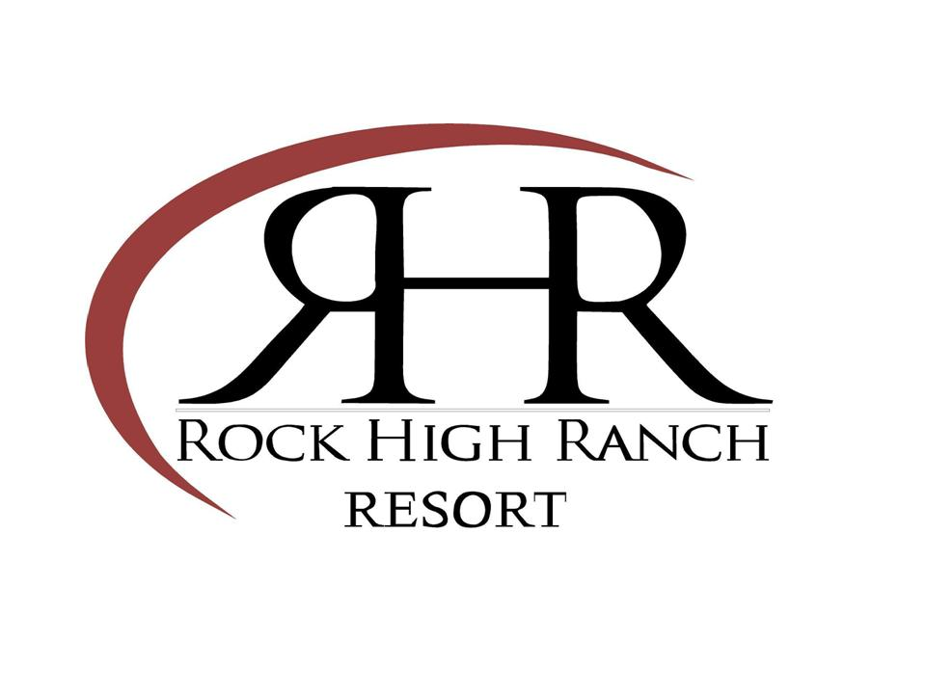
Wedding Packages

Rock High Ranch is a family owned and operated small resort facility and wedding venue located just 5 miles outside of Canton, TX. Our venue is nestled in the country, surrounded by our 35 acres of majestic trees, fields, and numerous ponds. We specialize in outdoor weddings, utilizing numerous ceremony sites, and our rustic, yet refined Dinning Hall and attached pavilion for receptions.

Up to 100 guests: $2500. Included is choice of ceremony site, up to 100 chairs for ceremony, tables and chairs for reception to seat 100, and white tablecloths for all our tables.

100 to 150 guests: $3000. Included is choice of ceremony site, up to 150 chairs for ceremony, tables and chairs for reception to seat 150, and white tablecloths for all our tables.

150 to 200 guests: $3500. Included is choice of ceremony site, up to 200 chairs for ceremony, tables and chairs for reception to seat 200 and white tablecloths for all our tables.

200 to 250 guests: $4000. Included is choice of ceremony site, up to 250 chairs for ceremony, tables and chairs for reception to seat 250, and white tablecloths for all our tables.

Included in all our packages: day use of a suite for the bride and her party to dress in, day use of a room for the groom and his party to dress in, use of our commercial kitchen to prep your food, use of our 600 lb ice maker, use of numerous chaffing dishes (you provide sterno cans), and 2 hrs for rehearsal.

We offer a 2 day package. For $1000 extra you may have access to the venue the “day before” to prepare and decorate so the day of the wedding is yours to just enjoy! (10AM-9PM)

- We have “on site” lodging for your out of town guests or your wedding night. We offer a 20% discount on all rooms for you or your guests when they come to your wedding.
- If alcohol is wanted at your event, a security guard is required. An off duty peace officer is hired at a cost of $50/ hr, minimum 4 hrs. Typically 4 hrs is all that is needed.
- You may arrive at 10 AM and must be gone by 12 AM (midnight). If more time is needed, consult RHR staff prior to the event.

- Rock High Ranch can accommodate weddings/ events up to 450 guests. For weddings larger than listed above the price increases $500 per 50 guests. Tax is included.

