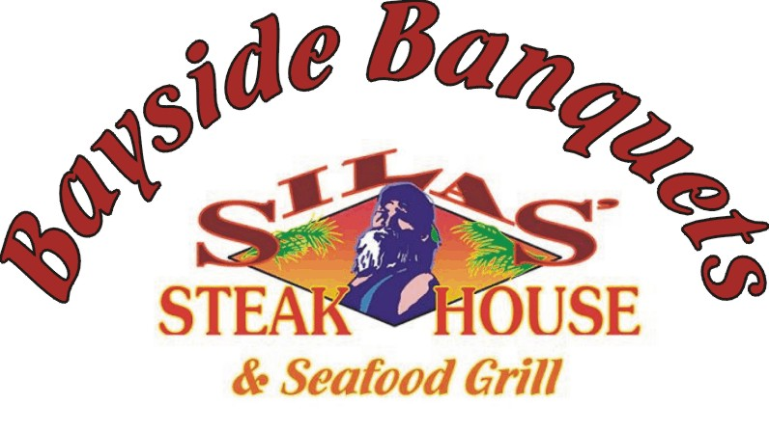

Bayside Banquets
Standard Banquet Package

- Banquet room with dance floor for 4 hours
  - Set up and tear down
- Set up and breakdown of bar (includes bartender)
- Set up of table and chairs
  - House tablecloths, white chair covers , and colored sashes (20+ colors to choose from) provided.
  - Complementary house center pieces, or you may bring your own. You can upgrade to our fresh flower centerpiece for a nominal fee
- Cake and gift tables with white linen
- Complimentary cake cutting
- Chapel/Ceremony setup with food and beverage – fee TBD
  - As a back up location for beach weddings
- Buffet Dinner
- Complementary parking in our spacious lot

- Pine Key Lodge ~ minimum of $1500.00 in F&B sales
- Long Key Lodge ~ minimum of $3000.00 in F&B sales

Each additional Guest over the F&B minimum is $38.10 per person for the basic banquet package (includes tax and service charge)
Children’s buffet pricing available on request (after minimum has been met)

** A $250.00 non-refundable deposit is requested to reserve the date and room for your event**
We accept payment by check (made payable to Silas Steakhouse) and submitted in person to 5501 Gulf Boulevard, St. Pete Beach, FL 33706; or a debit/credit card in person or over the telephone.
The deposit is applied to your balance, which is due two weeks prior to your event.

Buffet Dinner
  - Salads (select one)
    - Mixed garden fresh greens with Poppy seed vinaigrette
    - Caesar salad with homemade Caesar dressing
  - Starches ( select two from ALL choices)
    - Potato Au Gratin ; Garlic Mashed Potatoes;
    - Wild Rice Pilaf ; Rosemary Chef Potatoes;
    - Confetti Yellow Rice ; Macaroni and Cheese;
    - Penne Pasta Alfredo
  - Vegetable (select two from ALL choices)
    - Fresh green bean almandine ; Orange glazed carrots:
    - Mixed vegetable medley ; Broccoli ; Confetti Yellow Corn ;
    - House Style Creamed Corn
  - Entrees (select 1 of each)
    - Chicken
      - BBQ Chicken Breast
      - Chicken Marsala
      - Chicken Rockefeller with Alfredo Sauce
      - Lemon-Herb chicken
    - Beef
      - Beef Tips Burgundy
      - Beef Stroganoff
      - Cajun Steak Kabobs
    - Salmon
      - Pecan Crusted Salmon
      - Maple Glazed Salmon
      - Balsamic-Dijon Blackened Salmon

  - Bread and Butter
  - Water included
  - Soda service included if FULL bar is utilized
  - Cash Bar included (other bar options available)

Available ADD-ON Options

- Buffet dinner Carving Station
  - Honey Glazed Baked Ham ~ Slow Roasted Turkey Breast
    - Choice of one ~ $6.95 per person (plus tax and SC)

  - Slow Roasted Prime Rib ~ $7.95 per person (plus tax and SC)
  - Slow Roasted Top Round ~ $6.95 per person (plus tax and SC)

- Desserts (choice of one) $4.95 per person (plus tax and SC)
  - Chocolate Fountain with fruits and cookies
  - Make your own Ice Cream Sundae bar
  - Assorted CHEF’S CHOICE of mini desserts

- Beverage Services (all include set-up/tear down and bartender)
  - Hosted Bar ~ Bar tab established and reduced by each drink served
  - Open Bar ~ 3 Hour Open bar with unlimited non-alcoholic drinks (Long Island Ice Tea, doubles and shots not included)
    - Well Brand $19.00 per person (plus tax and SC)
    - Premium Brand $22.00 per person (plus tax and SC)
    - Extra Hour ~ Well Brand $4.50 ~ Premium Brand $5.50 ~ (per person, plus tax and SC )
  - Non-Alcoholic Beverages (if an OPEN, HOSTED, or CONSUMPTION bar is not utilized)
    - Soft Drinks ~ $2.25 per person (plus tax and SC)
    - Sweet Ice Tea and Lemonade ~ $2.25 per person (plus tax and SC)
    - Coffee ~ $2.95 per person (plus tax and SC)
  - Champagne Toast ~ $3.50 per person (plus tax and SC)

All food and beverage services will include 7% state tax and 20% Service Charge

