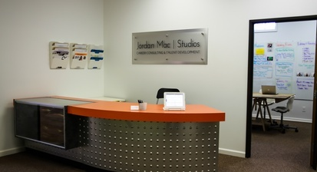
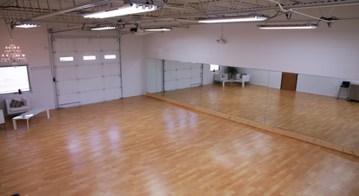
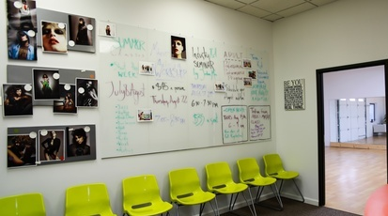

Studio Rental

Art Galleries

Band Rehearsals

Dance Rehearsals

Meetings

Networking Events

Classes & Workshops

Album Release Parties

Listening Parties

Bachelorette Parties

Photo Shoots

Videos Shoots

Private Parties

Group Lessons

Private Lessons

Casting Calls

Jordan Mac | Studios

444 W Maple Rd, Suite E

Troy, MI 48084

248.688.9816

www.jordanmacstudios.coma

1,000 square feet studio. Wifi is included for free.
View pricing and availability online at www.jordanmacstudios.com or call us at 248-688-981a6

