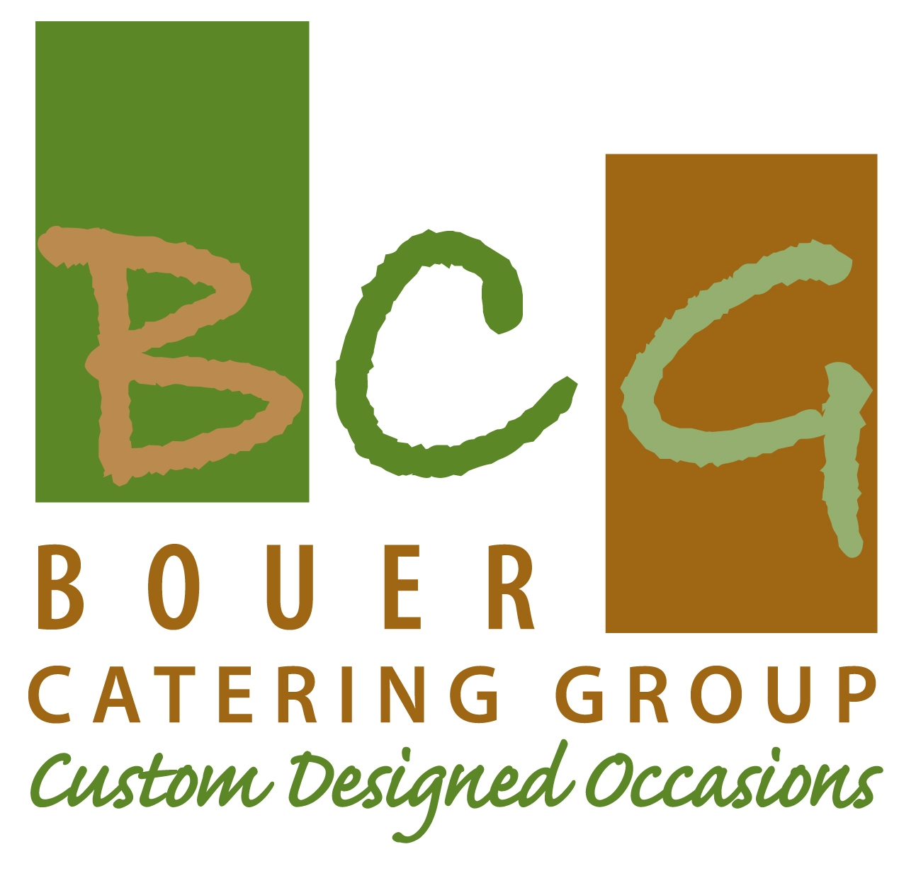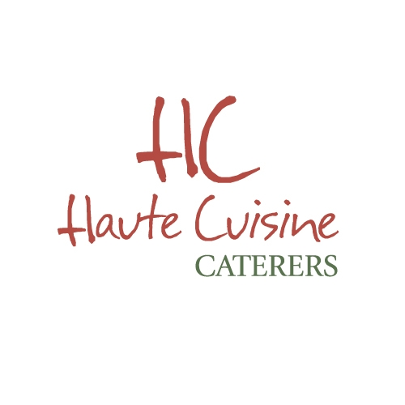

Hors D’ Oeuvres Passed Butler Style

VEGETARIAN

Tomato Bruschetta Served on a Crisp Baguette

Vietnamese Summer Roll

*Quinoa Cake with Mushroom Ragout

Vegetable Spring Roll with Sweet Chili Sauce

Herb Risotto Ball with Marinara Sauce

Spanikopita

Wine Fries – Sweet Potato &Marshmallow Fluff

Wine Fries - Sea Salt Fries & Ketchup

Crisp Potato Pancakes, Apple Sauce & Sour Cream

Mushroom Popover

*Honey Garlic Matzo Ball

CHEESES

*Pizzettas~ Rueben, Artichoke, Jalapeno

Goat Cheese, Tomato & Arugula Pizzetta

Portobello, Gorgonzola & Basil Pizzetta

Skewers of Caprese

Baked Brie Cup with Maple Walnut Sauce

Herb and Goat Cheese Stuffed Mushrooms

Caramelized Pear & Bleu Cheese Cinnamon Crisp

Tomato Bisque with Mini Cheddar Grilled Cheese

Mini Toasted Ravioli with Pesto Cream Sauce

*Smoked Gouda Mini Mac & Cheese Cups

POULTY

*Open Faced Mini Chicken Parmesan on Baguette

Chicken Potpie Popover

Chicken Empanadas with Pico di Gallo

Chicken Saté with your choice of Tamarind Sauce, Curry or Jack Daniels Barbeque

Chicken Quesadillas with brie, caramelized onions and cilantro berry salsa

Chicken Sausage and Peppers Stuffed Mushrooms

Chicken Curry Spring Roll

Coconut Chicken with a Thai Duck Sauce

Mini Chicken Taco Slaw and Avocado Cream Chicken Avocado Spring Roll with Tamarind Sauce

Caribbean or Curry Chicken Patty

*Duck Spring Roll with Mango Chili

*Seared Duck Breast on Scallion Pancake with Hoisin Sauce or Cherry Compote on Rice Cake

**Jerk Turkey Burger Pineapple chutney spicy mayo

Buffalo Chicken Spring Roll with a Bleu Cheese Dip

SEAFOOD

Pumpernickel Bread with Salmon, cream cheese capers

Seared Tuna with Wasabi Cream on a Wonton Crisp

Tilapia Ceviché in a Martini Glass

Seared Tuna and Wasabi Aioli on a Rice Cake

Salmon Cakes with Mustard Sauce

Surimi Crab Cakes with Mustard Sauce

Crab Rangoon

Tropical Tuna Tar Tar in a Cucumber Cup with

Spicy Mayo

Mini Blackened Fish Taco with Slaw and Avocado Cream

Fish and Chips with Tartar Sauce

Quesadilla with Surimi Crab and Avocado

Caviar Canapé

Corn Chowder with a Surimi Crab Cake

BUTCHER

Franks in a Blanket

Sweet and Sour Meatballs

Beef Saté with your choice of Tamarind Sauce, Curry or Jack Daniels Barbeque

Burger and Fry

Pretzel Dogs

Churrasco Steak with Chimichurri

Ropa Vieja on corn pancake

Rare Filet, Toasted Baguette with Caramelized onions &Horseradish Cream

Mini Beef Philly Cheese Steak

Spaghetti and Meatball

Mini Meatloaf and Mashed Potato

+ Grilled Baby Lamb Chops $5 per person

with English Mint Sauce or mint/feta pesto with

*BREAKFAST

Bagelette with Lox

Mini Pancake with Banana Foster Topping

French Toast Stix and Syrup Drizzle

Waffle Stix and Syrup Drizzle

Mini Cinnabuns

Hash Meatballs

Hot Coco w/Donut Hole or Mini S’mores

COLD DISPLAY PLATTERS
Imported and Domestic Cheese Board

Middle Eastern Delights
Hummus, Chickpea Salad, and Israeli Salad served with assorted Middle Eastern Breads
Falafel Add $2/pp –This Includes Attendant

Vegetarian Antipasto

Trio of Bruschetta
Tomato, Olive, and White Bean with Cabrales and Truffle Oil with Assorted Breads

Mediterranean Grilled Salmon

Chilled and Grilled Vegetable Platter

Classic Crudités

Gazpacho Shooters

Baked Brie with Brandied Maple Walnut Sauce or with Honey and Apples

Fresh Fruit and Berry Platter

Warm Spinach and Artichoke Dip with Tri Colored Tortilla Chips

Smoked Salmon Mousse
Sundried Tomato Tort
Caviar Pie
Smoked Fish Dip with Jalapeños and Lemon

UPGRADES
Trio of Mozzarella with Grilled Eggplant, Tomato and Grilled Portobello - $5.00 PP
Carved Nova with Traditional Condiments…$3

Classic Caviar Set Up…$3

Whole Roasted Salmon…$3

Trio of Ceviche…$5
Salmon, Grouper and Snapper

GOURMET STATIONS $1000 each per 100 guests

Each additional protein is $5/pp unless otherwise noted next to item

Each additional side is $3/pp

*IT’S ALL GREEK TO ME

Choose 1 Protein

Lemon Thyme Oregano Chicken, Gyro Beef, Keftas, Moussaka- Beef or Vegetarian,

Baked Lemon Pepper Fish or Baked with Olives, Feta, and Peppers, Souvlaki

Sides Choose 2

Spinach Feta Pasta, White Bean and Olive Salad, Greek Salad, Spanakopita

Herbed Greek Potatoes, Veggie Cous Cous, Greek Salad, Chickpea Feta Salad, Falafel

Served With Tzatziki Sauce, Pita Bread, Crisp Pita Chips

*GRILLED CHEESE 3 WAYS

Choose Your Cheese and Add Ins to Create 3 Unique Grilled Cheese Selections

Pick 3:

Cheddar, Pepper jack, Brie, Greyer, Gouda, Mozzarella, Swiss

Choose Bread: 1 For Each Sandwich or All the Same

White, Whole Wheat, Multi Grain, Sourdough, Rye, Marble, Baguette

Choose A Topping: 1 For Each

Caramelized Onions, Apple, Avocado, Roasted Peppers, Sautéed Mushrooms,

Tomato, Sundried Tomato, Roasted Tomato, Herbs, Walnuts

Pear, Sprouts, Arugula

Spreads:

Jams-Raspberry, Apricot, Strawberry & Pepper – Grain Mustard

On The Side:

Garlic Parmesan Parsley Fries

UPGRADE: Add A Protein at $1.50/pp

Turkey, Corned Beef, Kosher Salami

*TWICE BAKED POTATO BAR

(CAN BE CONVERTED TO MASHED POTATO BAR)

We Scoop Out ½ of a Potato, Mix in your Favorites, and Refill the Skins!!

Choose 2 Potatoes:

Idaho, Red, Yukon Gold, Sweet

Cheddar, Mozzarella, Swiss, Chopped Broccoli, Creamed or Chopped Spinach, Chives,

Jalapenos, Turkey Bacon, Caramel Onions, Chili, Nacho Cheese, , Sea Salt,

Butter, Chopped Tomatoes, Sautéed Mushrooms, Sour Cream, Chopped Herbs,

Salsa, Gravy, Roasted Peppers, Guacamole, Pesto, Cinnamon & Brown Sugar

CARIBBEAN JERK

Choose 1

Jerk Chicken-Fish-Beef, Escovisch (Fish), Jerk Sliders with Slaw –Turkey or Beef

Beef or Chicken Jamaican Patties, Salt Fish Fritters, Chicken Stew

Choose 2

Rice & Peas, Plantains, Sautéed Cabbage, Cucumber Salad, Carrot Raisin Salad

ENGLISH PUB

Choose 1

Steak Pie, Bangers (Chicken) and Mash, Shepherd’s Pie, Fish and Chips

Served with Mushy Peas and Welsh Rarebit (English Favorites)

Or Smashed Potatoes and Gravy and Peas

UPGRADE TO ENGLISH CARVERY $150 Chef Fee

Rare Roast Beef and Yorkshire Pudding

MORACCAN

Choose 1

Baked Tilapia Chermoula, Beef or Chicken Shish Kebobs, Lamb Sliders,

Falafel, Chicken and Olives

Choose 2

Vegetable Cous Cous, Yellow Rice, Bastella, Lentil Salad, Hummus & Tabbouleh,

Stuffed Grape Leaves, Crispy Eggplant,

Served with Tahini, Pita Bread and Crisp Pita Chips

Lamb Shank – Upharge $4/pp

THAI

Choose 1

Chicken Pad Thai, Coconut Chicken, Ginger Chicken Stir Fry, Beef and Chicken Satay(mix)

Thai Beef and Peppers, Coconut Curry Beef or Chicken,

Choose 2

Fried Wontons, Steamed Dumpling, Thai Stir Fry, Jasmine Rice,

Coconut Rice, Ganglesam, Curry Noodles, Green Beans with Peanuts

*Crispy Duck with Scallions, Cucumber and Hoisin Upcharge $4/pp

OLD WORLD

Choose 1
Old Fashioned pot Roast, Stuffed Cabbage, Chicken Paprikash, Brisket,
Hungarian Goulash, Beef Burgundy, Sauerbraten
Choose 2
Micro Matzo Ball Soup, Potato Dumplings, Potato Pancakes, Potato Kugel,
Braised Cabbage & Carrots, Garlic Spaetzle, Potato, Blintzes
Kreplach, Kasha Varnishkes, Potato Pancakes, Derma, Chopped Liver

DOWN HOME COOKIN
Choose 1
Mama D’s Fried Chicken, Home Made Meatloaf, Chicken &,
Chicken & Dumplings, BBQ Chicken, BBQ Ribs, Country Fried Chicken Steak
Choose 2
Collard Greens, Grits, Cheesy Grits, Succotash,
Hoppin John, Corn Bread, Mashed Potatoes
Served With
Biscuits and Gravy

BOUER DELI
$150 Chef Fee
Sliced on Our Deli Slicer: Choose 2
Corned Beef, Turkey Breast, Pastrami, Roast Beef, Tongue,
Hard Salami, Beef Bologna, Chopped Liver
Choose 2
Cole Slaw, Potato Salad, Steak Fries, Cucumber Salad,
Mini Knish, Vegetable Soufflé,
Served with:
Assorted Breads, Wraps, & Rolls, Sliced Cheese Tray,
Assorted Pickles-Sours, ½ Sours, Pickled Tomatoes

“DRIVE IN” STATION

Select 2 Proteins and 2 Sides

Proteins~ Hot Dogs, Mini Hamburger, Rachel’s, Reuben’s

Sides ~ Grilled Cheese Sandwiches, Tater Tots, Seasoned Fries, Sweet Potato Fries, Jumbo Onion Rings

Dr. Brown Sodas, Mini Cokes, A&W Root beer…$2.00/pp

The Griddle Slider

Includes Ketchup, Mustard, Mayo, Shredded Lettuce, Slice Tomato, Pickles, Cole Slaw and French Fries

Select 2

Beef, Jerk Turkey, Herb Chicken Medallion, BBQ Brisket, Sloppy Joes, Lamb, Crab Cake and Blackened Fish Slider

PASTA YOUR WAY

Action – One Pasta with 2 Sauces and Assorted Toppings and Garlic Bread

Mozzarella Cubes, Artichokes, Caramelized Onions, Peas, Broccoli,

Fresh Basil, Mushrooms and Roasted Peppers

Add One Protein…$200

Chicken, Surimi Crab, Chicken Sausage or Meatballs

FAJITA STATION

Includes Soft and Crispy Shells with Chips, Salsa, Lettuce, Tomato, Shredded Cheese, Guacamole and Peppers & Onions

Select One Protein and 2 Sides

Proteins ~ Flank Steak, Chicken Breast, Ropa Vieja or Blackened Mahi

Sides ~ Rice and Beans, Spanish Rice, Refried Beans, Corn Cakes, Tostones, Plantains

or Avocado and Onion Salad

ASIAN STATION

Select 1 Protein and 2 Sides

Honey Garlic Chicken, Sweet & Sour Chicken, Chef’s Special Ginger Chicken and Vegetables,

Chicken Lettuce Wraps, Mushu Chicken, Sesame Chicken,

Pepper Steak, Mahi Lemon Grass with Garlic Sauce, Ginger Salmon

Vegetable Fried Rice, Garlic Egg Noodles, Lo Mein, Cilantro Rice

Stir Fried Vegetables, Egg Rolls, Crispy Green Beans

Additional Cost: Peking Duck with Pancakes, Hoi sin and Asian Slaw $5.00

Crispy Noodles, Asian Boxes, Duck Sauce

and Chop Sticks

ITALIAN STATION

Includes Penne Pasta with one of our Signature Sauces and Garlic Bread

Select 1

Eggplant Rollatini, Meatballs, Herb Crusted Tilapia, Chicken-Parmigianino, Marsala/Madeira

Lasagna Stack

Veal Parmigianino $500

Select 1

Caesar Salad, Chopped Salad, Caprese Salad

Trio of Mozzarella – Additional Cost

CARVING STATION plus $150 for Carver

Select 2

London Broil, Turkey, Corned Beef, Pastrami,

Brisket, Flank Steak or Carved Jumbo Franks en Croute

Select 2

Roasted Potatoes, Potato Skins, Fries, Mashed Potatoes, or Rolls

Braised Cabbage, Cole Slaw, Creamed Spinach, Grilled Vegetables

ADDITIONALS

Whole Ribeye…$12, Filet Mignon…$14

Rack of Lamb…$15, Short Ribs…$18 – 20

Skirt Steak…$7, Leg of Lamb…$7

WELLINGTON STATION

Salmon Florentine and Chicken Wellington

Beef Wellington $400

Select 2 Sides

Roasted Potatoes, Potato Skins, Fries, Mashed Potatoes, or Rolls

Braised Cabbage, Cole Slaw, Creamed Spinach, Grilled Vegetables

LATIN STATION

Includes Curry Sauce, Chimichurri and White Rice and Black Beans

Select 1

Herb Marinated Churrasco Steak, Ropa Viejo, Chicken Asada or Arroz Con Pollo

2 Sides

Spanish Rice, Tostones, Plantains, Arepas, or Corn Cakes

The French Riviera

Station includes Assorted Cheeses, Crackers and Breads

Puff Pastry Cup: Select Two

Beef Bourguignon with Sherry Mushrooms, Coco van or Seafood Newberg

Or

Crepes: Select Two

Chicken and Mushroom, Spinach & Feta, Brie with Apples, Roasted Vegetables with Goat Cheese

CHOP STICK SALAD STATION

Chopped Lettuce

Chopped Grilled Chicken, Grape Tomatoes, Cucumbers, Peppers, Broccoli, Carrots

Chick Peas, Olives, Raisins, Tortilla Strips, Wontons, Croutons,

Sunflower Seeds and Slivered Almonds Cranberries,

Crumbled Goat, Bleu and Feta Cheeses

Caesar Dressing, Bleu Cheese, Ranch and Balsamic Vinaigrette

RISSOTTO BAR

Ours Chefs Delicious Classic Risotto

Accompanied with many Add Ins:

Asiago, Sautéed Mushrooms,

******************************************************************

JAPANESE STATION…$12/per adult~$8/per teen

Assorted Sushi Rolls

California, Vegetable, Salmon and Tuna

Cones with Spicy Tuna & Salmon

Accompanied with Edamame Salad and Sesame Noodles

Sushi & Sashimi $300

Tempura Vegetables with Ponzu $200

Pan Seared Gyoza $300

Mini Salad with Ginger Dressing $200

Miso Soup Shooters $200

CHICAGO STEAK STATION…$2500/per 100 adultsd

Short Loin of Beef “Porterhouse Steak”

Cottage Fries, Onion Rings, Creamed Spinach,

Peter Luger Steak Sauce, A1 and Horseradish Cream

SERVED DINNER

SALADS

Traditional or Knife and Fork Caesar

Bistro Salad

Baby Greens with Dried Berries, Sweet Walnuts, Maytag Blue Cheese and a Sweet Balsamic Vinaigrette

Greek Salad

Chopped Greens with Feta, Olives, Tomatoes, Cucumbers and Lemon Vinaigrette

Wedge Salad

Iceberg, Crispy Onion Straws, Cherry Tomatoes and Bleu Cheese Dressing

Oriental Salad

Shredded Lettuce, Mandarin Oranges, Crispy Rice Noodles, Napa Cabbage,

Sliver Almonds with Sweet Oriental Dressing

Chopped Salad

Chopped Greens, Chick peas, Tomatoes, Cucumbers, Asiago Cheese

And Balsamic Vinaigrette Dressing

Summer Salad

Strawberries, Sunflower Seeds, Cheese, Baby Greens and Balsamic Vinaigrette

*Japanese Ginger Salad

PLATED APPETIZERS

*Honey Garlic Matzo Balls or Honey Garlic Chicken

Crepe Antoinette, A Crepe Filled with Mushroom and Chicken

*Vegetable Crepe, A Mixed Vegetable Crepe Topped with a Velvety Cream Sauce

Eggplant Rollatini stuffed with Spinach and Fresh Tomato Sauce

*Hoisin Duck on Scallion Pancake

*Chicken, Beef, or Veggie Kabob

Sugar Cane Chicken Sate or add Filet…$5 per person

Spicy Tamarind Sauce, Baby Arugula and Asian Noodles tossed in Avocado Vinaigrette

Southwestern Salmon Cake, Surimi Crab Cake or Chef Leslie’s Fish Cake

Roasted Corn and Black Bean Salsa, Topped with Roasted Garlic Tomato Ragu

Caprese Pin Wheel with Fried Basil and Crisp Baguette

Toasted Raviolis with Pesto Cream Sauce, Ala Vodka Sauce or Fresh Marinara

Trio of Chef Homemade Soups – Select 3

Tomato Bisque, Mini Matzoh Ball, Mushroom Barley, Baked Potato, French Onion,

Broccoli and Cheddar, Gazpacho, Corn Chowder and Cream of Mushroom…

Tomato & Red Onion Salad with Fresh Basil and French Baguette

Steamed Dumplings – Chicken or Vegetable

Pot Pies – Chicken, Mushroom, Veggie, or Beef

*Chicken or Beef Jamaican Patty

APPETIZER/SALAD DUET SUGGESTIONS – ITEMS CAN BE SELECTED SEPARATLY

*Chicken, Beef, or Veggie Kabob Served With Israeli Salad and Pita Crisps

*Hoisin Duck on Scallion Pancake with Oriental Salad

Eggplant Rollatini served with Caesar Salad or Mixed Greens with Balsamic Vinaigrette

*Chicken or Beef Adana, Spanikopita, or Stuffed Grape Leaves with Geek Salad

Mini Potpie – Chicken or Mushroom served with a Chopped Salad

*Honey Garlic Chicken or Honey Garlic Matzo Balls with Oriental Salad

Toasted Ravioli with Chopped or Caesar Salad

Lasagna Stack with Caesar Salad

Middle Eastern Delights – ½ Pita with Falafel, Israeli Salad, Tahini Garnished with Hummus and Crispy Pita

Four Pieces of California Roll with a Japanese Ginger Salad

FISH ENTREES:

BASIC FISH CHOICES: SALMON, MAHI, TILAPIA, BASA

Tornados of Salmon

Pin Wheel of Salmon, Pan Seared and Pecan Crusted

Served with Sticky Rice Pilaf and Tropical Mango Salsa

*Caribbean Citrus

Served with Coconut Rice and Spinach Topped With Mango Fresh Salad

Ginger Lime Pesto

Served with Cilantro Rice and Black Bean and Corn Salsa

Moroccan Spiced

Served with Vegetable Cous Cous

Oriental Glazed

Served with Fried Rice and Crisp Asian Vegetables

Herb Crusted

Served with Cranberry Brown Rice, Sautéed Spinach and Lemon Buerre Blanc

Pistachio Crusted

Served with Smashed Potatoes, Baby Green Beans and Vanilla Rum Sauce

Upgraded Fish Available at Market Price: COD, SNAPPER, GROUPER, SEABASS, HALIBUT, TUNA

CHICKEN ENTREES:

Chicken Wellington

Breast of Chicken filled with Mushroom Sherry Pate, Currant Port Wine Sauce served with Roasted Potatoes and Grilled Vegetable Stack

Oriental Chicken with Sweet Glaze

Horseradish Mashed Potatoes, Asian Slaw and Crisp Noodles

Chicken Francesca –

Herb Lemon Butter Sauce with Capers and Baby Artichokes served with Herbed Risotto

Grilled Chicken Marsala Stack –

Grilled Portobello Layered with Grilled Chicken with a Mushroom and Marsala Wine

served with Smashed Potatoes and Green Beans

Grilled or Milanese Chicken Bruschetta with Pasta and Broccoli Rabe

Mediterranean Roasted Chicken Breast

Lemon, Oregano and Olives served with Roasted Potatoes and Green Beans

Chicken Florentine Stuffed with Spinach and Sliced served with Roasted Potatoes and Green Beans

Corn Tortilla Crusted Chicken

Goat Cheese Smashed Potatoes and Tomato and Avocado Relish

Miso Glazed Chicken

Glass Noodles and Mint/Cilantro Asian Vegetables

*Seared Duck Breast ***$5/pp Upgrade***

Served with Wild Rice and a Cherry Sauce and Green Beans

BEEF ENTREES:

Filet Mignon: Grilled or Herb Roasted…$15

Sauces - Herb Demi, Cabernet Demi, Bordelaise, Au Poivre or Béarnaise

N.Y. Strip: Grilled or Whole Roast Sliced Sirloin…$15

Sauces - Herb Demi, Cabernet Demi, Bordelaise or Béarnaise

Aged Prime Rib…$15

Prime Rib of Aged Beef Roasted Cut and Highly Seasoned

Braised Short Ribs***$18/pp Upgrade***

Served with Truffle Smashed Potatoes

DESSERT

Chocolate Molten Cake with Crème Anglaise and Brown Sugar Whipped Crème

New York Style Cheesecake

Sliced with Fruit Compote and Whipped Cream

Fried Cheese Cake with a Fruit Compote

Brownie Sundae

Banana Foster Bread Pudding

Caramelized Banana and Whipped Cream

Banana Foster Served Over Ice Cream

Apple Pie Ravioli with Cinnamon Dusted Vanilla Ice Cream

Cinnamon Apple Crumb and Walnut Cake

Vanilla Ice Cream

Runny Chocolate Chip Cookie Soufflé

Served with Vanilla Ice Cream

ENHANCED DESSERTS

His and Her Desserts…$3

Dessert Sampler…$5

Mini Apple Pie, Mini Chocolate Molten and Vanilla Ice Cream

Classic Crème Brulee…$5

Berry Crème Brulee…$8

Praline Basket with Fresh Berry Bottom and topped with Crème Brulee

Nestled on a Bed of Whipped Cream

Passed Desserts…$8.00

Assorted Chef Selections

VIENNESE STATION…$15

To include an assortment of:

Peanut Butter and Chocolate Pie, Carrot Cake, Chocolate Cake, Mini Molton & Cheese Cakes

Fruit Platter, Banana Fosters with Ice Cream,

Cake Pops, Cannoli, Banana Pudding, Rice Pudding

Chocolate Fondue

Strawberries, Bananas, Pretzel Rods, Nilla Waffers, Rice Crispy Treats, Marshmallows

Crepe Station

Rolled Nutella Crepes

Toppings of Bananas and Raisin

Fresh Berries

Served with Whipped Cream and Chocolate Sauce

