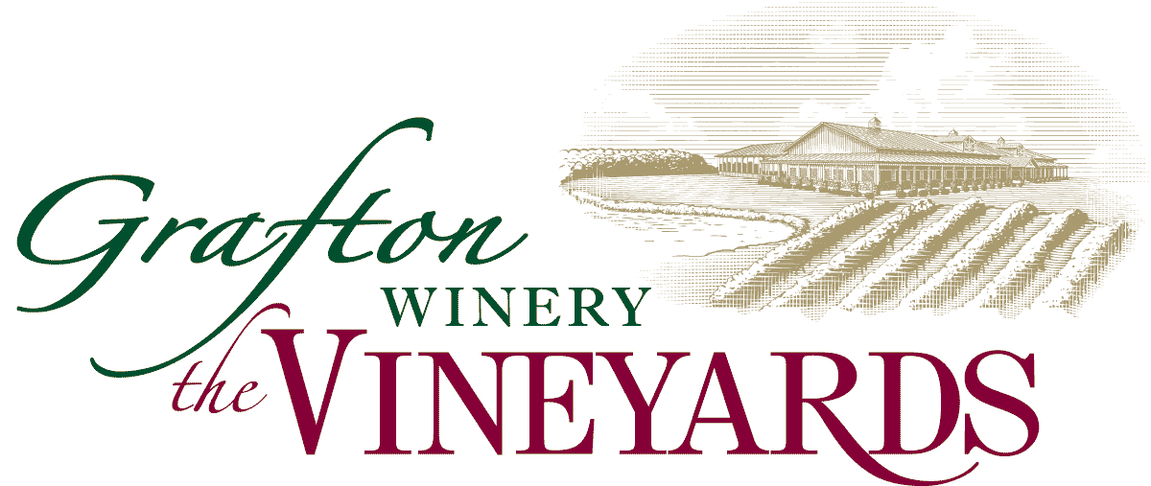
Event Package

Pavilion (400 Guests)
And
Tasting Room (300 Guests)

Rental Pavilion $2,500 – Saturdays, $2,000 - Fridays and Sundays
Fees: Tasting bar area open during pavilion event add $900
Tasting bar rental without pavilion $2,500 Weekends

Go beyond the stale hotel conference center for your next corporate function and visit us at Grafton Winery, the Vineyards. Our beautiful venue and knowledgeable staff will exceed your expectations to assure your event is just how you planned it would be.

We want this part of your event plans to be simple. Below is a list of the items included in your rental fee. If we have missed anything you need, please discuss with the Vineyard Event Coordinator.

Rental fee includes:

- Exclusive use of the spacious outdoor pavilion
- Tours of our vineyard and the manufacturing area and wine sampling for your group
- The Vineyard Event coordinator will be onsite for your event.
- Guest tables –round and/or banquet tables available
- Accessory tables are provided
- White Chairs
- Linens -White, black or ivory table linens and napkins for guest and accessory tables. Select colors are available for napkins.
- White, black or ivory skirting as needed for hear table
- Setup and clean up service for items provided by The Vineyards
- 2 Bartenders for duration of the event
- Catering Kitchen
- Sound System
Decorations:

- Decorating of The Vineyards can begin as early as 8:00 am the day of the event. Please keep in mind that this is an outdoor venue and plan your decorations accordingly. The Vineyards does not provide any decorations or storage.

- The beautiful natural setting should help you limit your need for excessive decorations. Table decorations and floor plants will be all you will need. We ask that you please refrain from using glitter, confetti, rice, silly string and birdseed. Nothing may be taped or attached to the walls or ceiling.

- Client/vendors are responsible for removing all equipment, decorations, flowers and miscellaneous items at the conclusion of the event. All items left at The Vineyards one hour after the conclusion of the event shall be removed by The Vineyards and discarded. If excessive cleanup is required, a service fee of $75.00 may be assessed.

Bar Service Options:

- 3 hours - Beer and Wine, $18 per person plus tax and gratuity.
- 4 hours - Beer and Wine, $21 per person plus tax and gratuity.

Packages include up to 6 Grafton Winery Wines, up to 4 draft beers, soda, tea and coffee. Wine and beers are subject to availability. Reserve wines are available but are excluded for the package. Draft beer choices include Grafton Brewhaus draft beers, draft Bud Light, draft Michelob Ultra and draft Bud Select. Reserve wines will be priced per selection.

- Cash bar is also available for $150 and your guests will be charged per drink. You have the option to pay a select amount toward the bar service and after that amount is exhausted the bar will convert to a cash bar.

Please note there is to be no outside alcohol brought in the building. If outside alcohol is found in the event there will be a $250.00 fee assessed and the alcohol will be confiscated. If outside alcohol is found again, the event will be terminated immediately and no refund will be allowed.

In accordance with the state and local law, it is the Grafton Winery’s policy to (a) request property identification (photo ID) of any person of questionable age and refuse alcoholic beverage service if the person is either under age or proper identification cannot be produced and (b) refuse alcoholic beverage service to any person who, in the Grafton Winery’s sole judgment, appears intoxicated.

Catering:

To simplify the selection process we have selected caterers for you to choose from. Familiarity goes a long way to ensure the success of your event and these professionals have choices to satisfy anyone’s pallet.

Choose the baker of your choice for your wedding cake. If you don’t have a favorite several of our caterers can provide you with that service as well. Please advise your baker that your reception venue is outdoors and inform them of the timing of your even so that they may schedule delivery accordingly.

Deposit and Payments:

To reserve the date, you must make a deposit equal to 50% of the venue fee and sign a contract. The deposit is nonrefundable. This can be made by credit card, check or cash.
- A credit card must be on file for any incidentals and/or damages to the property.
- Balance of payment is due 2 weeks prior to event

Just a few other details:

- The Vineyards in not responsible for any personal property, gifts, decorations, equipment or other belongings brought into the facility by the client or the client’s guests.
- The Vineyards reserves the right to control the volume level for any event entertainment including bands, DJ, etc.
- All events must conclude by 11:00 pm with the music ending at 10:00 pm. Guest need to vacate the property at the end of the event or the client will be charged a $100 fee for anyone remaining in the event space after 11:00 pm.
- The Vineyards reserves the right for the tasting bar to be open to the public during events. Inside access to the tasting bar will not be available unless prior arrangements have been made.
- We want to keep you and your guests comfortable as possible. For warmer months please keep in mind that The Vineyards is not air conditioned and your guests should be advised to dress appropriately.
Air conditioners may be rented for the space for a fee of $1,250 or current pricing. The lead time for reserving an air conditioner is 1 week and is based on availability.
- The Vineyards requires rental of a heater(s) if “weather.com” forecasts a low temperature of 60 degrees Fahrenheit or below for your event. Setup and removal will be taken care of by The Vineyards. The client is responsible for the rental fee.
*Please remember to inform your guests that this is an outdoor event space*
Additional Charges
Sales Tax:
Sales tax is charged on all venue fees and beverages at the current rate
Service Charge:
A service charge equal to18% of all beverages is added to the final bill

Client Information

Client: ________________________________________________________________________

Address: _____________________________________________________________________________

City: _________________________________State: ___________ Zip Code: ___________

Phone Number: _________________________ Email: ______________________________
Other contact numbers: ________________________
Event Information

Event Date: ________________________ Type of Event ___________________________

Event Times: Start Time: ___________ End Time: _____________

Table Setup: ___________________ Final Headcount: ____________________

Special Notes: ______________________________________________________________________________

______________________________________________________________________________
______________________________________________________________________________
By signing below, I agree that I have read the guidelines and agree to the terms.
Client Signature: __________________________________ Date: _______________

Vineyards Signature: _____________________________ Date: _______________

Deposit: Date of deposit_____________________
- Check number__________________________

- Cash______________________________ Receipt given_____________________

- Credit Card _______________________ Expr: __________Sec Code__________

