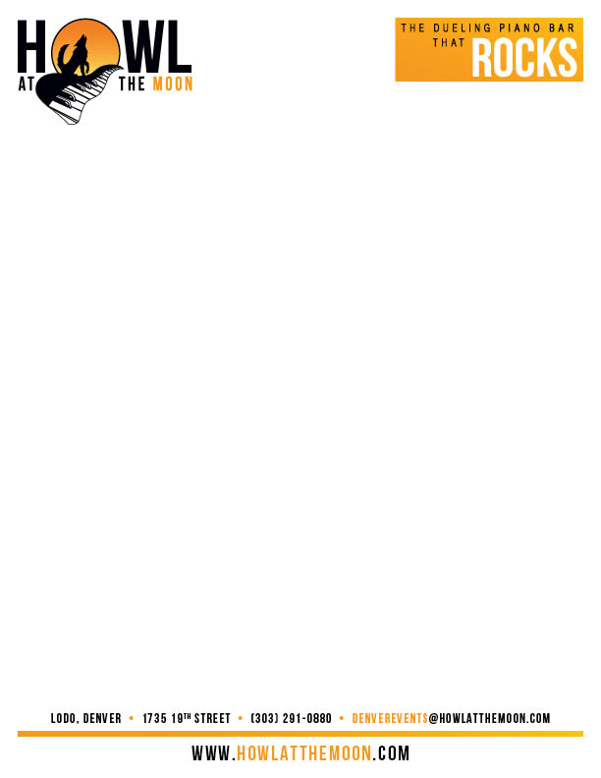

Howl at the Moon Company Song Questionnaire:

Help us learn about your company by filling out the answers to these questions:

What is the name of your company_______________________________________________________________________________________________________________________________________________________________________________________________________________

What does your company do? Tell us about your industry_______________________________________________________________________________________________________________________________________________________________________________________________________________

How long has your company existed? Who founded it?_____________________________________________________________________________________________________________________________________________________________________________________________________________________

Who are your competitors and would you like us to poke fun at them? If so, what can you tell us about them?_________________________________________________________________________________________________________________________________________________________________________________________________________________

What is the purpose of your event? Is it a conference, a teambuilding, an annual event, a “just for fun” event?_________________________________________________________________________________________________________________________________________________________________________________________________________________

Are there any fun people, funny stories or people in your company who you would like to have included in the song? If so, what makes this person/ these people stick out?___________________________________________________________________________________________________________________________________________________________________________________________________________________________________________________________________________________________

Are there any inside terms/ slogan/ company jargon that we can include in the song?__________________________________________________________________________________________________________________________________________________________________________________________________________________

Funny stories make for funny songs. If you have anything that sticks out such as a funny story from a previous event or a person/s who are known for funny things please list them here___________________________________________________________________________________________________________________________________________________________________________________________________________________________________________________________________________________________

Please list any information that you do not want in your song____________________________________________________________________________________________________________________________________________________________________________________________________________________________________________________________________________________________________________________________________________________________

Additional information____________________________________________________________________________________________________________________________________________________________________________________________________________________________________________________________________________________________________________________________________________________________
________________________________________________________________________________________________________________________________________________________________________________________________________________________

