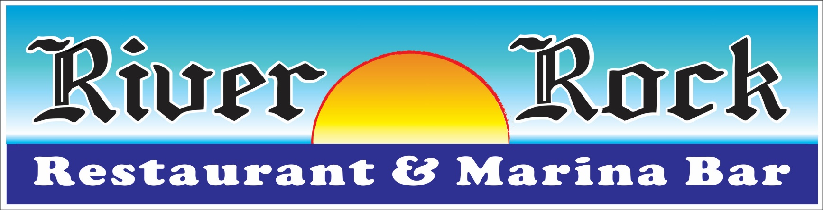
Bb ,…
“?
f

Buffet Function (Tier 1)

Choose Two (2)
Caesar Salad -Tender romaine, croutons, pecorino Romano cheese and River Rock House Caesar dressing
Mesclun Greens - Tri-colored baby mesclun greens, grape tomatoes, julienne carrots, Bermuda onion and our house poppy seed vinaigrette
River Rock House Salad - Crispy blend of iceberg and romaine, cucumber, tomato, carrots, red onion and balsamic vinaigrette

Choose Four (4)
Sweet Water Stuffed Flounder - Atlantic Flounder filled with Maryland Crabmeat and a citrus beurre blanc
Chicken Francaise - Lightly sautéed boneless breast of chicken with a white wine butter compliment
North Atlantic Salmon - Pesto-encrusted salmon fillet, slow roasted in our wood burning oven
Medallions of Beef - Tender, braised beef medallions in a cabernet shallot demi-glaze
Zuppa de Pesce - clams, mussels, shrimp and scallops in a san Marzano tomato-basil Pomodoro served over seasoned yellow rice
Fettuccini Carbonara - Sautéed Italian prosciutto, baby peas in a pecorino Romano cream sauce

Choose Three (3)
Garlic Roasted Potatoes Rice Pilaf Roasted Summer Squash
Caramelized Onion whipped Yukon Gold Potato Vegetable Medley
Carrots Coins, Pearl Onion and Broccoli Florets

Dessert
(Choice of One)
Cheese Cake
Ice Cream
Double Fudge Brownie

Beverage Table of Soda, Coffee & Tea

$28.99 + tax & gratuity
(Fri & Sat Evening – Additional $5 per person)

Add House Wine - $32.99 per bottle
Add Draft Beer - $12.99 per domestic pitcher
$15.99 per imported pitcher

Enjoy Your Event in a Private Area Overlooking the Beautiful Manasquan River
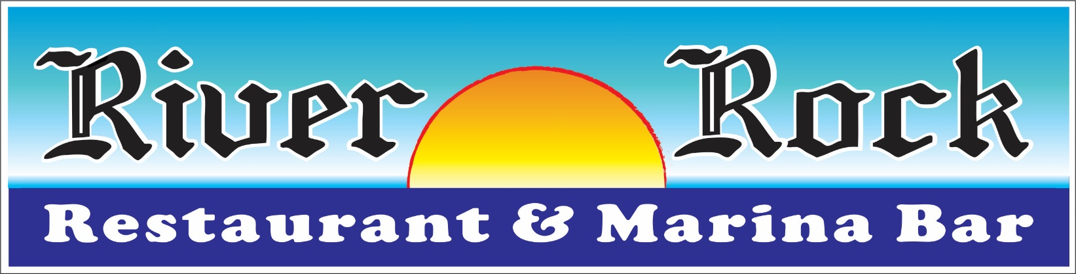

Buffet Function (Tier 2)

Choose Two (2)
Caesar Salad -Tender romaine, croutons, pecorino Romano cheese and River Rock House Caesar dressing
Mesclun Greens - Tri-colored baby mesclun greens, grape tomatoes, julienne carrots, Bermuda onion and our house poppy seed vinaigrette
River Rock House Salad - Crispy blend of iceberg and romaine, cucumber, tomato, carrots, red onion and balsamic vinaigrette

Choose Four (4)
Chicken and Broccoli Scampi - Braised tender chicken, broccoli florets, fresh herbs and penne pasta served scampi style (Garlic, lemon, white wine and butter)
Italian Sausage and Peppers - Sweet Italian sausage, roasted bell peppers and Pomodoro sauce
Penne Ala Vodka - Penne pasta, san Marzano tomato basil Pomodoro vodka sauce
Roasted Pork Loin - Spice and herb encrusted loin of pork served thinly-sliced with either teriyaki or Carolina Barbeque finish
Pasta Primavera con Alfredo - Fresh seasonal vegetables in a traditional pecorino cheese cream sauce
Golden Flounder - Semolina dusted flounder fillet with a salsa fresco compliment
Rigatoni Bolognese - Our classic take on this beef, vegetable and plum tomato rich and cream dish tossed with rigatoni pasta
Beef Burgundy – Tender beef tips cooked in a burgundy wine sauce

Choose Three (3)
Garlic Roasted Potatoes Rice Pilaf Roasted Summer Squash Vegetable Medley
Caramelized Onion whipped Yukon Gold Potato Carrots Coins, Pearl Onion and Broccoli Florets

Dessert
(Choice of One)
Cheese Cake
Ice Cream
Double Fudge Brownie

Beverage Table of Soda, Coffee & Tea

$25.99 + tax & gratuity
(Fri & Sat Evening – Additional $5 per person)

Add House Wine - $32.99 per bottle
Add Draft Beer - $12.99 per domestic pitcher
$15.99 per imported pitcher

Enjoy Your Event in a Private Area Overlooking the Beautiful Manasquan River

