CODMAN COMMUNITY FARM
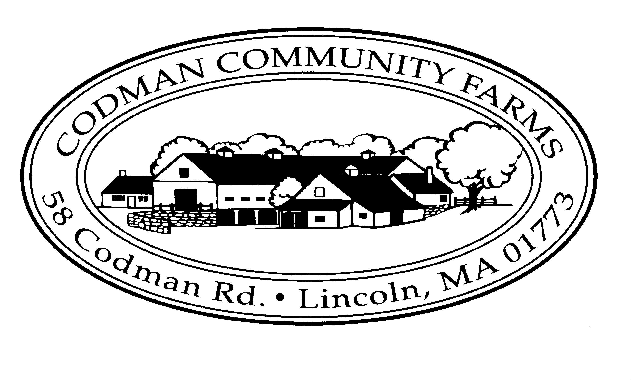
58 Codman Rd., Lincoln, MA 01773
(781) 259-0456 www.codmanfarm.org

BARN RENTAL AGREEMENT

Codman Community Farm (“CCF” or the Farm) is the property of the Town of Lincoln and is registered on the National Registry of Historic Places. Originally part of the adjacent Codman Estate, the Farm is a working farm in active daily use.

Barn “C” (the “Barn”), which measures 35’ x 78’, is an authentic, rustic barn available for rent to Codman Community Farm members for evening events. Rental of the Barn entitles the Renter to the use of the interior of the Barn, the Barn’s kitchen facilities (limited use as described below), and on-premises parking (in designated areas). Renters may also erect a tent outside of the front barn doors to the Barn.

All of the Farm’s activities take place even on days when the Barn is rented for events. Visitors to the Farm, including families with children as well as volunteers who feed the animals and collect eggs, are typically present on the Farm until closing time (generally 6:00pm daily). The Farm Store, located inside the Barn, is open 24 hours. Customers are encouraged to access the store through a separate entryway to avoid coming into contact with event guests.

All inquiries about dates available for renting the Barn should be directed to the Farm by emailing: barnrentals@codmanfarm.org.

TERMS AND CONDITIONS OF RENTAL

After CCF accepts a rental application from a Renter and the two parties agree on and commit to a date for an event, the Renter agrees to be bound by the following terms:

- AVAILABILITY: The Barn is available for rent on weekend and weekday evenings (between 4pm and 12pm, inclusive of set up and cleanup) from May 15th to October 15th pending the approval of CCF staff.

- CAPACITY: The maximum capacity of the Barn, including occupancy of a tent that Renters may choose to bring and erect outside of the Barn, is 100 people.

- RENTAL FEE of $2,150: This fee covers rental of the Barn; pre-event and event coordination and on-site management during the event; cordoning off parking areas and putting up parking signs before event; and removing bagged trash and recycling after the event. (CCF requires that a licensed and insured bartender either provided by Renter’s caterer or JP Neri Professional Services serve any and all alcohol offered at events.)

- IN ADDITION: The Town of Lincoln requires that a Lincoln Police Detail is present at events at which alcohol will be served. (Arranging and paying for the Police Detail are the responsibility of the Renter as noted below in Section 5, Additional Fees.)

- TIME FRAME: The rental period is for eight (8) hours, including access to the Barn for set-up prior to the event and break down/clean-up of the Barn following the event. All events must end by 11:00pm. CCF must approve the rental time frame prior to booking the event.

- ADDITIONAL FEES:

  - Security Deposit: A $500 security deposit is due upon confirmation by CCF and the Renter of the date of the event. The Security Deposit will be refunded provided the requirements in Section 12 (Trash) are satisfied.

  - Police and Fire Details: Due to the historical nature of the Farm and the structure and materials in the Barn, the Town of Lincoln requires that a Lincoln Fire Detail be present during all events. Arranging and paying for the Lincoln Fire Detail are the responsibility of the Renter. If alcohol is going to be served, the Town of Lincoln requires that a Lincoln Police Detail be present. Arranging and paying for the Police Detail are the responsibility of the Renter.

  - JP Neri Professional Services: Arranging and paying for JP Neri are the responsibility of the Renter. Contact is Leo Lafarge @ 617-935-1169 or bluesuedeleo@comcast.net

- PAYMENT: 50% rental deposit is due (check made payable to Codman Community Farms) with your signed application. The balance is due in full two (2) months before the event.

  - A $200 administrative fee will be charged for any events cancelled within (1) one month of an event. Refunds within the one-month period will be made at the discretion of CCF.

- THE PREMISES: Rental of the Barn entitles the Renter use of the interior of the Barn (including two restrooms, one of which is handicapped accessible), the Barn’s kitchen facilities (limited use as described below under “Food Preparation”), and on-premises parking (in areas designated on the day of the event). If they wish, Renters may also bring and erect a tent immediately outside the front doors to the Barn.
  - Renters and their guests are welcome to walk around the Farm during events until dusk.
  - Children must be supervised at all times.
  - Renters, their guests and service providers assume all risk in the use of these premises.
  - All exits shall remain free from obstructions at all times.
  - The Barn floor will be swept clean and will be free of equipment on the day of the event.
  - Smoking, open flames, or candles of any kind are strictly prohibited at all times at CCF. Renters may bring in and use battery operated luminaries.
  - There is no access to the Barn’s lofts, to the rear section of the Barn, animal pens below or in buildings adjacent to the Barn, other buildings on the Farm (including smaller barns housing animals and equipment and the Sugar Shack), to the Farm House (a private residence), or the Farm’s offices adjacent to the Farm’s kitchen. Climbing in lofts, on hay or on equipment is prohibited.

- FOOD PREPARATION: All food must be prepared off-site. Renters and/or their caterers may use the Barn’s kitchen as a staging area only. The Farm’s kitchen equipment/appliances (e.g., ovens, stove tops, and refrigerators) are not available for use by Renters, their caterers, or other service providers.

- CATERERS: Caterers must be licensed and must carry a minimum of $1,000,000 General Liability Insurance that covers the function, and must file a Certificate of Insurance with Codman Community Farm two (2) weeks prior to the event.

- ALCOHOL: If alcohol is to be served, CCF requires that Renters use a licensed and insured bartender. Renters may use a licensed and insured bartender covered under their caterer’s insurance policy provided the caterer has $1,000,000 in bartending liability. However, neither the Renter nor their caterer may sub contract bartending services from a party not covered under the caterer’s insurance and license. If Renters are not using a caterer who provides this service and they wish to serve alcohol, Renters must use John P. Neri Professional Services, a licensed and insured bartender familiar with the Barn and CCF. In addition:
  - No alcohol is to be placed on tables for communal consumption.
  - A Lincoln Police Detail is required to be obtained and paid for by the Renter.
  - Consumption of alcohol must end 30 minutes before event ends.

- TABLES AND CHAIRS: CCF has tables and chairs Renters may reserve at least (1) one week prior to the event for $100. CCF will set up and break down the tables and chairs prior to/after the event. If the Renter plans to rent tables and chairs elsewhere, delivery times and set-up should be coordinated with CCF staff at least (1) one week prior to the event.

- TRASH: The Renter must collect and bag all trash, including all recyclable materials such as bottles and cans. Trash and recyclables must be bagged separately for CCF to remove at the end of the event. In addition, the Renter is expected to leave the Barn and the premises in good condition at the end of the event and must remove all personal items from the Barn and the Farm, including all items delivered by Renter’s service providers. Failure to comply with these requirements may result in the loss of the Security Deposit.

- MUSIC: Any music must be played at a volume respectful of the neighbors. Music must stop at 10:45pm.

- LIABILITY: The Renter assumes personal liability for the function. Renters will be responsible for, and reimburse Codman Community Farm and/or the Town of Lincoln for any loss, damage or injury to the buildings, their contents, grounds, equipment, or any person, arising out of/or in connection with their use of the premises. Renters agree to indemnify and hold the Town of Lincoln and Codman Community Farm harmless from and against any liabilities, damages, claims or expenses (including reasonable attorney’s fees and court costs) arising out of/or in connection with use of the premises or from any violation of the terms of this agreement.

- CANCELLATION: As noted above in Section 7 (Payment), CCF will charge a $200 administrative fee is for any events cancelled by the Renter within (1) one month of the date of the event. Refunds within the two-month period will be made at the discretion of CCF. CCF reserves the right to cancel the Renter’s function at anytime, even while it is in progress, should the Renter or any of the Renter’s services providers or guests violate terms of this agreement. This cancellation may be at CCF’s sole discretion. This decision will be binding and final. In such cases, CCF shall retain all payments and shall not be liable for any charges or forfeited deposits imposed by the Renter’s caterer, dealer, or other service providers.

- ENDING TIME: All events must end no later than 11:00pm.

This agreement will not be in effect until a date has been agreed to and reserved by CCF and the Renter for the event, both parties have signed this agreement, and separate checks for the rental deposit and security deposit have been provided by the Renter to CCF.

______________________________________________ ______________________________________
Date of Event Type of Event

Will alcohol be served? Yes/No (circle one)

______________________________________________ ______________________________________
Name of Renter (Please Print) Renter’s Phone Number

______________________________________________ ______________________________________
Signature of Renter Date

______________________________________________ ______________________________________
David Alperovitz, CCF Board President Date

