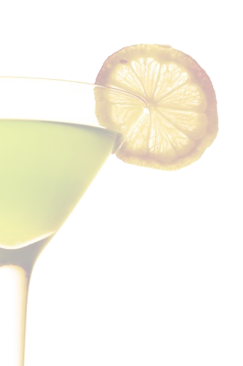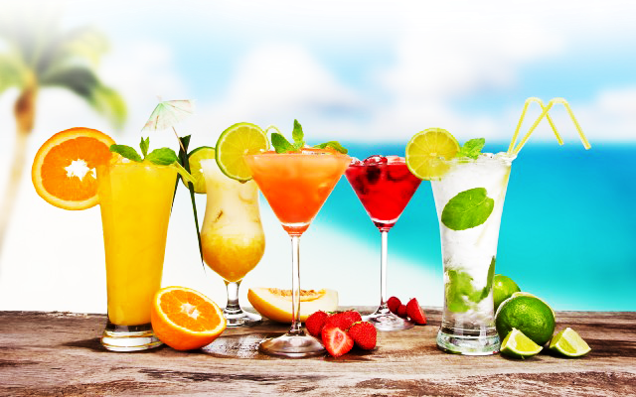

Mocktailsdss

Purple People Eater

Blue Hawaiian Punch & Cranberry Juice topped with Sprite, Sugared Rim,

garnished with Lime Slice

Sweet Sunrise

Orange Juice and Sprite, a splash of Grenadine, garnished with a Sugared Rim and an Orange Slice

Sparkling Cider

Pressed Apples with just the right amount of Bubbles

Mock Mimosa

Sparkling Cider and Orange Juice a Sugared Rim and a Slice of Orange

Orange Paradise

Orange Juice and Pineapple Juice, a Sugared Rim, Garnished with

a Pineapple Wedge

Pink is In

Sprite, a splash of Cranberry Juice garnished with Lime

Green with Envy

Lemonade & Blue Hawaiian Punch, a Sugared Rim, garnished with an Orange Wheel

Luxardo Maraschino Cherries

***Mocktail Menu***

Shirley Temple or Roy Rogers

Ginger ale or Coca-Cola with a generous splash of Grenadine, garnished with Maraschino Cherries