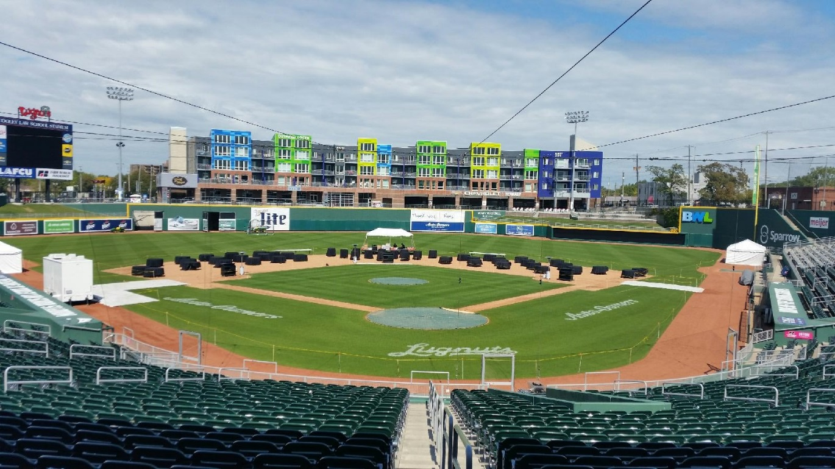

Outdoor venues are all the rage! Host your Wedding rehearsal, ceremony, and reception in OUR back yard!!

Cooley Law School Stadium – Downtown Lansing

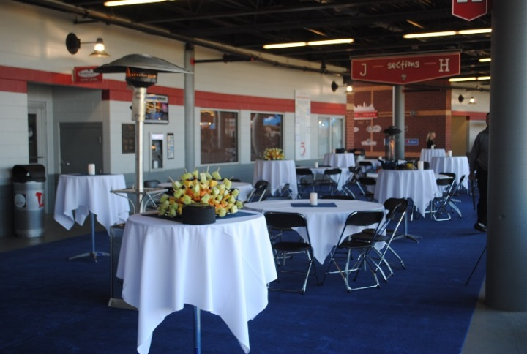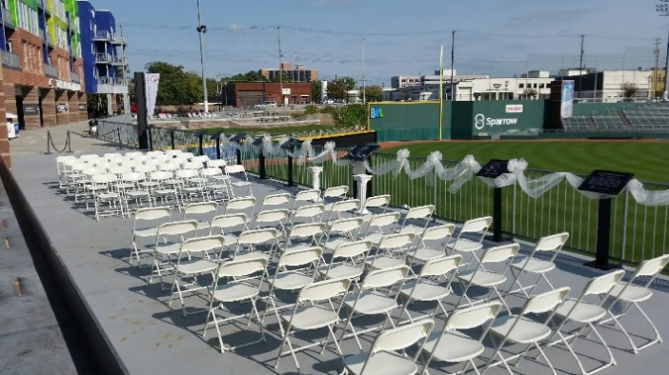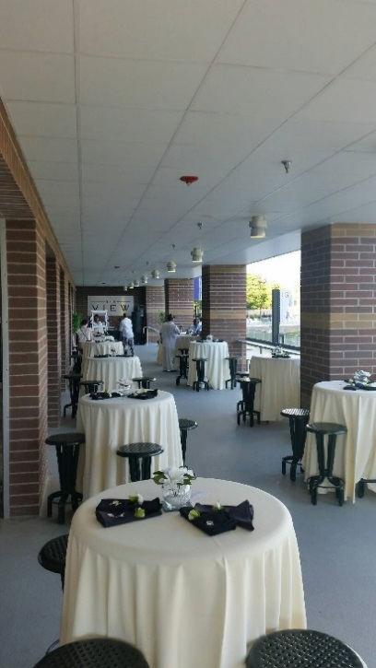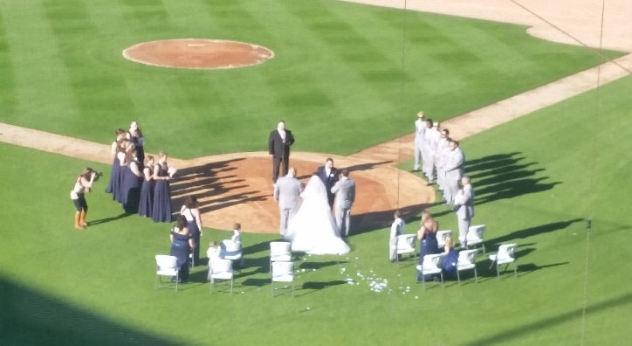

Patio at the VIEW & Good Hops

40-80 guests

Party on the Concourse

100-750 guests

Dinner on the Diamond

200-500 guests