

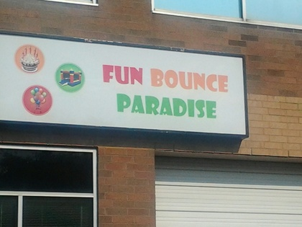 **4425 FITCH AVENUE, BALTIMORE MD. 21236**  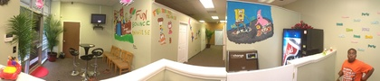

**🕿: 443-902-9032 Visit us on funbounceparadise.com e-mail:** [**funbounceparadise@gmail.com**](mailto:funbounceparadise@gmail.com)

**[](http://bounceplayworld.com/images/gallery/photos-02.JPG) [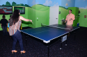](http://bounceplayworld.com/images/gallery/photos-51.jpg) [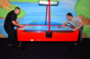](http://bounceplayworld.com/images/gallery/photos-60.jpg)**  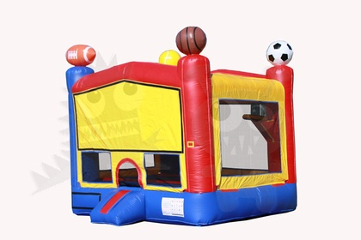 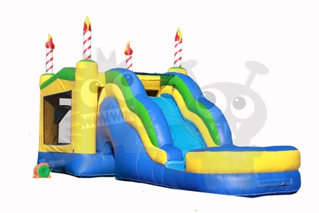

**ADULTS NIGHT OUT!!!  BYOB**

**EVERY 2ND SATURDAY OF THE MONTH**

**Adults get to bounce and play in our game room.**

**FROM 9:00PM - 2:00AM**

**Entrance Fee - $15.00 (PIZZA + SODA)**

**CALL 443-902-9032 TO RESERVE**

(limited space available for adult bounce & play party)