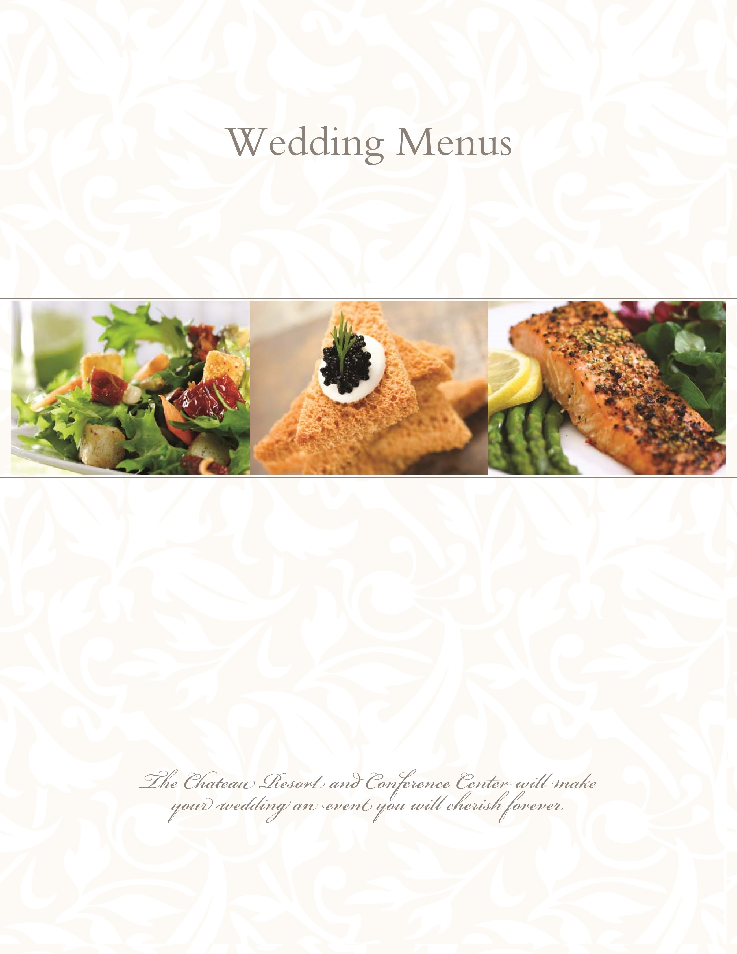
P
A llow our professional wedding consultants to assist you with your special day.
We invite you for a personal consultation and private tour.
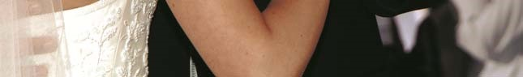

Exclusive Features
Two elegant ballrooms
Complimentary suite for the bride and groom
All inclusive packages
Choice of four course served dinner, buffet dinner, or hors d’oeuvres reception
Private rooms and savings for your rehearsal dinner, or bridal shower

Thank you for your interest in the Chateau Resort and Conference Center

All Wedding Packages Feature the Following:

Butler passed Hors d’oeuvre Reception for One Hour
Champagne or Sparkling Cider Toast for all guests
White glove service
Cake cutting service
Optional cocktail arrangements: light, open, or cash bar
Private hospitality suite for the bridal party upon arrival
Complimentary suite with Champagne for the bride and groom
Complimentary breakfast for the bride and groom Preferred room rates for your out of town guests
White Floor Length Tablecloths
White Chair Covers
Hotel Centerpieces
Champagne Toast for all Guests
Premium Wine Service
Premium Liquor Service

-

Begin with a Social Hour

– Unlimited for one hour

Butler Passed and Stationed Hot Hors d’oeuvres
-Please select two-
Beef Brochettes
Petite Chicken Cordon Bleu
Swedish Meatballs
Italian Meatballs
Petite Franks in a Blanket
Miniature Spring Rolls
Petite Quiche Lorraine
Spinach and Cheese in a Phyllo Pastry
Baked Brie in a Phyllo Pastry with Raspberry Sauce
Chicken Satay
Chicken Quesadilla Cornets
Spinach and Mozzarella Cheese Stuffed Mushrooms
-Please select one
Crab Stuffed Mushroom Caps
Scallops Wrapped in Bacon
Coconut Shrimp
Beef en Croûte
Cold Hors d’oeuvres
-Please select two
Pesto Chicken Crostini
Sliced Fresh Fruit Presentation with Raspberry Yogurt Dip
Vegetable Crudites with Ranch Dip
International Cheese Cubes and Crackers with Mustard
Tomato and Roasted Red Pepper Bruschetta

Elegantly Plated Dinners

Appetizer Selections
-Please select one-
Honeydew Melon with Prosciutto
Penne Pasta in Sun dried Tomato and Shitake Cream Sauce
Seasonal Fresh Fruit and Berries
Strawberries Zabaglione
Mini Crab Cake with Pesto Mayonnaise and Roasted Red Pepper Coulis

Salad Selections
-Please select one- Tossed Salad
Caesar Salad
Vine Ripened Tomato, Mozzarella, and Basil over Mesclun Greens
Hearts of Romaine with Gorgonzola Cheese and Poached Pears in Orange Cognac Vinaigrette
Mixed Greens with Boursin Cheese, julienne Red Onion, and Roasted Red Peppers, Arugula, Pear, and Pecan Salad with crumbled Blue Cheese and Sweet Vinaigrette

Starch Selections Vegetable Selections
-Please select one- -Please select one-
Twice Baked Potato Broccoli Florets
Chive and Garlic Mashed Red Bliss Potatoes Honey Glazed Carrots
Long Grain Wild Rice, Rice Pilaf Green Bean, Wax Bean, and Carrots Roasted New Red Potatoes Broccoli, Cauliflower, and Carrot Blend

Accoutrements
Fresh Rolls and Butter
Fresh Brewed Coffee, Decaffeinated Coffee, Flavored Hot Teas,
& Iced Tea

Elegantly Plated Dinners

Plated Entrée Selection

Silver Entrée Selections
-Please select two-
Honey Mustard Chicken Breast
Seafood stuffed Fillet of Flounder
Sautéed Chicken Piccata or Francese
Sliced Sirloin of Beef Bordelaise
Chicken Shitake
Pork Loin with a Mushroom Cream Sauce
Almond crusted Tilapia with a Mango Salsa
Baked Chicken with Traditional Bread Stuffing

Gold Entrée Selection
Chicken Cordon Bleu
Grilled Salmon with Lemon Dill Beurre Blanc
Slow Roasted Sirloin with Brandied Green Peppercorn Demi-Glace
Petite Beef Filet Mignon and Jumbo Stuffed Shrimp
Shrimp and Jumbo Scallops Scampi over Linguini
Stuffed Chicken Felix
(stuffed with asparagus, crabmeat and imported cheeses)
Herb Crusted Chicken Breast with a Mango Salsa
Twin Tornadoes of Beef with Demi-Glace and Béarnaise Sauces

Platinum Entrée Selection
Beef Wellington
Chicken Oscar
Broil Lobster Tail
Veal Chops with Mushroom Marsala

Grand Buffet Dinners

Salad Selection
-Please select three-
Antipasto Tray; Caesar Salad
Pasta Primavera Salad; Red Skin Potato Salad, Basil, Tomato, and Fresh Mozzarella Salad
Tossed Green Salad; Fresh Mixed Fruit Salad
Hand Carved Selection  -Please select one-  Roast Turkey Breast with Country Gravy  Baked Ham with a Mango Chutney  Sliced Sirloin of Beef Bordelaise | Specialty Carved Selection  -for and additional $5.00 per person per item-  Herb Crusted Pork Loin with Rosemary jus Lie  Slow Roasted Prime Rib au Jus  Leg of Lamb with Mint Jelly and Pan Jus

Entrée Selection
-Please select two-
Beef Tips with Onions and Peppers in Demi-Glaze
Grilled Pork Loin with Caramelized Apples and Onions
Broiled Haddock Provencal, Grilled Salmon with Dill Sauce
Roast Turkey with Traditional Stuffing, Chicken Jerusalem
Honey Mustard Chicken, Chicken Marsala, Chicken Piccata
Seafood Newburg with Rice, Crab Stuffed Fillet of Flounder
Starch Selection  -Please select one-  Roasted Baby Red Potatoes  Chive and Garlic Mashed Potatoes  Long Grain Wild Rice, Rice Pilaf | Vegetable Selection  -Please select one-  Broccoli Florets  Honey Glazed Baby Carrots  Broccoli, Cauliflower, and Carrot Blend

Accoutrements
Fresh Rolls and Butter
Fresh Brewed Coffee, Decaffeinated Coffee, Flavored Teas, and Unsweetened Iced Tea

Hors d’oeuvre Reception

Stationed Hors d’oeuvres
-Unlimited for two hours-
Mirrored Presentation of Cheese and Crackers with Mustard
Mirrored Presentation of Fresh Fruits with Raspberry Yogurt Dip
Crudités Vegetables with Ranch Dip

Hand Carved Items
-Please select one-
Roast Turkey Breast with Country Gravy
Baked Ham with a Mango Chutney
Sliced Sirloin of Beef Bordelaise
,

Premium Hors d’oeuvre Selections
-Butler passed and stationed-
-Please select one- Coconut Shrimp
Beef en Croûte
Crab Stuffed Mushroom Caps
Scallops Wrapped in Bacon
Petite Chicken Cordon Blue Bites
Antipasto Platter with Stuffed Salami Cornets
Baked Brie in a Phyllo Pastry with Raspberry Sauce
Additional Hors d’oeuvres
-Please select four-

Italian Meatballs
Swedish Meatballs
Miniature Spring Rolls
Assorted Petite Quiche
Chicken Quesadilla Cornets
Spinach and Cheese in Phyllo
Chicken Satay
Fried Mozzarella
Cheddar Jalapeno Poppers
Beef or Chicken Brochettes
Spinach Stuffed Mushrooms

Bar Options

Open Bar
-Unlimited for four hours-
Call Brand Liquors, Imported and Domestic Beer, Wine and Soda
Skky Vodka, Beefeaters Gin, Bacardi Rum, Jose Cuervo Gold Tequilla, Seagrams 7 Whiskey, Johnnie Walker Red Scotch, Jack Daniels Whiskey, Jim Beam Bourbon, Domestic & Domestic Light & Imported Beer, Chardonnay, Cabernet Sauvignon & White Zinfandel Wines

Light Bar
-Unlimited for four hours-
Imported and Domestic Beer, Non-Alcoholic Beer, Red & White Wine and Soda

Cash Bar
-Beverages sold by the glass-
Includes open bar selections and can be tailored to your wishes
Premium liquor packages are available on open bar arrangements
Absolute, Tangueray, Bacardi & Captain Morgan, Petron, Crown Royal, Dewar’s, Southern Comfort, Jim Beam, Domestic, Domestic Light & Imported Beer, Chardonnay, Cabernet, Merlot, White Zinfandel & Pinot Grigio

Wedding Package Prices
Open Bar Light Bar | Cash Bar
Silver Plated Dinner Package $90 $80 | $70
Gold Plated Dinner Package $100 $90 | $80
Platinum Plated Dinner Package $110 $100 | $90
Buffet Dinner Package $105 $95 | $85
Hors d’oeuvre Package $85 $75 | $65
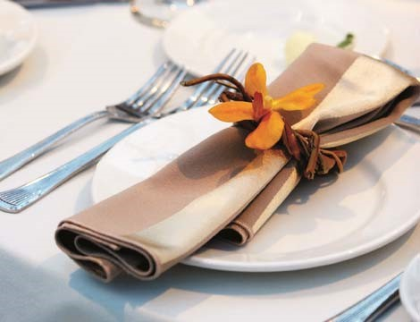
-Price per person -

Package Price List

Price is per person and subject to 22% service charge and 6% PA state tax.
Choice of three entrees are available for an additional $3.00 per person on plated dinners.
Buffets are limited to one and a half hours.

Cash Bar and Host Bar Drink Prices
Call Brands $7.50 Top Shelf or Cordials $8.50
Domestic Beer $5.00 Imported Beer $6.00
Wine $8.00 Soft Drinks $2.50

Prices are based on a per drink basis. All cash bars and host bars are subject to a $150.00 fee per Bartender (maximum of 4 hours) plus 22% Service Charge and 6% tax.
