Silver Cocktail Party Menu

Cool choices
- Fresh Mozzarella & Grape Tomato Sticks w/Basil Pesto (V) (GF)
- Fava Bean & Avocado Bruschetta w/ pecorino (V)
- Zucchini boats w/ babaganoush & roasted heirloom tomatoes(GF)(V)
- Bruschetta w/ Tapenade (V)
- Canapes with Prosciutto, Brie, Fig jam
- Shrimp & Cucumber skewers w/Soy Glaze (GF)
- Devilled Eggs w/Pickled Shallots & Parsley (GF)

Warm choices
- Vegetarian slider w/fried green tomato, mozzarella, basil aioli (V)
- Baby Potatoes with Aioli (GF) (V)
- Mediterranean Tart – w artichokes, olives & parmesan (V)
- Baked Brie w Cranberries on a canape (V)
- Thai Shrimp Cakes w/Lemongrass Dressing & Alfalfa (GF)
- Smoked Salmon Rose on Crispy Potato Pancakes (GF)
- Assorted Mini Quiche –Spinach & Feta, Potato & Bacon, Roast Red Pepper
- Asian Chicken Sticks w/Sweet Chilli Dressing (GF)
- Bacon Wrapped Apricots (GF)
- Thai Turkey Meatballs w/Satay Dressing (GF)
- Chorizo, Mushroom & Red Pepper Kabobs (GF)
- Pigs in a Pretzel w/Bavarian Mustard
- Mediterranean Meatballs w/Sun Dried Tomato Dressing (GF)

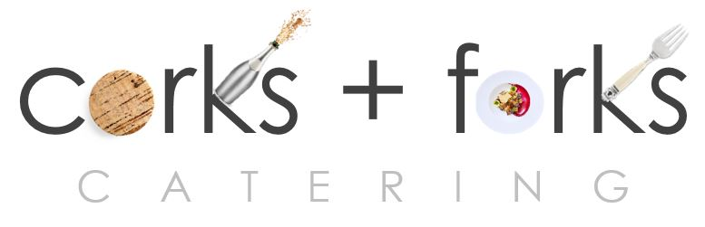

PO Box 8762 WPB FL 33407 PH: 561 339 2444
www.corksandforkscatering.com

