2020 Wedding Pricing
 | April 1 – November 6 | November 7 – March 31 | Holiday Weekends**
Monday-Sunday | $4,000 | $3,500 | $5,000

*Above pricing does not include a 15% administration fee
Package is Inclusive of the following:
The wedding party has exclusive use of the Vineyards, Lawn, Barrel room, Library and Lower patio 11am-11pm.
(6) 8’ Round Dining Tables
(4) 6’ Round Dining Tables
(10) 4’ Square Dining Tables
(3) 6’ Rectangle Dining Tables
(6) 8’ Rectangle Dining Tables
(60) Upholstered Dining Chairs
(40) Woven Chairs
(2) Oak Wine Barrels for ceremony
Bridal Suite for entire day and to be used as a honeymoon suite overnight
Groom’s area for groom and groomsmen morning of the wedding
Onsite venue manager, present through the entire day

Main Winery, Tasting Room and Tap Room will be open to the public:
Sunday-Wednesday 10am-6pm & Thursday-Saturday 10am-9pm.
Optional for an additional fee:
Tasting room can remain open for your guests $500
Prince Michel etched logo wine glasses as favors for your guest $3/glass

Prince Michel Venues

The Vineyard
Nestled just outside the main winery, this romantic vineyard setting is accommodating for up to 100+ guests.

The Patio
The Patio is the perfect cozy spot for a smaller intimate wedding or cocktails of less than 50 people.

The Lawn
Surrounded by the beauty of the Blue Ridge, the Lawn accommodates 100+ guests.

The Wine Barrel Room
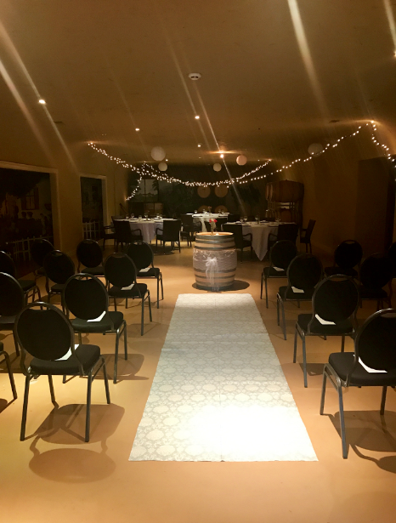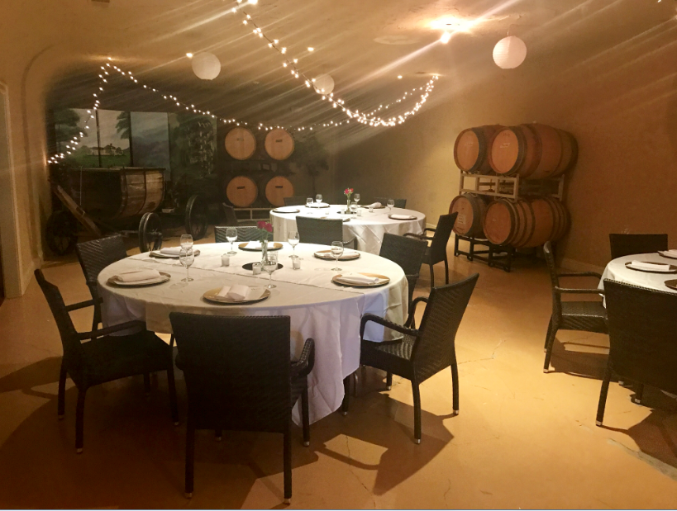
Our Barrel Cave comfortably seats up to 90 guests and can be used in many different ways from ceremony to reception.

The Bridal Suite
Our Bridal Cottage allows the bride and her bridesmaids to relax and pamper themselves on the day of the wedding.

The Groom’s Suite
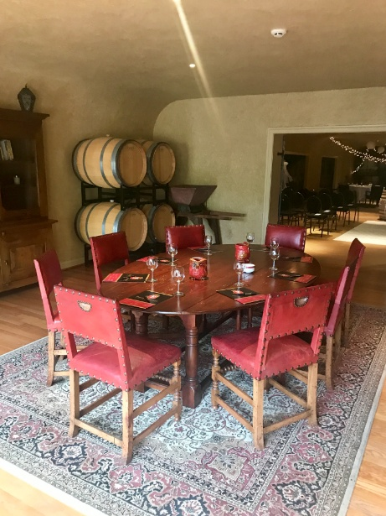
Our Groom’s Suite is the perfect laid back spot for the groom and his groomsman to relax the day of the wedding.

Prince Michel Frequently Asked Questions:

Do you have an event coordinator?
No we do not offer an event coordinator, but you will have a Venue Manager who will make sure your day runs as smoothly as possible. They will coordinate your rehearsal and ceremony.

How long do we have access to the facility?
You are allotted a 12 hour time frame (11am-11pm). Additional hours will be billed at $500 per hour. Music must be cut off by 10:30pm. The facility is exclusively yours from 6:00pm until 11:00pm.

When can we get into the Bridal Suite and Groom’s Suite?
The Bridal Suite and Groom’s Suite is yours starting at 11:00 am. Bridal suite will to be used overnight as a honeymoon suite as well.

What if I want my ceremony earlier?
With approval by the Venue Manager, you may move your ceremony up to one hour before the allotted time for an additional $500.

What is the payment schedule? 50% of venue rental fee is due upon signing of the contract. Balance due no later than 60 days prior to wedding. Final bar bill is due at the end of the event.
What is the cancellation policy? The deposit is non-refundable unless we are able to rebook the date. If we are able to rebook the date, the deposit will be refunded minus a $200.00 processing fee. Final payment is due in full 60 days prior to the wedding date. Once final payment is made, there are no refunds.

What happens if it rains the day of my wedding?
By 12:00pm the day prior to the wedding we make the call whether to tent your ceremony or move it indoors. Tent rental will be your responsibility. If you choose not to go with a tent, our indoor space is versatile!

Must I use vendors of your choosing?
We highly recommend all of the vendors on our list, but you are free to hire the professional of your choosing. Your caterer is responsible for all event setup, breakdown and cleanup. All vendors must have proper licensing.

Do you have any restrictions on decorations?
You are more than welcome to bring in any décor items you would like, although hanging is restricted from our ceiling. Décor must be approved by Venue Manager prior to the wedding date.

Can we set up lawn games for our guests to play? Yes, our lawn provides the perfect setting for lawn games. You can bring your own or you can rent games that we have available. Lawn games must be approved by Venue Manager prior to the wedding date.

What alcohol can be served at my wedding?
All wine and cider must be purchased from Prince Michel. No liquor is allowed.

How do we order wine for our event? One of the Tasting Room Managers will meet with you prior to the event and conduct a tasting of the wines, where you will make your choices. There is a two case minimum, with payment due 2 weeks days prior to the event. There are no returns on your original order. Additional wine is available for purchase and will be on hand if needed the night of your event. Payment is due for this wine at the completion of the event, either by check or credit card.

Is there enough parking?
We have plenty of parking that can accommodate all your guests and buses.

Are tents included in the price or do they cost extra? Tents are not included; they must be rented through the rental agency.

Will there be another wedding at Prince Michel on the same day as mine?
Never! We only schedule on wedding per day to ensure 100% attention to your big day.

May I schedule a rehearsal?
Yes, you are allotted one hour for rehearsal. Please contact your Venue Manager to schedule your rehearsal.

When do I need to give a headcount? Two weeks prior to the event.

