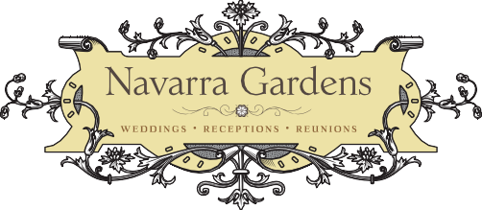

Navarra Gardens Helpful Bridal or Special Event Q & A

Q: When can we schedule a tour of the venue?
A: By appointment, Friday through Sunday are our preferred appointment times, but we will try to accommodate special requests.
Q: Do we have to use your vendors?
A: NO. We try to help keep your expenses in line with your budget allowing you to find your fit and style.
Q: Do you have someone who can assist with the planning?
A: Yes, we can arrange 3hrs of one on one assistance at a flat rate of $250 ($60 each additional hour)
Q: Can we use your gorgeous grounds for an engagement or other type of photo shoot?
A: Absolutely depending on time required, prices start at $75.00 for a full day or $50.00 for two hours
Q: Is alcohol allowed at venue?
A: Yes, you can bring and serve alcoholic beverages with the proper OLCC licensed servers (for private no charge events).
Q: Are there any additional fees we need to be aware of?
A: No, our paperwork spells out our basic or package fees there are no additional taxes or fees levied. Tips at guest discretion
Q: What hours do we have access to the venue the day of the event?
A: 9am – Dusk. Our team starts around 7:00 am setting your custom venue layout, the goal is to have it ready for your 9:00 am arrival.
Q: Can we plan a wedding rehearsal on site?
A: Yes, however, for a flat fee of $130.00 we can accommodate this request, by offering the Air B n B/ Bridal Cottage rental to our brides the day prior to the big event. Check in is at 3:00 PM and venue is made available to you at no additional charge. Couples and guests find this option an amazing tool and stress reducer for brides and family. (price includes overnight stay for four guests - additional guests $25 per person)
Q: What happens if it rains?
A: Exciting news! Our 4200 Sq.Ft. Event Center, that has two gigantic pairs of 20” doors either-end that open to vistas, is now available for smaller groups, there are also 20” covered patios either end. Two ADA bathrooms and a half kitchen are also available, along with a Studio apartment for guests or family use Fees subject to usage. Minimum fee for bathroom only usage $500.00.
Q: Do you have decorations available at the venue?
A: We do have some fun reasonable items we keep on hand for rent; wine barrels, wooden ladders, bishop hooks, lanterns, tiki torches, speaker/PA unit, and including, wine glasses and tumblers Chaffing dishes with Sterno’s, serving platters, and dishes, and catering items, (including wine & water glasses, full sets of dishes for up to 35 guests, most item pricing from $30.00 - $60.00
Q: Do you have someone who can assist with the planning?
A: Yes, we can arrange 3hrs of one on one assistance at a flat rate of $300. ($60 each additional hour)
Q: do you provide food on site?
A: Yes, we can provide Pizza, Salads and Charcuterie Boards on our barrel hoop trays
Q: My parents’ anniversary, can we come to celebrate an intimate milestone in our lives?
A: Yes, we love to host customized memorable events – even celebrations of life. We have been honored to host intimate dinners, family reunions and celebrations of life

