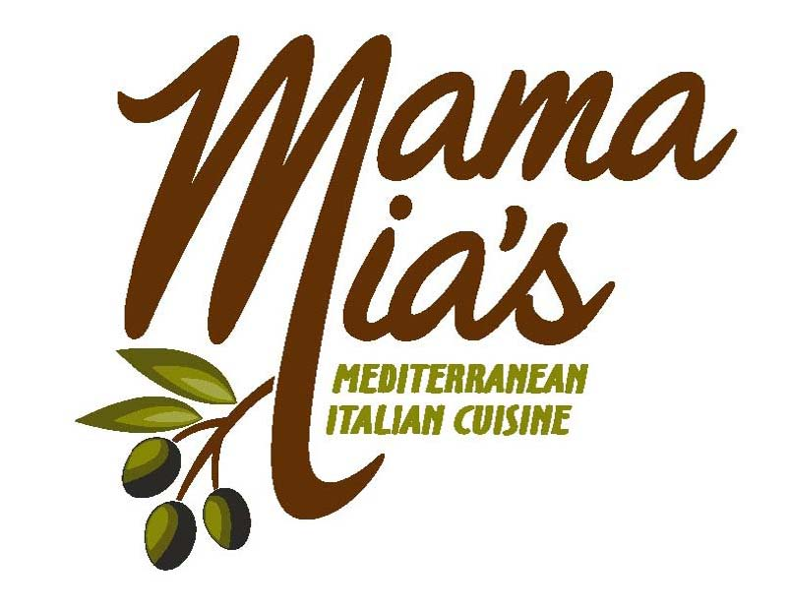
Appetizer Platters
Each Tray/Half Pan Feeds 15-20
(Tax and Gratuity not included)

Sausage Rollatini $ 75.00
Hand tossed pizza dough rolled with Italian sausage, onions and bell peppers

Bruschetta $ 40.00
Traditional tomato, garlic, onions and basil served w/ seasoned crostinis
Balsamic and served with crostinis

Chicken Roll $ 75.00
Breast of chicken, pesto, bell peppers and cheese rolled in
Hand tossed pizza dough then sliced

Caprice $ 75.00
Buffalo mozzarella, fresh tomato and basil drizzled w/ balsamic

Mediterranean Delight $ 50.00
Garlic Hummus, Baba Ghanoush, Toubouli and Tzaeke.
Served with crostinis & flat bread

Teriyaki Meatballs
Half Pan - $ 75.00 Full Pan - $120.00
Beef meatballs with a homemade teriyaki glaze

Sautéed Mushrooms HP - $ 75.00
Sautéed with garlic, onions, tomatoes and scallions in a Marsala cream sauce

Pot Stickers Half Pan - $75.00
Vegetable or Pork Pot Stickers made with our own special sauce

Potato Skins
Half Pan - $88.00 Full Pan - $145.00
Baked and Stuffed with bacon, cheese, and chives, served with sour cream

Hot Wings
Half Pan $ 88.00 Full Pan - $145.00
Chicken wings fried, and tossed in mango habinero sauce served w/ ranch

Hot Spinach and Artichoke Dip QP $ 53.00
Hot Dip served with homemade crustinis

Appetizer Platters
Each Tray As Shown
(Tax and Gratuity not included)

Cheese Display $ 165.00 – Serves 50 People
Domestic and imported cheese, including pastry wrapped brie with a hint of honey, candied pecans, craisins served with seasoned crostinis and baguettes

Meat Platters $ 160.00 - Serves 50 People
Ham, Salami, Prosciutto, Roast Beef, Marinated Mushrooms

Seasonal Fruit Display
$ 85.00 – Serves 40 People

Vegetable Tray
$ 60.00 - Serves 40 People

Grilled Eggplant $ 75.00 - Serves 30 People
Grilled eggplant, feta, sun-dried tomatoes, capers and red onions
Drizzled with balsamic

Antipasti Platter $ 140.00 - Serves 50 People
Grilled veggies including eggplant, marinated mushroom, artichoke hearts zucchini kalamata olives, peppercinis, salami & sliced baguettes

Marinated Seafood $ 165.00 - Serves 50 People
Mussels, shrimp, clams and fish, marinated in a wine and garlic sauce

Baked Smoked Salmon Platter $ 195.00 - Serves 25 People
Baked filet of salmon, with capers, lemon, and tomato garnish

Jumbo Shrimp Cocktail $140.00 - Serves 40 People
Jumbo Prawns served with fresh lemon and spicy cocktail sauce

Teriyaki Chicken Bites $ 85.00 - Serves 30 People
Baked chicken bites smothered with teriyaki glaze

Salads
$ 3.50 per Person
(Tax and Gratuity not included)

Traditional Caesar Salad.
Romaine lettuce with two types of parmesan cheese, croutons, and homemade Caesar dressing
Organic Green Balsamico
Mixed Greens served with fresh carrots. Served with two choices of dressing.
Fattoush salad
A harmonious mix of romaine hearts, tomatoes, cucumbers, fresh mint, red onion, bell peppers cilantro and croutons in a lemon Sumac dressing.
GREEK SALAD

Romaine lettuce, cucumbers, tomatoes, artichoke hearts, red onion, croutons, feta cheese kalamata olives & peppercinis served with Greek dressing
Mediterranean SALAD

Romaine lettuce, breast of chicken, orange slices, craisins, onions & red bell peppers, with a citrus vinaigrette.
SPINACH SALAD

Baby spinach, feta cheese, and candied walnuts, red bell peppers drizzled with vinaigrette.
Pasta Salad
Fussily pasta with red bell peppers, black olives, celery, and red onion topped with parsley
Potatoe Salad
Red Potatoes, hardboiled egg, red bell peppers, celery in a tangy mayo and mustard whip.

Garlic Bread and Rolls
Homemade Rosemary rolls $ 4.75 for 10 rolls
Garlic Bread $ 8.00 per Loaf

Dinner Options

Half Pan feeds 15-20 PEOPLE

Full Pans Feed 25 -30 People
(Tax and Gratuity not included)

Salmon GENOVESE - HP – $ 120 FP – $ 210
Filet of Salmon with lemon butter, capers, and artichoke sauce served with Penne Pasta

Chicken Jerusalem HP – $ 120 FP – $ 210
Chicken tenders with artichoke hearts, mushrooms and white wine cream sauce

Mediterranean Chicken HP – $ 120 FP – $ 210
Breast of chicken with garlic, scallions, artichoke, red bell pepper and kalamata olives in a lemon butter sauce

Chicken BERNARDO HP – $120 FP – $ 210
Chicken tenders sautéed with garlic, and olive oil tossed with broccoli, tomatoes, parmesan
Moranan chicken HP – $ 120 FP – $ 210 Chicken breast sautéed with seasonal vegetables, green onions, tomatoes, chick peas in a Moroccan spice lime sauce served with penne pasta.
Chicken Picatta HP – $ 120 FP – $ 210 Chicken Breast with capers in a lemon butter sauce served with penne pasta

Eggplant Scaloppini HP – $ 120 FP – $ 210
Fresh sliced eggplant bearded with Italian herbs and sautéed with mushrooms, green onions, tomatoes, scallions in a Marsala sauce. Served with penne pasta
Smoked SALMON LINGUINI HP – $ 120 FP – $ 210 Smoked salmon, sun-dried tomato and baby spinach in a dill cream sauce over linguini

TORTELLINI NAPOLITANO HP – $ 110 FP – $ 175
Meat ravioli served with mushrooms, garlic, fresh tomatoes, and scallions, in a creamy Marsala sauce

Calabrese HP – $ 110 FP – $ 175
Hot and spicy homemade Italian sausage with diced tomatoes, onion, and meat sauce

TORTELLINI POMODORO HP – $ 110 FP – $ 175
Cheese filled pasta with a cream sauce, tomatoes, basil, and marinara

LASAGNA HP – $ 110 FP – $ 175
Layers of pasta with ricotta cheese, Italian sausage and spices
Penne pasta with choice of sauce HP – $ 110 FP – $ 175 Penne Pasta with a choice of Marinara, Meat sauce, Pesto, Alfredo, Pomodoro

Mexican Food Options

Include:
Salsa with Homemade Corn Tortilla Chips
Authentic Spanish rice & Frijoles Rancheros

Entrees:

Choose One Item $ 21.00 per Person
Choose Two Items $ 24.00 per Person
Choose Three Items $ 27.00 per Person

Enchiladas Mama Mia’s Way – Cheese, Chicken, or Beef

Taco Bar – Beef or Chicken

Chili Verde or Colorado
Includes tortillas

Add On:

Guacamole ……. $ 1.75 per person
Tortillas …………$ 1.00 per person

Dessert
$ 3.50 PER PERSON
Chocolate Cake
Tiramisu
Carrot Cake

