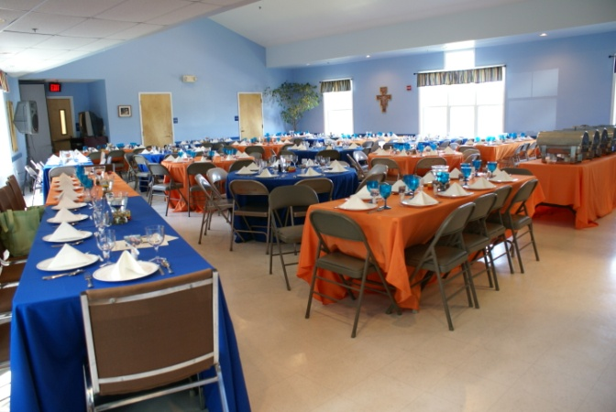
Contact Information

If you have any additional questions or if you would like to see the Hall, please feel free to contact Anne Rouse, Office Assistant, at (301) 262-3285 or email: office@stgeo.comcastbiz.net

St. George’s Episcopal Church is located at 7010 Glenn Dale Road in Glenn Dale, Maryland. It sits across the street from the Glenn Dale Post Office.

The Parish Office is open Monday through Thursday from 9 to 12. The office is closed on Fridays. Please call ahead to make certain someone is in the office to assist you.
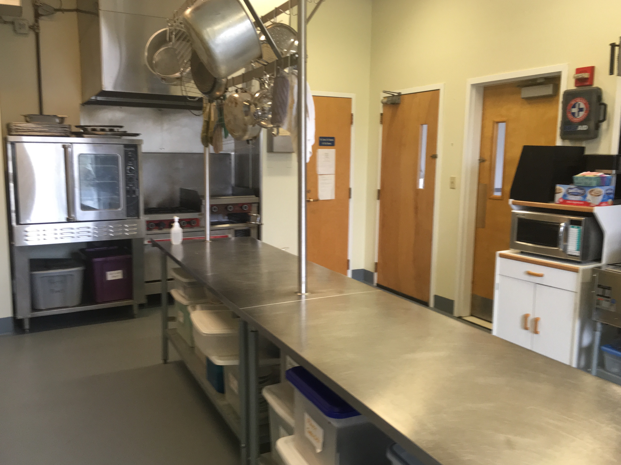
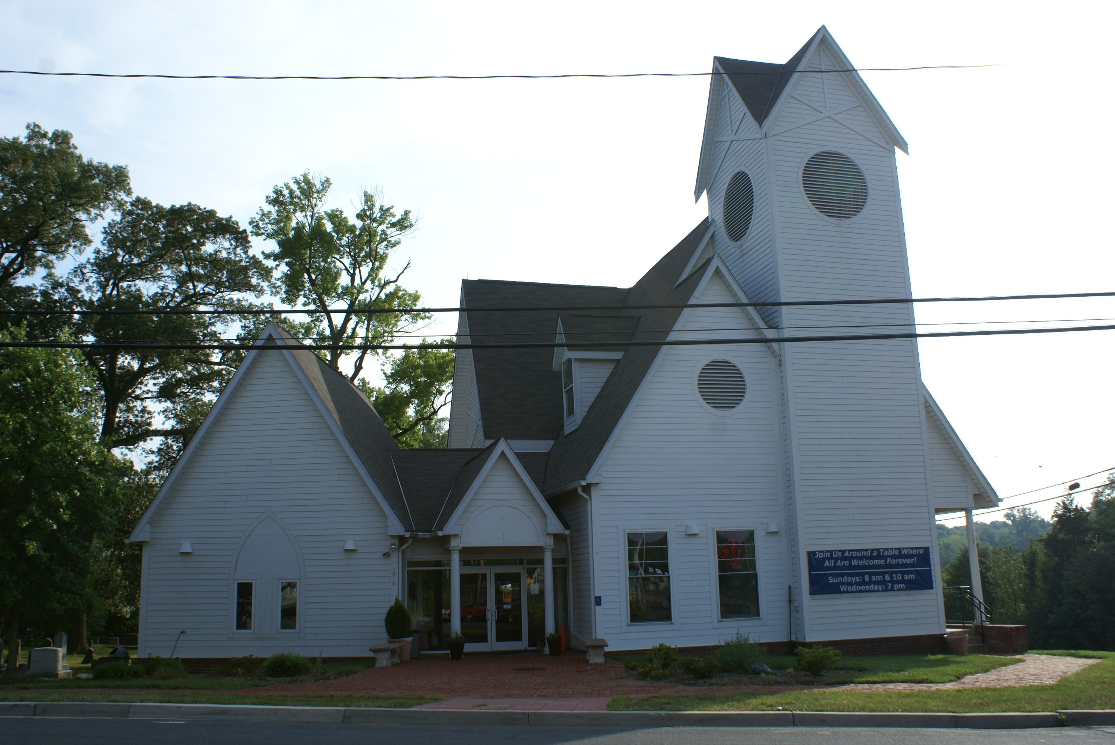

St. George’s Episcopal Church
is located at
7010 Glenn Dale Road
Glenn Dale, Maryland 20769

St. George’s sits at the corner of Route 193 and the Severn-Lanham Road between Greenbelt and Bowie. The church is conveniently located a short distance from the Capital Beltway (Hwy 495) and the Baltimore-Washington Parkway (Hwy 295).

Parking is available on site.

St. George’s Welcomes You
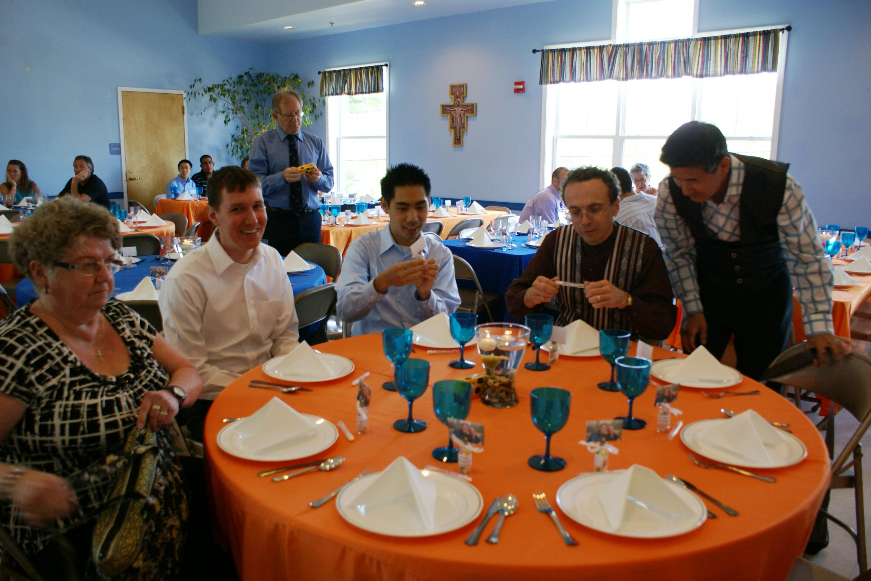
to Miller Hall

St. George’s
Episcopal Church
Glenn Dale, MD
(301) 262-3285
office@stgeo.comcastbiz.net

“We are delighted that you are interested in using St. George’s Miller Hall for your group’s celebration or other event. An important part of our ministry at St. George’s is making our facilities available to the community at large.”

-The Reverend Connie Reinhardt
Rector, St. George’s Episcopal Church

Welcome to St. George’s

St. George’s is a welcoming and open community with a tradition of hospitality. Miller Hall, our event space, is available for parties, receptions, and other events. The Hall is typically available on Friday and Saturday evenings anytime between 8:00 pm and 2:00 am. The Hall may also be available at other times. Please inquire with the office. We will do our best to accommodate your event within our church calendar.
Miller Hall Capacity

Miller Hall is located on the first floor of the St. George’s Church building and can be reached without using stairs. The Church provides 125 chairs, six round tables seating eight guests per table, eight six foot tables seating eight to ten persons per table, and ten eight foot tables seating ten to twelve persons each. Hall capacity is not to exceed 125 people.

Miller Hall also has a commercial grade kitchen for use during events. Restrooms and coat racks are located nearby.

Hall Donation Fee

The typical Miller Hall Rental Donation Fee is $750.00 ($125.00 per hour). This fee covers the six hour rental period from 8:00 pm to 2:00 am. A Miller Hall Rental Donation of $125.00 per hour is also available for shorter events but the hourly rate is firm and non-negotiable.

To Reserve the Hall

If you are interested in using Miller Hall, please arrange to visit the Parish Office to tour the space and to complete and sign a contract. By executing this written lease agreement, you are acknowledging and consenting to abide by the Building Use Guidelines. A Security Deposit must be paid in order to hold your reservation. The balance of your rental fee must be paid one week prior to the date of your event.
Security Deposit

St. George’s requires a Security Deposit in the amount of $300.00 if no beer and wine are served at the event. If the Party intends to serve beer and wine, the Security Deposit is $400.00. The Security Deposit may be refunded to the Party following the event provided it has been determined by St. George’s that there has been no damage to the premises and that all Building Use Guidelines have been followed. This includes a satisfactory cleaning of the Hall and the outside grounds. If you intend to serve beer and wine (hard liquor is not permitted in Miller Hall) you are required to obtain an insurance rider, either through your insurance company or a company we can recommend, to cover any liability issues.

Cancellations

Cancellations are permitted up to 30 days prior to the date of the event. Any cancellations within 30 days of the event will result in forfeiture of the Hall Rental Donation Fee and the Security Deposit.

Security Officer

A Security Officer representing St. George’s will be on site during the entire event. The Security Officer is present for troubleshooting and to make sure your event goes smoothly.

