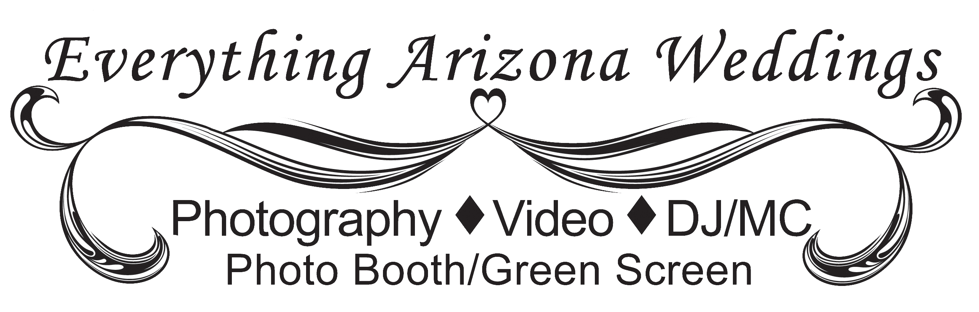
Wedding Package Pricing
V71515

Ultimate Package –
Includes all four services listed below:
Photography
DJ / MC (ceremony & reception)
- Open Photo Booth, Printing Station /Green Screen (up to 3/hrs unlimited prints)
- Video

Platinum Package –
Includes your choice of three services listed below:
Photography
DJ / MC
- Open Photo Booth, Printing Station /Green Screen (up to 3/hrs unlimited prints)
- Video

Gold Package -
Includes your choice of any two services listed below:
Photography
DJ / MC
- Onsite Photo Printing Station/ Green Screen (up to 3/hrs unlimited prints)
- Video

Photography Only

DJ / MC Only

On-Site Photo Printing Station/Green Screen (up to 3/hrs unlimited prints)

Video Only

All Prices based on full wedding and reception and up to 8 hours of time. (Except Photo Booth)

480-577-6222 Info@EverythingArizonaWeddings.com
www.EverythingArizonaWeddings.com

What You Get

Photography - Basic Package Includes:

- Up to 8 hours of services - we know how much time it really takes to get the results you want.
  - Pre-Ceremony photos, Ceremony, Post Ceremony, and Reception
- Custom photography timeline to make sure we have the perfect plan.
- Online Planning Tools that allow you to plan aspects of your wedding including your photography.
- You own all your images and the rights to your images “forever”.
- All photos professionally edited in “Photo Shop.”
- All photos posted to a private secure web site so you can share with family and friends.
- Facebook sneak peek – a few (4-6) photos to share within one week of ceremony.
- A custom slide show of highlighted images (15-40) and music posted to Facebook within 2 weeks.
- 3 complete DVDs with all your edited photos – delivered to you within 45 days.

DJ/MC - Basic Package Includes:

- Up to 8 hours of DJ/MC services.
- We work with you to create the reception timeline.
- Online Planning Tools that allow you to listen to and choose your special music.
- High-End professional sound system.
- Wireless microphones for toasts, etc.
- Professional DJ lighting to add to the experience.
- DJ / Masters of Ceremony for your reception - adding just the right amount of direction and fun.

Video - Basic Package Includes:

- Up to 8 hours of video services to include:
  - Pre-Ceremony, Ceremony, Post Ceremony, and Reception;
  - Five interviews with VIPs which can include bride & groom, parents, grandparents, some of the bridal party, other friends and family.
- Wireless microphones to be used during ceremony and interviews.
- Facebook sneak peek – a short highlight video to share within one week of ceremony.
- Three complete custom DVDs movies of your wedding – delivered to you within 90 days from your wedding:
  - Custom covers for your DVDs
  - Custom personalized menu on each DVD

Open Photo Booth/Green Screen & Onsite Photo Printing - Basic Package Includes:

- Up to 3 hours of service & unlimited 4x6 prints (More time and larger sizes available if needed).
- Professional Photographer & Computer Printer Technician always included.
- You pick your background theme - 12’x12’ background (large enough for groups of several people)
  - We can create custom backgrounds for your needed theme using Green screen photography which can put your guest right on the beach, on the edge of the Grand Canyon, or anywhere you can imagine. We will create a custom background for you based on your direction.
  - If green screen is not your thing we have a variety of quality muslin backdrops to choose from.
- We create a custom border around photo with your names, wedding date, and any text you may want.
- Quality photos print instantly for your guests.
- All photos posted to a private secure web site so you can share with family and friends.
480-577-6222 Info@EverythingArizonaWeddings.com
www.EverythingArizonaWeddings.com

