Package Includes:  Ballroom Rental, Dance Floor, Setup & Breakdown of tables and chairs, White Table Linen, Glass Mirrors on tables, Tables for Gifts, Cake and DJ, Event Security, Special Guest Room Rate Available | We have about 14,000 of versatile indoor and outdoor meeting/banquet space that can hold 10-300 people to fit any type of event. | Add-on Amenities  White chair covers at $2.00 each  China & Silverware at $9.50 per place setting  Sparkling Cider Toast at $20.00 per bottle  Cake Cutting Fee at $35.00  Bartender Fee at $130.00
Cactus Ballroom  (Price varies depending on room sections utilized)  1-30 guests - $750.00  31-50 guests - $950.00  51-70 guests - $1200.00  71-100 guests - $1400.00  Oasis  18-50 guests - $600.00 | River Park Ballroom  up to 200 guests $2950.00  Poolside Pavilion Tent  & Oasis Bar/Patio  60-90 guests - $1800.00  up to 300 guests - $4000.00
Special Discounts available if event is held Sunday through Thursday. All prices are subject to applicable sales tax, service charge, and subject to change. Food and Beverage pricing varies for the Ramada Tucson and we offer flexible catering options: use our menu options, ask about one of our preferred caterers or you can choose your own.
[Grab your reader’s attention with a great quote from the document or use this space to emphasize a key point. To place this text box anywhere on the page, just drag it.]
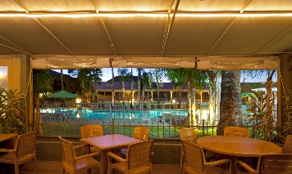
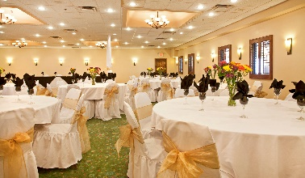
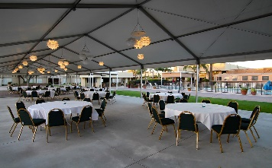

To book your event or if you have any additional questions, please contact
Mary Brashear at (520) 239-2311 or mbrashear@tucsonramada.com
RAMADA BY WYNDHAM TUCSON
777 W. Cushing Street | Tucson, AZ 85745
P: (520) 239-2300 | F: (520) 239-2329 | www.tucsonramada.com

2024 Social Event Package
Introducing

