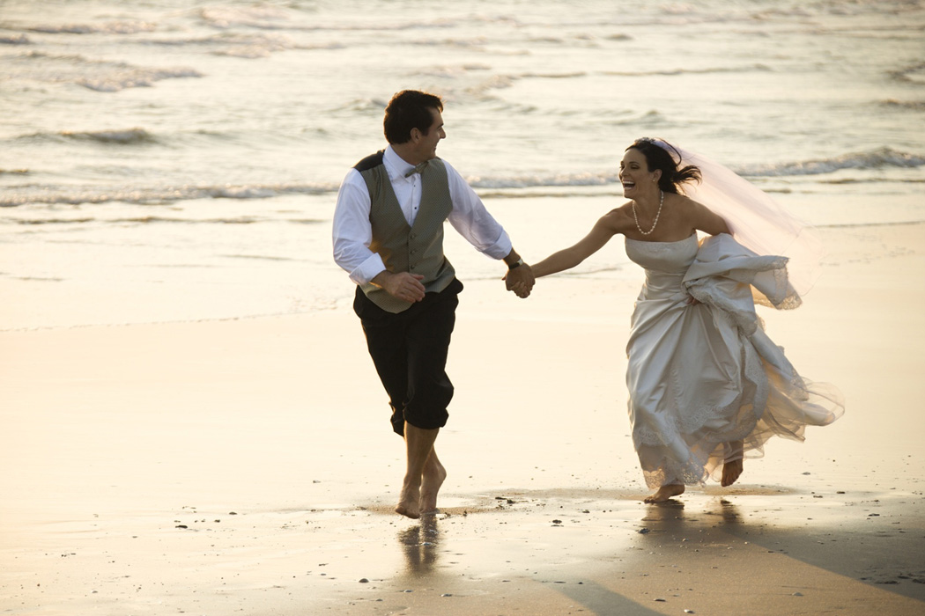
Beach Wedding
Good afternoon and welcome! What you about to witness today is a celebration of love and of life. The words and traditions you will hear and see reflected in this ceremony are based on our Bride and Groom’s connection to each other, and to the divine nature that is alive in all things, from the world around them to their relationship itself. It speaks of the importance of friends and of family, and the honor rightly given to these things, as well as the highest of honors that they pay unto each other this day as they lay the groundwork for that which shall be their life together.
As the tides ebb and flow, so too, do the fortunes of life. Footprints in the sand are washed away; driftwood moves on its endless quest for a peaceful harbor. Only a deep and abiding love can withstand the tides of change in two lives.
DECLARATION OF INTENT
Marriage is a bond to be entered into only after considerable thought and reflection. As with any aspect of life, it has its cycles, its ups and its downs, its trials and its triumphs. A couple who wed are joined not only by the mutual affection and love they share, but also by their hopes, dreams and by their resolve, come what may, to remain together through time. The promises and vows that they make together shall aid them in this pursuit, and guide them into their common future. Therefore, a wedding is more than a celebration of the love which lives in our bride and groom’s hearts today. It reaches into the future and proclaims their intentions for that which tomorrow shall hold, fixing like a star on the horizon their worthy goal. I will ask you now if you are prepared to make these promises.
______, will you love _________, comfort him, honor and keep him all the days of your journey?
I WILL
________, have you come here today of your own free will to take ______to be your wife, that you may live together as equal partners sharing all that life has to offer?
I HAVE
Will you love her, comfort her, honor and keep her all the days of your journey?
I WILL
Living by these promises that you make today, may your future be blessed even beyond that which all of those who are gathered here, who love you both so dearly, would dare to wish for you.
The Circle is Cast: We cast the circle of ancient lore; waves upon a timeless shore; with no beginning, nor an end; it always knows a foe from friend; mystic stories of legends old; rings of power, forged in gold, Circle of life, ring of stones; cycle of creation, birth to bones; A ring around the silv’ry moon; we cast you now, this month of June.
As we light the white candle, know that it represents the element of air and symbolizes the power of thought, communication and knowledge.
The red candle represents the elements of fire and symbolizes the power of passion, energy and vitality.
The blue candle represents the element of water and symbolizes feeling, emotions, and cycles.
The green candle represents the Earth and symbolizes solidarity, manifestations and possessions.
CALL THE QUARTERS:
Turning to the East: Spirits of the east whose element is air, give your blessings to Yahayra and who are about to be married. Grant to their union your gifts of communication wisdom and understanding.
Turning to the South: Spirits of the South whose element is fire, give your blessings to Yahayra and who are about to be married. Grant their union your gifts of vitality, passion and creativity.
Turning to the West: Spirits of the West whose element is water, give your blessings to Yahayra and who are about to be married. Grant to their union your gifts of love, intuition and friendship.
Turning to the North: Spirits of the North whose element is earth, give your blessings to Yahayra and who are about to be married. Grant to their union your gifts of stability, strength and abundance.
Elemental Blessing
Since ancient times, people have communed with nature to learn more about themselves by example. Since it is within nature that we all do abide, we ask for _____and ______ the blessings of nature’s most abiding element: Water. We do this that they may fully come to understand the lessons that this element has to offer. The attributes of which are an example of those aspects that are mirrored not only within divinity be within ourselves as well.
We ask the spirits of water, that their love for each other and the comfort of loved ones like the serenity of the deep blue ocean, be the oasis that forever surrounds our bride and groom. May they be well loved, and love well, letting the surety with which water makes its journey to the sea, flowing over rocks or around trees, even turning into vapor and riding a cloud, ever serve as a reminder that with love all is well and will endure.
_____and______ Will you now step up and hold close to your heart the bag of sand representing the essence of all that you are and all that you possess. As you do so, embody the grains with all your hopes and dreams for the future. Bring to mind all that you are, all that you aspire to be and all the particles that make you unique and wonderful in the eyes of your beloved.
Each take their own bag of sand.
Within a marriage each person is both their own and each others. Their personal integrity does not diminish by their union, in fact it is enhanced. Their hopes and dreams remain their own, as individual as each grain of sand. Yet they have a new life ahead with endless possibilities and new dreams that are theirs together.
Will you now join the contents of that which you hold in the palm of your hand, join your essences, and create this physical representation of the sacred place in which souls touch.
They intermingle their sand.
Presentation of the Rings
May I have the rings please?
A circle is the symbol of the sun and the earth and the universe. It is a symbol of perfection and peace. In these rings is the symbol of unity, in which your lives are now joined in one unbroken circle, in which, wherever you go, you will always return to one another and to your togetherness. The circle is one of nature’s simplest forms. The arc of the rainbow, the halo of the moon and the smallest of raindrops simulate the circle. Even when a stone is cast upon the water, it generates waves in ever expanding circles. Consider this marriage as being two stones meeting the water simultaneously. The ensuing waves interlock, and the growth of the enlarging circles show the combined energies of the lives of this couple. May your love always be constant, as these never ending waves that pour beneath our feet, flowing endlessly from the depths of the sea.
Groom_as it is your wish for _____ to be bound to you, repeating after me, will you now give voice to that which is in your heart:
I ______in the spirit of Love that resides within us all, by the life that courses within my blood, and the love that resides within my heart, promise that I shall not seek to change you in any way, I shall respect your beliefs, your people, and your ways as I respect myself. I take you to my hand, my heart and my spirit, to be my chosen one. To desire you, and be desired by you, without sin or shame. For nothing can exist in the purity of my love for you. I promise to love you wholly and completely without restraint, in sickness and in health, in plenty and in poverty, in life and beyond, where we shall meet, remember and love again.
REPEAT for Bride……..

By the power vested in me, I now pronounce that you are now as your hearts have always known you to be, Husband and Wife. May your love endure as powerful and endless as the sea and be as dependable as the tide. You may now kiss each other.

