First view before the ceremony  Why should you hire a Wedding Planner?  Here are the top 5 reasons  - Saves you money  - Saves you time  - Liaison between you and your vendors  - Keeps you on track  - Wedding Day management.  Wedding Planners are the person or people behind the seen making sure every aspect of the wedding goes as planned and allows the couple to enjoy the day stress free. |  |  | Who We Are  About Us  Take the stress out of wedding planning and feel like a guest. We are the people you need to bring you the wedding you are dreaming of.  Contact Us  Phone: 352-449-6352  Email: afantasytoremember@gmail.com  Web: www.afantasytoremember.com  a Fantasy to remember  18240 Villa City Road  Groveland Florida34736 |  |  | 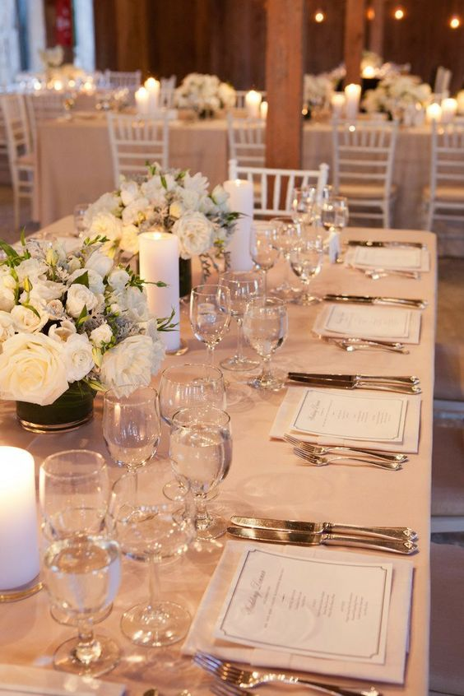  a Fantasy to remember  - Wedding and Event Planners

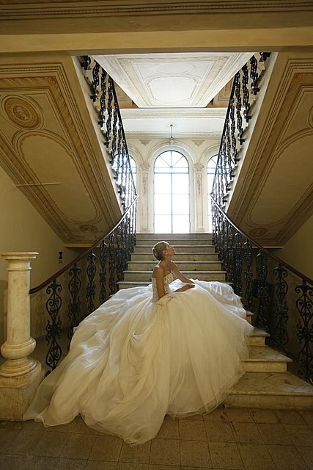  Our Mission  A Fantasy to Remember Wedding and Event Planners is a full service company that provides complete consulting services for Weddings, Anniversaries, Parties, and any kind of Event. We are here also to be your adviser, coordinator, supervisor, financial adviser, mediator, liaison, or just that shoulder to cry on if needed. We are here to help keep things calm, and stress free. So the couple and their families can enjoy this glorious day for many years to come. |  |  | Our Objective  Whether it’s our first client or our 100th client we want to give them the same attention to detail. We want every detail to be both a pleasurable and memorable experience. Therefor we offer a collection of packages and services tailored to their needs. We are confident that this will be a fantasy to remember with those unforgettable memories to last a life time.  “Paula was a real blessing for us. Really fabulous lady. She provided great service, was fantastic to work with! We could not have pulled off this day without her. She kept everyone on time and kept things moving. Her and her team did the table decoration, decorated the venue for the wedding and the reception. They even stayed late to clean everything up.” |  |  | 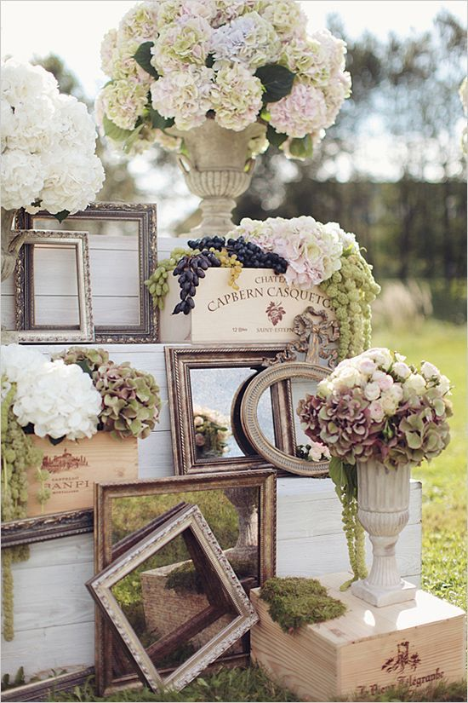  beautiful entrance to a wedding  What sets apart from everyone is that we take a fresh approach to every wedding. With our team made up of 5 ladies of all ages we are sure to have someone who will have the creativity to see your vision.  Our Services  Day of (month of) Service  Partial Planning  Full Planning  Destination Wedding Service  Travail Specialist

