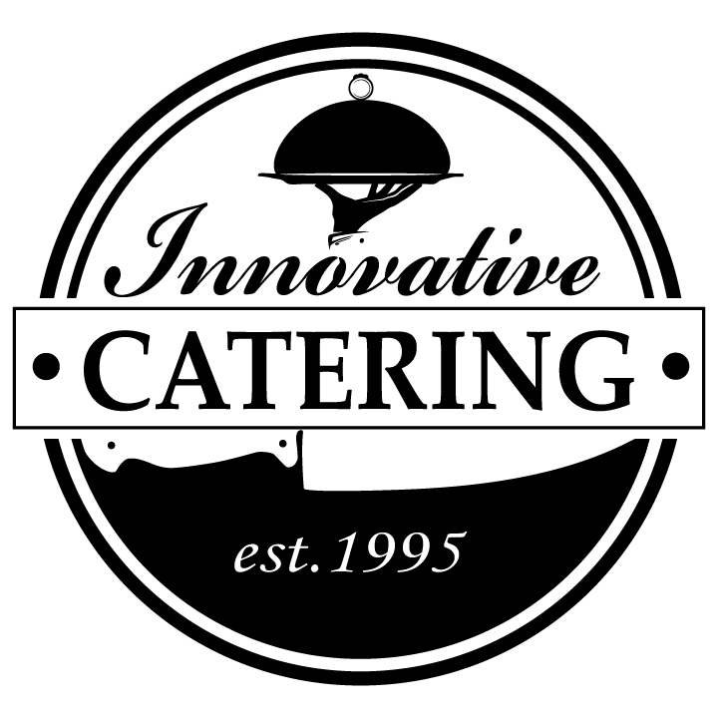

Thank you for considering Innovative Catering for your catering needs. We are excited to have the opportunity to work with you. Here are some services that can take the worry out of your planning

A little about our company:

- In business for 28 years in Lynchburg 6- Experienced in large scale events 25-2500
- Serve safe certified staff 7- Operate from a 2000 sq ft commercial kitchen
- Fully insured company 8- Friendly and Professional Staff
- Licensed in Virginia 9- Locally owned and operated
- Hold current health inspection 10- Preferred Caterer at almost every local venues

Some of the services we provide or arrange:

Custom Ice Carvings Tables & Chairs Linen Services Venue Arrangements
Event Planning Photo Booths ABC Licensing Indoor & Outdoor Games
Bartending Caricature Artist DJ Arrangement Band Arrangement
China Servicing Cake Cutting Multi-Shift Events Smoking & Grilling On Site
Candy Bars Food Stations Casino Night Events Meat Carving Stations

Full Service Events 20% with $600 Minimum Delivery Disposables and Set up $200 Just Basic Food Delivery $50

