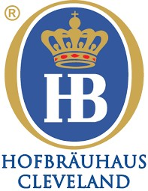

Bus Group Menu

$29 per person (Plus Service Charge & Tax)
Non-Alcoholic Beverages Included
Starter
(Choice of One for Entire Group)

Sauerkraut Balls

Pretzel with Bier Cheese

Entrees
(Each Guest may choose One)

Schnitzel Weiner Art
Classic Breaded Pork Cutlet, Served with Cranberry-Orange Relish and Bavarian Potato Salad

Gegrillte Haehnchenbrust (Grilled Chicken Breast)
Grilled Chicken Breast, Creamy Mushroom Gravy, Served with Spaetzle

Pierogies and Mettwurst
Sauteed Cheddar and Potato Pierogies, Sauteed with Mettwurst and Caramelized Onions,
Topped with Sour Cream and Green Onions
Wurstplatte
Sausage Plate with One Frankfurter and One Chicken Sausage,
Imported Sauerkraut, Mashed Potatoes, and Onion Mustard

Dessert
Crème Puff
German Chocolate Cake

