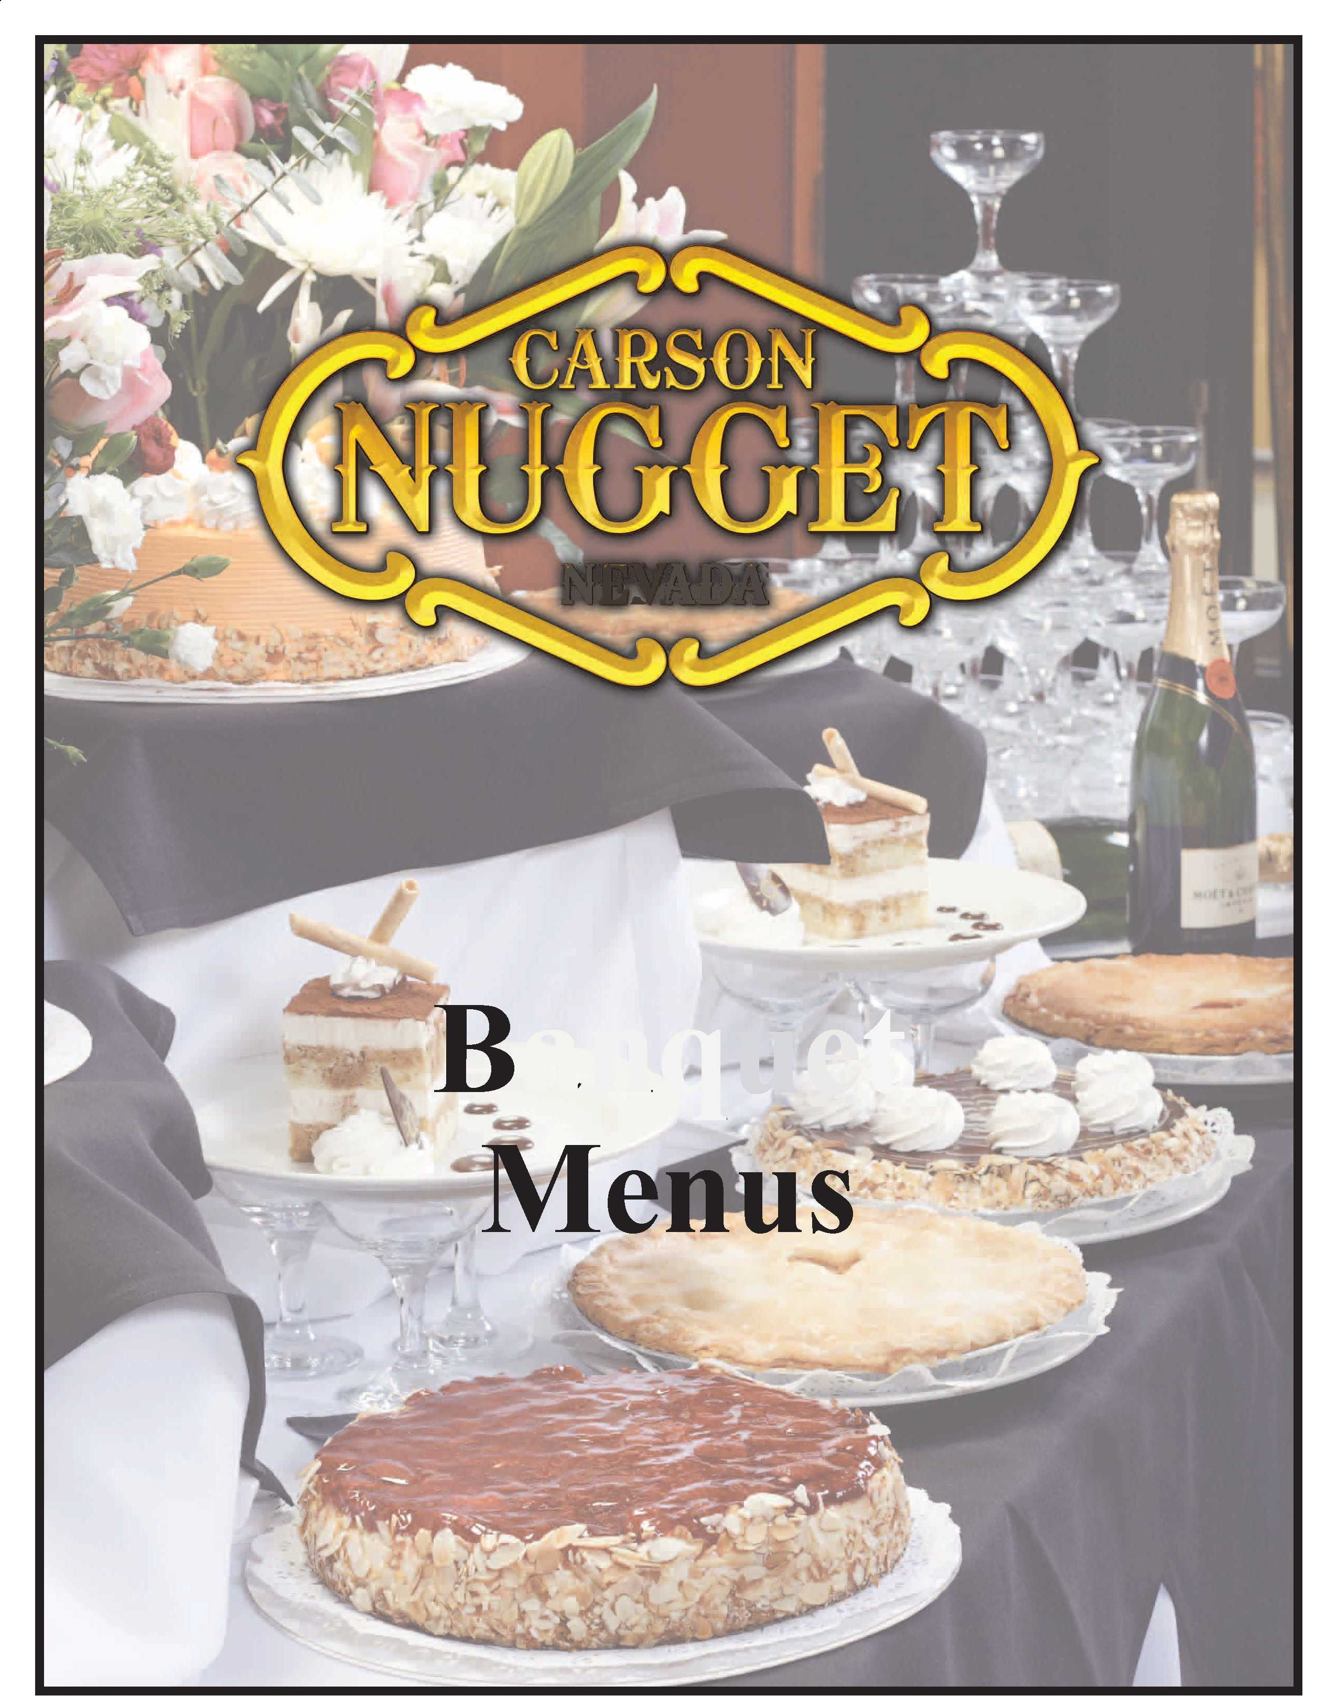NEVADA

anquet
Breakfast Buffet Menu | Refreshments
The Continental Breakfast | Beverage
Assorted muffins,
fruit platter, served with fresh juice selection, | • Coffee (per pot) | $10.00
coffee & hot tea | • Coffee (per urn, serves approx. 80) | $96.00
$16.75 per person | • Iced Teas (per pitcher) | $5.00
 | • Soft Drinks (each) | $1.50
The Early Bird | • Juice (per pitcher) | $15.00
Assorted cold cereals, | • Bottled Water (each) | $1.00
oatmeal, fresh muffins, fresh
cut fruit platter, yogurt, condiments that | From The Bakery
includes: trail mix, raisins, and brown sugar, | All bakery items are by the dozen/ except pies
also served with milk, juices, coffee & hot tea
$19.50 per person | • Cream Pies (Boston, Coconut,  Banana, & Chocolate) | $5.00
 | • Fruit Pies (Cherry, Peach & Apple) | $5.00
The Gambler | • Bagels & Cream Cheese | $26.00
Scrambled eggs, bacon strips, sausage, | • Assorted Muffins | $34.00
biscuits & gravy, cheese blintzes, home-fries, | • Assorted Doughnuts | $28.00
fresh cut fruit platter, assorted cookies & | • Assorted Cookies | $16.00
muffins, served with juice, coffee, and tea | • Brownies | $24.00
$21.50 per person
 | Break Enhancements
The Sierra
 | **all break enhancements are per person**
Scrambled eggs with cheese, sugar cured
ham, chorizo, home-fries, French toast or | • Fresh Cut Fruit Platter | $3.50
pancakes, fresh cut fruit platter, assorted cookies | • Fruit Bowl (apples, oranges, & bananas) $2.00
muffins, served with juice | • Spinach Artichoke Dip | $2.40
coffee, and tea | • Potato Chips & Onion Dip | $1.50
$22.75 per person | • Tortilla Chips & Salsa | $3.50
Breakfast Enhancements | • Pretzels (bowl) | $14.00
**all prices are per person** | • Soup of the Day (by the cup) | $ 2.25
• Grilled NY Breakfast Steaks $10.00 | Assorted Platters
• Corned Beef Hash $4.00 | **all platters are for 12 people**
• Mini Quiche $6.00
 | • Assorted Finger Sandwiches | $24.00
• Whole Fruit (Apples, Oranges, Bananas) $2.00 | • Assorted Cheese & Crackers | $29.00
• Yogurt (add granola for $1.00) $4.00 | • Assorted Sandwich Platter | $31.00
 | • Assorted Vegetable Platter | $29.00
 | Assorted Meat & Cheese Tray | $36.00
All food and beverage prices are subject to a 18% service charge and 7.60% State Sales Tax.

Sit Down Menu
Salads | Entrees
**all salad luncheons come with baked | **all luncheons listed below come with baked
rolls and butter, and coffee & tea, as well as | rolls and butter, your choice of salad (mixed green,
your choice of one dessert** | spinach, or Caesar) and coffee & tea, as well as your
 | choice of dessert**
Chicken Caesar Salad | Chicken Fettuccine
Crisp romaine lettuce with creamy Caesar | Sautéed pieces of chicken breast, tossed
dressing, croutons, Parmesan cheese, and | with fettuccine pasta, with a rich and creamy
fresh grilled chicken breast | Alfredo sauce, and mixed with fresh broccoli,
$17.00 per person | tossed with freshly grated Parmesan cheese
 | $24.00 per person
Grilled California Chicken Salad
Served on a bed of romaine lettuce, fresh
tomatoes, avocado slices, jack cheese, and
sliced grilled chicken breast
$17.00 per person
 | Chicken Florentine
 | Choice of creamy Alfredo sauce or
Chef's Salad | Marinara Sauce, served over a bed of
Chilled mixed lettuces, served with diced honey | Spaghetti noodles and fresh asparagus.
glazed ham, turkey, and cheese, topped with | $27.00 per person
fresh diced tomato, hardboiled egg, and olives
$17.00 per person
The Chopped Cobb Salad
Combination of mixed lettuces, topped with
diced chicken, crumbled bacon, hard boiled | Petite Filet Mignon
eggs, diced tomatoes, bleu cheese crumbles, | Served with wild rice pilaf and fresh vegetables,
and served with bleu cheese dressing | and topped with a wild mushroom sauce
$17.00 per person | $30.00 per person
Seafood Louie Salad
Fresh mixed greens, shrimp or snow crab,
hardboiled egg, sliced black olives, fresh diced
tomatoes, lemon wedges, and Louie dressing
$24.00 per person
All food and beverage prices are subject to a 18% service charge and 7.60% State Sales Tax.
10/13/16 | Banquets.F12.Banquet Menu Pricing

Sit Down Menu
**all dinners listed below come with
baked rolls and butter, your choice of salad
(mixed green, spinach, or Caesar) and coffee & tea,
as well as your choice of one dessert**

Roasted Pork Loin
Tender slices of pork loin, demo-glace, sliced
apples, served with twice baked potato and
chefs fresh vegetable selection
$31.50 per person

Grilled Salmon or Baked Halibut
Comes with choice of sauce (almandine sauce or
cucumber dill sauce), served with chefs fresh
vegetable selection and wild rice pilaf
$33.50 per person

Grilled Filet Mignon &
Chicken Breast Duo
Served with a mushroom demi-glace, wild rice
pilaf and chefs vegetable selection
$36.00 per person

Slow Roasted Prime Rib
Slow roasted, served with au jus & horseradish
cream sauce, comes with twice baked potato
and chefs fresh vegetable selection
$36.00 per person

Grilled Filet Mignon &

Shrimp Scampi Duo
Served with fresh vegetables and wild rice pilaf
$38.50 per person

Grilled Filet Mignon &

Grilled Salmon Duo
Comes with your choice of sauce, served
with chefs fresh vegetable selection and
twice baked potato
$39.50 per person

Buffet Style Menu
All buffets come with choice of mixed green salad, choice of 2 specialty salads, a fresh cut
fruit platter, baked dinner rolls, assorted
desserts, coffee & iced tea**

The American Buffet
Baked chicken, beef stroganoff with noodles,
fried shrimp, mashed potatoes & gravy, and
served with chefs fresh vegetable selection
$32.50 per person

The Italian Buffet
Chicken Parmesan, baked manicotti in
Marinara sauce, lasagna,
fresh vegetables, and garlic bread
$32.50 per person

The Western Buffet
Your choice of fresh baked fish with house
salsa -or- fried shrimp, BBQ ribs, BBQ chicken,
fried potatoes, baked beans, served with chefs
fresh vegetable selection
$35.00 per person

The Seafood Buffet
Deep fried prawns, fresh steamed clams,
seafood Newburg, halibut almandine, wild rice
pilaf, and fresh vegetable selection
$39.50 per person
The Fiesta Buffet
Mixed green salad, choice of 2 specialty salads fresh cut fruit platter, beef & chicken enchiladas, beef & chicken tacos, refried beans, Spanish rice, with flour & corn tortillas
$24.00 per person

All food and beverage prices are subject to a 18% service charge and 7.60% State Sales Tax.

Buffet Style Menu | Banquet Salad Selections
Create Your Own Buffet
The create your own buffet comes with
mixed green salad, choice of 2 specialty
salads, a fresh cut fruit platter, an appropriate | • Ham & Pasta Salad
starch, baked dinner rolls, assorted desserts, | • Three Bean Salad
coffee & iced tea | • Ravioli Salad
 | • Coleslaw
The Following Are Your Hot Choices: | • Potato Salad
• Fried Cod Nuggets | • Seafood Salad
• Fried Shrimp | • Shrimp Salad
 | • Chicken Salad
• Teriyaki Beef Kabobs | • Macaroni Salad
• Teriyaki Chicken Kabobs
 | • Caesar Salad
• Beef Stroganoff
• Beef Lasagna | • Cucumber & Tomato Salad
• Vegetarian Lasagna | • Spinach Salad
• Chicken Florentine | • Marinated Vegetable Salad
• Salisbury Steak
• House made Meatloaf
• Chicken Fettuccine Alfredo
• Polish Sausage & Sauerkraut
• Italian Sausage with Peppers & Onions | Dressing Selections
• Barbecued Ribs
 | • Ranch Dressing
Choice of any 2 items $28.00 per person | • Bleu Cheese Dressing
Choice of any 3 items $32.00 per person | • Italian Dressing
 | • Thousand Island Dressing
Carving Station
**live carver will be $30.00 per hour**
 | Salad Condiment Selections
Tri Tip Serves 10-12 people $66.00
Baked Ham Serves 12-16 people $66.00 | • Tomatoes
 | • Cucumbers
Slow-Roasted Pork Loin | • Croutons
Serves 12-16 people $78.00 | • Bacon Bits
Slow-Roasted Prime Rib | • Sunflower Seeds
Serves 25-35 people $330.00 | • Carrots
 | • Black Olives
**all carved items will come with appropriate | • Hardboiled Egg
sauces, garnishes, and accompaniments**
All food and beverage prices are subject to a 18% service charge and 7.60% State Sales Tax.

Banquet Bar Prices

Well Drinks $4.50
(Includes Domestic Beer and Wine)

Call Brands $5.50

Premium Brands $6.50
(Includes Imported Beer & Wine)
All beverages prices are subject to an 18% service charge and 7.60% tax
Hosted Bar constitutes a bar where the hosting party will pay for all drinks.
The bar bill is based on actual consumption and the bill is presented at the end Of the Function

No-Host Bar constitutes a bar where the individual guests will pay for their
drinks as they are ordered at the bar. For a complete Wine and Champagne price list, please contact your Banquet Sales Manager.

All food and beverage prices are subject to a 18% service charge and 7.60% Tax

