Extreme Screen Theatre & Lobby ………………………………..$6,000
*availability based upon Movie Schedule. Rental rates are not available by the hour.
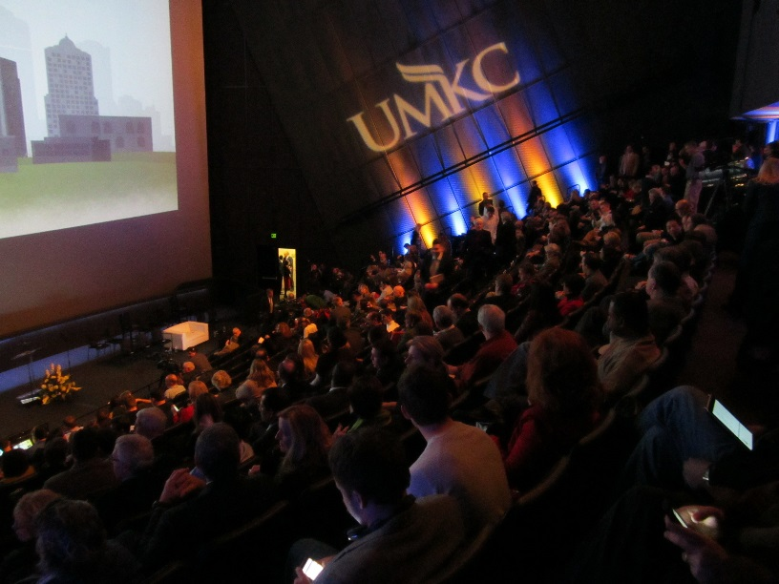

Theatre Seating Capacity: 400 stationary seats
Lobby Capacity: 400 (standing)

Theatre equipped with:
Furniture:
400 black leather stationary theatre seats
Audio/Visual:
Seats 400 for 2D movies and 380 for 3D movies
MDI silver screen, 80 feet by 53 feet
Two 4K digital DCI-compliant Barco projectors
Two lenses with 6.6K lamps
GDC 4K digital server
Three 9-foot-tall JBL stage speakers behind the screen
Real-D 3D
2 handheld wireless mics
House sound system
Other Amenities:
Internet access
Telephone/teleconferencing capabilities
Hearing impaired headsets
1,000 sq. ft. stage w/ holding area for speakers/presenters

